DOCTORAL (PHD) DISSERTATION

Haruna Seidu

UNIVERSITY OF SOPRON
Faculty of Wood Engineering and Creative Industries

Sopron, Hungary
2026

DOCTORAL (PHD) DISSERTATION

University of Sopron
Faculty of Wood Engineering and Creative Industries
József Czirák Doctoral School of Wood Sciences and Technologies
Head of School: Professor Dr. Laszlo Bejo

CHARACTERISATION OF EUCALYPTUS HYBRID PLYWOOD PRODUCED IN GHANA, A POTENTIAL SUBSTITUTE FOR THE EUROPEAN BIRCH PLYWOOD.

Author: Haruna Seidu
Supervisor: Professor Dr. Róbert Németh

Sopron, Hungary
2026

CHARACTERISATION OF EUCALYPTUS HYBRID PLYWOOD PRODUCED IN GHANA, A POTENTIAL SUBSTITUTE FOR THE EUROPEAN BIRCH PLYWOOD.
Dissertation for doctoral (PhD) degree
University of Sopron’s József Czirák Doctoral School
of Wood Science and Technologies.

F1 Wood Science programme
Written by:
Haruna Seidu.
Made in the framework of
F1 Wood Science programme
of József Czirák Doctoral School, University of Sopron

Supervisor: Professor Dr. Róbert Németh
I recommend for acceptance (yes/no) (Signature)

The candidate reached ..............% at the complex exam,

Sopron, .......................... Chairman of the Examination Board

As assessor I recommend the dissertation for acceptance (yes/no)

First Assessor (Dr..................................................) yes/no
(signature)

Second Assessor (Dr. ...........................................) yes/no
(signature)
Possible third assessor (Dr....................................) yes/no
(signature) The candidate reached...............% in the public debate of the dissertation

Sopron.
.....................................
Chairman of the Assessor Committee
Qualification of the doctoral (PhD) degree.......................................................

....................................
Chairman of the University Doctoral
and Habilitation Council (UDHC)

DECLARATION

I, the undersigned Haruna Seidu by signing this declaration, declare that my PhD thesis entitled Characterisation of Eucalyptus hybrid plywood produced in Ghana, a potential substitute for the European birch plywood was my own work. For this dissertation, I complied with regulations of Act LXXVI of 1999 on Copyright and rules of the doctoral dissertation prescribed by the József Czirák Doctoral School, especially regarding references and citations¹.
Furthermore, I declare that during the dissertation preparation, I did not mislead my supervisor(s) or the programme leader with regards to the independent research work.
By signing this declaration, I acknowledge that if it can be proved that the dissertation is not self-made or the author of copyright infringement is related to the dissertation, the University of Sopron is entitled to refuse the acceptance of the dissertation.

Refusing to accept a dissertation does not affect any other legal (civil law, misdemeanour law, criminal law) consequences of copyright infringement.

Sopron.....................................2026
...........................................
Haruna Seidu

¹Act LXXVI of 1999 Article 34 (1) Anyone is entitled to quote details of the work, to the extent justified by nature and purpose of recipient work, by designating the source and the author specified therein.
Article 36 (1) Details of public lectures and other similar works, as well as political speeches, may be freely used for the purposes of information to the extent justified by the purpose. For such use, the source , along with the name of the author, shall be indicated, unless this is impossible.

ACKNOWLEDGEMENT

First and foremost, I am deeply grateful to Almighty Allah for granting me the strength, patience, and guidance throughout this academic journey. I would like to express my sincere appreciation to my supervisor, Prof. Robert Németh, for his ongoing guidance, encouragement, and invaluable support. His expertise and mentorship have been instrumental in shaping this research. My sincere thanks go to all the lecturers at the József Czirák Doctoral School, whose dedication and teaching greatly enriched my knowledge and academic growth. I am also indebted to Dr. Bak Miklós for his generous assistance during my laboratory work, and to Prof. László Bejó for his valuable input and support. I would like to acknowledge the efforts of the faculty administrators, Vera Tolvaj, and the University administrator, Barbara Lakatos, whose administrative support significantly smoothed my academic journey. I am grateful to my wonderful colleagues, whose collaboration and encouragement were a source of inspiration and motivation throughout this work.
Special thanks go to my beloved wife, Zeinabu Sulley (CA), whose love, encouragement, and constant push to reach greater heights kept me going. To my children, Siraj Haruna Seidu, Abdul Basit Haruna, and Mubarak Mohammed Haruna, and my extended family, I am deeply thankful for your prayers, patience, and unwavering support.
I would also like to extend my gratitude to Urs Uehlinger and his wife, Andrea Uehlinger, for organizing the exchange programme at the Bern University of Applied Sciences in Biel, which enriched both my academic and personal experience. Also, to Jagdeesh Tewari (MIRO Plymill Director) for his tutelage in best practices in plywood manufacturing, and to Charlie Bosworth (MIRO Strategic Director) for granting me access to MIRO Timber Products Ltd. and believing in my research capabilities.
I acknowledge with thanks the support from the CSIR-Forestry Research Institute of Ghana, which served as a vital research site, and to MIRO Timber Product Ltd., who generously produced all the plywood samples used in this study.I am especially grateful to the Stipendium Hungaricum Scholarship Programme and the Ghana Scholarship Secretariat for providing the financial support that made my doctoral studies possible. Finally, I extend my appreciation to all those whose names I may not have mentioned but who, in one way or another, contributed to the successful completion of this work

Table of Contents
DECLARATION iv
ACKNOWLEDGEMENT v
Table of Contents vi
List of Figures x
List of Tables xi
List of Abbreviations and Acronyms xii
Abstract xiii
Absztrakt xvi
Chapter 1. General Introduction 1
1.1 General Background and Context 1
1.2 Adaptability of Hybrid Eucalyptus in Ghana 2
1.3 European Birch plywood as a Benchmark 3
1.4 Problem Statement 5
1.5 Justification 5
1.6 Objectives 6
1.7 Research Questions and Hypothesis 6
1.7.1 Key Questions Addressed 6
1.8 Hypothesis and Expected Outcomes 6
1.9 Significance of the study 7
1.10 Limitations 7
Chapter 2. Literature Review 9
2.1 Overview of Plywood Materials 9
2.1.1 Uses of Plywood 10
2.1.2 Classification of Plywood 12
2.1.2.1 Class 1 Plywood (EN 636-1) 12
2.1.2.2 Class 2 Plywood (EN 636-2) 12
2.1.2.3 Class 3 Plywood (EN 636-3) 13
2.1.3 Types of Plywood 13
2.1.3.1 Types Based on Wood Species 14
2.1.3.2 Types Based on Adhesive Systems 14
2.1.3.3 Types Based on Manufacturing Processes 14
2.1.3.4 Specialty Plywood Types 15
2.2 Properties of Eucalyptus Hybrid 15
2.2.1 Growth Characteristics 15
2.2.2 Anatomical Characteristics of Eucalyptus pellita 16
2.2.3 Physical and mechanical properties of Eucalyptus Pellita 17
2.2.3.1 Physical Properties Eucalyptus pellita 17
2.2.3.2 Mechanical Properties of Eucalyptus pellita 18
2.2.3.3 Adhesive Compatibility 18
2.2.3.4 Applications and Future Prospects 19
2.3 Production Process 19
2.3.1 MIRO Plywood Production Model 19
2.3.2 Functions of the MIRO plywood manufacturing model 20
2.3.3 Advances in Plywood Production and Technologies 23
2.4 Environmental Impact and Sustainability Considerations 24
2.4.1 Life Cycle Assessment (LCA) 25
2.4.2 Bio-Based Adhesives 27
2.4.3 Waste Management and Resource 27
2.4.4 Innovative Production Techniques 27
2.4.5 Quality Assurance Standards 28
2.5 Market Dynamics 28
2.5.1 Overview of the Plywood Market 28
2.5.1.1 Market Trends 29
2.5.1.2 Competitive Landscape 30
2.5.1.3 Regulatory Framework 30
Chapter 3. Mechanical Properties: Modulus of Elasticity and Modulus of Rupture 31
3.1 Background 31
3.2 Materials and Methods 32
3.2.1 Bending test 33
3.2.1.1 Sample Preparation 33
3.2.1.2 Conditioning of Samples 34
3.2.1.3 Testing Procedure 34
3.2.1.4 Data Analysis 35
3.3 Results and Discussion 36
3.3.1 Mean Modulus of elasticity and Rupture of PF and MUF-bonded plywood for different thicknesses. 36
3.3.2 Influence of Adhesive Type and Veneer Orientation on MOE and MOR 37
3.3.3 Conclusion 40
3.3.4 Acknowledgment 40
Chapter 4. Physical Properties: Density and Thickness Swelling 41
4.1 Background 41
4.2 Materials and Methods 42
4.2.1 Density 42
4.2.1.1 Sample Preparation 42
4.2.1.2 Conditioning 43
4.2.1.3 Measurement 43
4.2.2 Thickness Swelling 44
4.2.2.1 Sample Preparation 44
4.2.2.2 Conditioning 44
4.2.2.3 Immersion 44
4.2.3 Data Analysis 44
4.3 Results and Discussion 45
4.3.1 Mean densities and thickness swelling description. 45
4.3.2 ANOVA analysis on the thickness variation and adhesive type on plywood density 47
4.3.3 ANOVA analysis on the thickness variation of thickness swelling and adhesive type of plywood 48
4.3.4 Regression analysis of factors affecting thickness swelling 51
4.0 Conclusion 53
5.0 Acknowledgment 54
Chapter 5. Bonding Quality 55
5.1 Background 55
5.2 Materials and Methods 56
5.2.1 Bonding test 56
5.2.1.1 Sample Preparation 56
5.2.1.2 Pre-treatments 57
5.2.1.3 MUF Bonded Plywood Pre-treatment 57
5.2.1.4 PF Bonded Plywood Pre-treatment. 57
5.2.1.5 Test Procedure 58
5.2.1.6 Calculation of Shear Strength and Assessment of Wood Failure 58
5.3 Results and Discussion 59
5.3.1 Mean Bonding Strength and Wood Failure Results 59
5.3.2 Comparative Analysis of Bonding Strength in PF and MUF Bonded Plywood for various thicknesses. 62
5.3.3 Effect of Thickness Variation on Wood Failure of PF and MUF Bonded Plywood 64
5.3.4 Correlation Between Bonding Strength and Wood Failure 65
5.4 Conclusions 67
5.6 Acknowledgment 68
Chapter 6. Fungal and Termite Resistance in Juvenile Eucalyptus and Birch Plywood 68
6.1 Background 68
6.2 Materials and Methods 70
6.2.1 Termite 70
6.2.1.1 Materials 70
6.2.1.2 Sample Preparation 70
6.2.1.3 Land Preparation and Staking 72
6.2.1.4 Experimental Control Measures Adopted 72
6.2.1.5 Examination and Inspection Criteria 73
6.2.2 Fungi 74
6.2.2.1 Materials 74
6.2.2.2 Sample Preparation and Conditioning 74
6.2.2.3 Growth Medium Preparation and Inoculation 75
6.2.2.4 Sample placement and testing. 75
6.2.2.5 Examination and Inspection Criteria 76
6.3 Results and Discussion 76
6.3.1Termite Test 76
6.3.1.1 Birch Plywood 76
6.3.1.1 Eucalyptus PF Bonded Plywood 78
6.3.1.2 Eucalyptus MUF Bonded Plywood 80
6.3.1.3 Triplochiton scleroxylon (Wawa) – Control group 81
6. 3.2 Fungal Test Results 83
6.4 Conclusion 84
6.5 Acknowledgment 84
Chapter 7. Research Summary 85
Novel Finding 87
Thesis 1. Mechanical Properties 87
Thesis 2. Physical Properties 88
Thesis 3. Bonding Quality 88
Thesis 4. Biological Durability 88
Reference 90

List of Figures
Figure 1: Shows the microscopic images of Eucalyptus pellita; cross-section (A), radial section(B), and tangential section (C) (Source: Chinese Academy of Forestry, September 2006. 32
Figure 2: MIRO Plywood Manufacturing Model 35
Figure 3: Shows bending samples being prepared using a dimensional saw. (Source: MIRO Timber Products Ltd. Workshop) 48
Figure 4: Illustration of a 3-point bending test setup according to EN 310: 1993 (Source: EN 310:1993) 49
Figure 5: Plywood sample undergoing a 3-point bending test 49
Figure 6: Measuring the width shown in ‘A’ and the thickness in ‘B’ 57
Figure 7: Illustration of nicking on a bonding test piece by shear method (Source: EN 314-1 standard) 70
Figure 8: Pre-treated samples were placed on tissue paper to absorb moisture 71
Figure 9: image ‘A’ shows a shear test piece in a clamp during testing, and ‘B’ displays tested samples showing the shear area. 72
Figure 10: Box plot of mean values for both PF and MUF bonded panels, ‘A’ and ‘B’ represent Bonding Strength and Wood Failure, respectively. 74
Figure 11: Correlation Between Bonding Strength and Wood Failure Across Varying Panel Thicknesses, A-9 mm, B-12 mm, C-15 mm, D-18 mm, and E-21 mm. 79
Figure 12: Labelled sample being weighed before drying. 84
Figure 13: Installation of stakes (samples) 84
Figure 14: Samples being dried in an oven at 104ºC 85
Figure 15:Preparation of the growth medium shown in ‘A’ and the inoculated growth medium in an incubator shown in ‘B’. 88
Figure 16:Graph and Image of the Birch plywood samples after 7 months of exposure to termites 91
Figure 17:Graph & Image of Eucalyptus PF bonded Plywood samples after 7 months of exposure to termites. 92
Figure 18: Graph and Image of Eucalyptus MUF-bonded plywood after 7 months of exposure to termites 93
Figure 19: Graph and Image of the control samples after 7 months of exposure to termites 94

List of Tables
Table 1 Details of the MIRO Plywood Manufacturing Model 37
Table 2: Longitudinal and transverse orientation comparison for both the PF and MUF (n=30 in each orientation) 53
Table 3: Analysis of Variance (ANOVA) for Density Differences in Plywood Bonded with PF and MUF Adhesives Across Thickness Ranges 63
Table 4: Analysis of Variance (ANOVA) for Thickness Swelling Differences in Plywood Bonded with PF and MUF Adhesives Across Thickness Ranges 65
Table 5: Multiple Regression Coefficients for the Effects of Adhesive Type, Density (kg/m³), and Thickness (mm) on Thickness Swelling (%) of Plywood 67
Table 6: Mean Bonding Strength and Wood Failure results of various thicknesses for PF and MUF 74
Table 7: ANOVA Results for Bonding Strength (fv) of PF and MUF Bonded Plywood at Different Thicknesses 76
Table 8: ANOVA of Wood Failure in PF and MUF Bonded Plywood at Different Thicknesses 78
Table 9: Plywood types of control sample used in the termite exposure experiment. 84
Tab 10 Classification of Durability of Wood and Wood-based materials to termite attack based EN 117 ratings. 87
Tab. 11 Rating system for the assessment of attack by termites on test stakes BS EN 252-2 87
Table 12: Plywood types and control samples used in the fungal exposure experiment. 88
Table 13 Durability Class of wood and wood-based material to fungi. 90
Table 14: Summarised termite test results for Birch Plywood 91
Table 15 Summarised Termite Results for Eucalyptus PF Bonded Plywood 92
Table 16: Summarised Termite Results for Eucalyptus MUF Bonded Plywood 94
Table 17: Summarised Termite results for Triplochiton scleroxylon (Wawa), the control group. 95

List of Abbreviations and Acronyms
ANSI – American National Standards Institute
CLT – Cross-Laminated Timber
DBH – Diameter at Breast Height
EN – European Norm (Standard, e.g., EN 314)
EU – European Union
EUTR – EU Timber Regulation
FLEGT IMM – Forest Law Enforcement, Governance and Trade Independent Market Monitoring
FSC – Forest Stewardship Council
GHG – Greenhouse Gas
GDP – Gross Domestic Product
HDPE – High-Density Polyethylene
HPVA – Hardwood Plywood & Veneer Association (now part of Decorative Hardwoods Association)
ITTO – International Tropical Timber Organization
LCA – Life Cycle Assessment
LVL – Laminated Veneer Lumber
MDF – Medium-Density Fibreboard
MIRO – MIRO Timber Products Ltd. (Plywood Production Model)
MOE – Modulus of Elasticity
MOR – Modulus of Rupture
MPa – Megapascal (unit of pressure/stress)
MUF – Melamine-Urea-Formaldehyde (adhesive)
NCO/OH Ratio – Isocyanate Index (ratio of isocyanate groups to hydroxyl groups in adhesives)
NZ – New Zealand
OSB – Oriented Strand Board
PEFC – Programme for the Endorsement of Forest Certification
PF – Phenol-Formaldehyde (adhesive)
PU – Polyurethane
ReCiPe – A life cycle impact assessment methodology
UF – Urea-Formaldehyde (adhesive)

Abstract
This study evaluated the mechanical, physical, bonding, and biological durability of plywood manufactured from juvenile Eucalyptus pellita produced in Ghana. Panels of five nominal thicknesses (9, 12, 15, 18, and 21 mm) were produced using two commercial adhesives, phenol formaldehyde (PF) and melamine–urea–formaldehyde (MUF), and tested using relevant EN and BS standards. Mechanical characterization (3-point bending: modulus of elasticity, MOE; modulus of rupture, MOR) used specimens prepared and conditioned to 12% moisture content (EN 310/326-1); physical tests measured density (EN 323) and 24-h thickness swelling (EN 317); bonding quality employed shear tests and wood-failure assessment (EN 314-1); biological durability comprised a 7-month field test against subterranean termites (EN 350 / BS EN 252) and a 16-week laboratory decay test with Coriolus versicolor (CEN/TS 15083-1). Data were analyzed with ANOVA/Tukey, correlation and multiple regression.
Mechanical properties, primarily the MOE and MOR, decreased with increasing panel thickness; longitudinal properties exceeded those in the transverse direction. PF-bonded panels consistently recorded higher MOE/MOR than MUF across thicknesses (e.g., PF longitudinal MOE ≈ 7,096 ± 1,567 N/mm² at 9 mm vs ≈4,627 ± 842 N/mm² at 21 mm). Orientation and thickness effects were statistically significant in most comparisons (p < 0.05–0.01). Physical properties results showed that the mean density declined with thickness for both adhesives; PF panels were denser than MUF (e.g., PF: 785 → 709 kg·m⁻³; MUF: 731 → 648 kg·m⁻³). Thickness swelling decreased with thickness and was lower for PF (5.90 mm → 3.62%) than MUF (7.92 mm → 3.11%); a multiple regression model (R² - 0.699) identified significant adhesive × density and adhesive × thickness interactions affecting swelling. Bonding PF produced higher and more consistent shear strength (1.58–1.67 N·mm⁻² for 9–15 mm, dropping to 1.12 N·mm⁻² for 18–21 mm) and high wood-failure percentages (78–83%), while MUF showed greater variability (bonding strength 1.24–1.67 N·mm⁻²; wood failure 53–72%); correlations between bonding strength and wood failure were stronger in thinner panels. Biological termite field trials ranked materials: control Triplochiton scleroxylon failed (mean mass loss 71.5%); birch plywood was not durable (40.6% mass loss); E. pellita PF panels were classified as Durable (9.4% mass loss, DC1), whereas MUF panels were Moderately Durable (14.0%, DC3). In laboratory decay tests, all tested plywood types (PF and MUF, birch and E. pellita) exhibited very low mass loss (2.6–3.1%) and were classified as Very Durable (DC1). In contrast, the beech control failed (≈35.7%, DC5) as expected.
Overall, juvenile E. pellita plywood, particularly when bonded with PF and produced as thinner laminates, demonstrates promising mechanical performance, dimensional stability, and biological resistance, making it suitable for demanding applications. MUF remains a cost-effective option for interior uses but exhibits greater variability and reduced moisture/termite resistance. The results emphasize the importance of selecting the right adhesive, ensuring veneer quality, and controlling pressing to optimize plywood performance; further long-term field studies and targeted process optimization are recommended.

Absztrakt
Ez a tanulmány értékelte a Ghánában termesztett fiatal Eucalyptus pellita-ból készült rétegelt lemez mechanikai, fizikai, kötési és biológiai tartósságát. Öt névleges vastagságú (9, 12, 15, 18 as 21 mm) lemezt gyártottak két kereskedelmi ragasztóval, fenol-formaldehiddel (PF) és melamin-karbamid-formaldehiddel (MUF), és a vonatkozó EN- és BS-szabványok szerint vizsgálták. A mechanikai jellemzés (hárompontos hajlítás: rugalmassági modulusz, MOE; szakítószilárdsági modulusz, MOR) 12%-os nedvességtartalomra előkészített és kondicionált mintákat használt (EN 310/326-1); a fizikai vizsgálatok keretében sűrűséget (EN 323) és 24 órás dagadást (EN 317) mértek; a ragasztás minőségét nyíróvizsgálatokkal és faanyag-hibaelemzéssel vizsgálták (EN 314-1); a biológiai tartósságot hét hónapos terepi vizsgálat és egy 16 hetes laboratóriumi vizsgálat (Coriolus versicolorral, CEN/TS 15083-1), valamint földalatti termeszekkel szembeni ellenállás vizsgálatával jellemezték (EN 350 / BS EN 252). Az adatokat ANOVA/Tukey-teszttel, korrelációval és többszörös regresszióval elemezték.
A mechanikai tulajdonságok, elsősorban a rugalmassági modulusz (MOE) és a hajlítószilárdság (MOR), csökkentek a lemez vastagságának növekedésével; a hosszirányú tulajdonságok meghaladták a keresztirányúakat. A PF-del ragasztott lemezek vastagságnál következetesen magasabb rugalmassági moduluszt (MOE) és hajlítószilárdságot (MOR) tapasztaltak, mint a MUF-fel ragasztottak esetében (pl. a PF hosszirányú MOE ≈ 7096 ± 1567 N/mm² 9 mm-es vastagságnál, szemben a ≈ 4627 ± 842 N/mm²-rel 21 mm-es vastagságnál). Az orientáció és a vastagság hatása statisztikailag szignifikáns volt a legtöbb összehasonlításban (p < 0,05–0,01). A fizikai tulajdonságok eredményei azt mutatták, hogy mindkét ragasztó esetében a vastagsággal csökkent az átlagos sűrűség; a PF lemezek sűrűbbek voltak, mint a MUF-fel készültek (pl. PF: 785 → 709 kg·m³; MUF: 731 → 648 kg·m³). A vastagsági dagadás a vastagsággal csökkent, és alacsonyabb volt a PF esetében (5,90 mm → 3,62%) mint a MUF esetében (7,92 mm → 3,11%); egy többszörös regressziós modell (R² = 0,699) jelentős ragasztó × sűrűség és ragasztó × vastagság kölcsönhatásokat azonosított, amelyek befolyásolják a dagadást. A PF ragasztás magasabb és egyenletesebb nyírószilárdságot eredményezett (9–15 mm-es lemezeknél 1,58–1,67 N·mm⁻², 18–21 mm-es lemezeknél 1,12 N·mm⁻²-re csökkent), valamint magas faanyag-törési százalékot (78–83%), míg az MUF nagyobb variabilitást mutatott (ragasztási szilárdság 1,24–1,67 N·mm⁻²; faanyag-törés 53–72%); a ragasztási szilárdság és a faanyag-törés közötti korreláció vékonyabb lemezeknél erősebb volt. A termeszekkel végzett terepkísérletek alapján rangsorolták az anyagokat: a kontroll Triplochiton scleroxylon nem bizonyult tartósnak (átlagos tömegveszteség 71,5%); a nyírfa rétegelt lemez nem volt tartós (40,6% tömegveszteség); az E. pellita PF lemezek tartósnak (9,4% tömegveszteség, DC1), míg az MUF panelek mérsékelten tartósnak (14,0%, DC3) minősültek. Laboratóriumi tartóssági vizsgálatok során az összes vizsgált rétegelt lemez típus (PF és MUF, nyír és E. pellita) nagyon alacsony tömegveszteséget mutatott (2,6–3,1%), és Nagyon Tartósnak (DC1) minősítették. Ezzel szemben a bükk kontroll várakozás szerint megbukott (≈35,7%, DC5).
Összességében a fiatal E. pellita rétegelt lemez, különösen PF ragasztóval ragasztva és vékonyabb lemezként előállítva, ígéretes mechanikai teljesítményt, méretstabilitást és biológiai ellenállást mutat, így alkalmas igényes alkalmazásokra. A MUF továbbra is költséghatékony megoldás beltéri használatra, de nagyobb a szórása, és csökkent a nedvességgel és termeszekkel szembeni ellenállóképessége. Az eredmények kiemelik a megfelelő ragasztó kiválasztásának, a furnér minőség biztosításának és a préselés szabályozásának fontosságát a rétegelt lemez tulajdonságai optimalizálása érdekében; további hosszú távú terepi vizsgálatok és célzott folyamatoptimalizálás javasolt.

Chapter 1. General Introduction

1.1 General Background and Context
Plywood remains the most demanded wood-based panel despite the existence of other wood-based panels such as medium-density fibreboard (MDF), particle board, and oriented strand board (OSB), (Chapman 2006, Gonçalves et al. 2018, Mantanis et al. 2018, Rathke et al. 2012, Yu & Fan 2017). According to the Forest Product Statistics (2021), plywood production makes up 118 million m³, representing about 32.2% of the worldwide supply of wood-based panels. Plywood is used widely for several construction products, including ceilings, cabinets, doors, furniture, and many others. According to research, the density and mechanical properties of plywood depend on the wood species and quality of the veneer, the glue layer, the compression or pressure during production, etc. (Kajaks et al. 2012, Okuma 1976, Bekhta et al., 2012, 2020) . Ghana has been one of the countries in the plywood industry that supplies plywood to the world market. In a report published by FLEGT IMM (2022), ITTO estimated Ghana’s export of plywood volumes as 16,904 m³ in the year 2020, a sharp decline from the 2018 export of 24,000 m³, which can be attributed to the dwindling of the natural forest at an alarming rate, in the last few decades, and this is due to the indiscriminate logging of trees (Ewudzie et al. 2018). Also, the global demand for premium wood species has contributed significantly to this phenomenon.

The raw material needs of the local plywood production cannot be overlooked, as there is demand for bigger-diameter logs for production. The traditional species dominating plywood production in Ghana are the Ciber pentandra, Lovoa klaineana, etc. (Ghana Forestry Commission 2011). This situation is affecting the carbon sink potential of the Ghanaian natural forest. Innovative and sustainable measures are being explored to supply the market while protecting the forest cover to curb this problem. In supporting this agenda, a forest organization is exploring the use of fast-growing Eucalyptus (Eucalyptus globulus) as a raw material to produce plywood to augment the increasing demand from the European and American markets. This will sustainably boost the contribution to the forest product of 3% of the Gross Domestic Product of Ghana, which contributes about $240.9 million in total exports (Tuffour-Mills et al. 2020).

The intervention of using juvenile eucalyptus to produce plywood has coincided with supply issues faced by the European plywood industry, which relies heavily on birch plywood importations from Russia. Alternative means to bridge the supply and demand gaps need to be explored as early as possible to safeguard the plywood market within the European Union. The birch plywood produced in Russia is proven to be top-notch plywood. Eucalyptus hybrid plywood is an engineered wood product made from thin layers of eucalyptus wood veneer bonded together. The strength characteristics of Eucalyptus hybrid plywood can vary depending on several factors, including the quality of the veneers, the type of adhesive used to bond the veneers, and the manufacturing process, particularly the pressing time.

1.2 Adaptability of Hybrid Eucalyptus in Ghana
Ghana, a country in the coastal regions of West Africa, is home to more than six hundred hardwood species, with densities ranging from low to high. Several attempts have introduced foreign timber species into the country for various reasons. Certain species were targeted for industrial purposes, such as Broussonetia papyrifera for sacks and fiber ropes, and Gmelina arborea for paper production(Bosu et al., 2013). Eucalyptus hybrids are now a common timber species that is grown for use as service poles for the telecommunications and electricity transmission industries of the country.
Despite being native to Australia, eucalyptus plants thrive in Ghana's tropical climate and produce high-quality wood that can be used for a variety of purposes. Eucalyptus trees are among the strongest and most adaptable tree species outside of tropical regions (Stanturf et al., 2013). There are now more eucalyptus plantations in Ghana because of the plywood industry's increased demand for plywood, yet the big-diameter timbers are fast dwindling. MIRO Timber Products Ltd. has established a plywood factory to use small-diameter logs for the manufacturing of plywood. In recent times, they have been conducting trials with Eucalyptus pellita. According to (Bremer & Farley, (2010) and Lemessa et al., (2022), these eucalyptus plantations have the potential to negatively change biodiversity, reduce carbon sequestration, and destroy natural forests. However, Eucalyptus hybrid plantations in Ghana are established in areas with less to no natural forest and degraded lands. The CSIR-Forestry Research Institute of Ghana has conducted several studies on the impacts of the plantation on the natural biodiversity (Attuaquayefio & Folib, 2009; Kwame, 2014). Research indicates that eucalyptus farms have a substantial impact on water availability and soil fertility, which in turn affects neighbouring ecosystems (Steenhuis et al., 2023).
Studies have shown that hybrid eucalyptus species have the potential to produce more biomass than regular eucalyptus under the right circumstances(Wongprom et al., 2025). Research conducted in Brazil shows that hybrids like Eucalyptus urophylla and Eucalyptus camaldulensis exhibit superior below-ground biomass output because of beneficial genetic traits (Dick et al., 2021; Kulmann et al., 2022). These findings are particularly relevant in Ghana because of the country's varied soil types and climate. These characteristics are crucial for sequestering carbon (Vieira & Rodríguez-Soalleiro, 2019); hybrid eucalyptus significantly boosts biomass production, which raises carbon stocks in forest ecosystems.
To maximize development rates, recent advancements in eucalyptus research emphasize the necessity of fertilizer and water control. Good irrigation techniques increase water efficiency, which raises wood production (Stape et al., 2004). The use of drought-resistant eucalyptus hybrids could lessen the effects of water scarcity, especially in areas of Ghana that face difficult drought conditions. It is important to understand how hybrids react to local conditions, and selecting the right species for Ghana requires examining how well genetically modified eucalyptus hybrids adapt to different hydric environments (Saadaoui et al., 2017). Soil enrichment is essential for the successful establishment of eucalyptus plants. It has been shown that fertilizer application enhances biomass generation. According to Bennet et al., (1997) hybrid eucalyptus species increased their stand volume by 45.8% after fertilization. This suggests that Ghana could achieve similar outcomes with the right fertilization techniques. Eucalyptus hybrids' adaptability to various soil types increases their viability for sustainable forestry in Ghana.

1.3 European Birch plywood as a Benchmark
For years, the European Birch (Betula pendula) plywood has been the industry benchmark due to its exceptional properties. The plywood is produced from sustainably managed forests in Northern and Eastern Europe, particularly Finland, Russia, and the Baltic countries. They are known for their remarkable strength, longevity, and visual appeal. The construction, furniture, automotive, and marine industries choose this material because of its extraordinary mechanical properties and constant quality.
Consistent multi-ply structure gives European Birch plywood exceptional stability, warping resistance, and load-bearing capacity due to the symmetrical arrangement of the veneers. The longitudinal strength and stability of birch plywood can be attributed to the inherent characteristics of birch wood. It has been established that birch plywood exhibits superior mechanical performance, such as modulus of elasticity and modulus of rupture, when compared to softwood alternatives (Wang et al., 2023; Akkurt et al., 2022). This is significant because these mechanical properties are critical for structural engineering applications where load-bearing capabilities are paramount (Akkurt et al., 2022; Wang et al., 2023). Unlike other types of plywood, which might have mixed hardwood or softwood cores, the Birch plywood is made entirely of high-grade birch veneers, producing a product with constant strength and performance. Moreover, its fine, smooth surface makes a great basis for laminating and painting, enabling a flexible material for both structural and decorative uses.
Moreover, the economic and technological advantages of birch plywood are well-documented. Birch wood is renowned for its efficient production processes in plywood manufacturing, contributing to lower glue consumption and reduced energy costs during the production phase (Çakıroğlu et al., 2019, and Akkurt et al., 2022). Research indicates that birch plywood not only maintains its strength over time but also enhances aesthetic qualities, which broadens its applications in both structural and decorative fields (Gusts & Adijāns, 2024, and Wang et al., 2023). The high strength-to-weight ratio of birch plywood also qualifies it as a suitable candidate for lightweight construction, which is increasingly relevant in modern architecture (Wang et al., 2023).
Furthermore, the environmental impact and sustainability of birch plywood make it an appealing option over other materials such as metal (Gusts & Adijāns, 2024, and Çakıroğlu et al., 2019). The utilization of adhesives during the manufacturing process has also evolved, with studies highlighting the effectiveness of newer adhesive formulations that keep both structural integrity and environmental compliance (Bekhta & Sedliacik, 2019 and Réh et al., 2021). This shift reflects a growing trend within the industry towards eco-friendliness while balancing performance and safety standards.
The physical properties can vary significantly based on processing techniques, such as hot-pressing and surface treatments, which influence glue adhesion and overall durability (Kask et al., 2021). This adaptability allows birch plywood to excel under various environmental conditions, including moisture exposure, where its properties can be further improved through treatments like acetylation (Wang et al., 2023 and Rudzīte & Bukšāns, 2021). Apart from its technical excellence, the Birch plywood defines sustainability and environmental responsibility. Certified by reputable forestry associations, including FSC® (Forest Stewardship Council) and PEFC (Programme for the Endorsement of Forest Certification), it is a preferred choice for environmentally friendly, sustainably produced goods. Modern sustainable building and industry depend critically on its low environmental impact, recyclability, and long lifetime.

1.4 Problem Statement
The EU markets for decades have depended heavily on Russian birch plywood with an annual demand of 1.5 million m³ in the estimated 2.2 million m³ industry (Blasten, 2022). There is a high shortage of products in the EU market due to the trade sanctions imposed on Russia by the European Union. To meet the demand gap, an alternative supply source is needed. Meanwhile, Ghana is faced with the challenge of forest depletion affecting the raw material for plywood production. To address these pressing issues, exploring sustainable forestry practices in Ghana could provide a dual solution by replenishing forest resources while supplying the EU market with much-needed plywood alternatives. Characterizing the properties of plywood produced from Eucalyptus pellita will be essential in determining its viability as a substitute for the birch plywood.

1.5 Justification
The challenges created by the imposition of sanctions on Russian goods and services have significantly affected the supply of birch plywood. Therefore, there is an urgent need to find suitable alternatives. According to Blasten (2022), depending on the technical and mechanical requirements, the Russian birch can be substituted by plywood made from species such as beech, poplar, maple, eucalyptus, etc.
Eucalyptus hybrids are fast-growing species, which can be used from the juvenile to the transition formative years to produce plywood. Preliminary tests conducted on the species at age 6 have proven to have desirable strength qualities. Establishing and matching eucalyptus to birch requires a comprehensive study considering several factors, including the age range of the eucalyptus, environmental considerations, adhesive choices, pressing times, etc. There have been other studies finding suitable replacements for birch plywood; however, the eucalyptus planted in the tropics, like Ghana, becomes a viable raw material to produce plywood due to its fast-growing ability. This becomes a sure sustainable way of restoring and maintaining the depletion of Ghana's forest resources.

1.6 Objectives
The main objective of this study is to characterize the properties of the plywood produced from the hybrid eucalyptus (Eucalyptus pellita) plywood bonded by MUF and PF adhesives. The specific objective of the research is as follows.
- Determine the modulus of elasticity (MOE) and modulus of rupture of the five different thicknesses.
- Determine the physical properties, including thickness swelling, Density, and moisture content of the various thicknesses.
- Determine the bonding quality of the selected thicknesses of eucalyptus plywood according to EN 314- 1& 2.
- Determine the biological durability of birch and eucalyptus plywood against Fungi and Termite attacks.

1.7 Research Questions and Hypothesis

1.7.1 Key Questions Addressed
The study seeks to answer the following pertinent questions that are truly relevant in addressing the problem stated.
- How do the modulus of elasticity (MOE) and modulus of rupture (MOR) vary across the five different sizes of plywood produced from hybrid eucalyptus?
- What are the physical properties (thickness swelling, density, and moisture content) of eucalyptus plywood of varying thicknesses?
- How does the bonding quality of selected thicknesses of eucalyptus plywood conform to the requirements of EN 314-1 & 2 standards?
- How does the biological durability of eucalyptus plywood compare to birch plywood when exposed to fungi and termite attacks?

1.8 Hypothesis and Expected Outcomes
Based on the above research questions, the following hypotheses could be proposed for the study
- The modulus of elasticity (MOE) and modulus of rupture (MOR) differ significantly across the five different thicknesses of the eucalyptus plywood.
- The physical properties (thickness swelling, density, and moisture content) of eucalyptus plywood do not vary with thickness.
- The bonding quality of eucalyptus plywood conforms to the EN 314-1 & 2 standards.
- Eucalyptus plywood exhibits comparable or superior biological durability to birch plywood against fungi and termite attacks.

1.9 Significance of the study
This study addresses two critical challenges, including finding a sustainable alternative to birch plywood in the EU market due to trade sanctions on Russia and the depletion of forest resources in Ghana. By exploring the potential of Eucalyptus pellita plywood as a viable substitute, the research contributes to both economic and environmental sustainability. By identifying a suitable alternative for birch plywood it would help to reduce the supply gap by 120,000 m³ from 1.5 million cubic meters annually in the EU market, ensuring the continued availability of high-quality plywood for the construction, furniture, automobile, and marine industries. The findings of this research will provide insights into the mechanical, physical, and biological properties of eucalyptus plywood. This will help determine its feasibility as a substitute for birch plywood.
Moreover, promoting eucalyptus as a raw material for plywood production in Ghana offers an opportunity for sustainable forestry practices. Given that eucalyptus is a fast-growing species, its use could help reduce pressure on the natural forest of Ghana while providing economic benefits of foreign exchange remittances through increased plywood production. This is in tandem with global efforts toward sustainable resource management and afforestation.
This study will contribute to scientific knowledge on plywood manufacturing, particularly in tropical climates, by evaluating factors such as adhesive influence on strength properties, bonding qualities, physical properties, and biological durability. The results will be beneficial to policymakers, the timber industry, and researchers interested in developing sustainable alternatives for wood-based products.

1.10 Limitations
Despite the broader objectives of the study, it has the following limitations.
- The research is limited to Eucalyptus plywood produced from Eucalyptus pellita grown in Ghana, and the findings may not be generalized to Eucalyptus species grown in different climatic and growth conditions.
- Due to the similarities in the materials, particularly the wood veneer, the plywood thicknesses were not considered in the durability experiment; however, the adhesives used in bonding were considered.
- In the durability tests involving birch plywood, only PF-bonded birch was used because MUF-bonded birch plywood was unavailable.
- The study did not consider the birch plywood in the mechanical, physical, and bonding quality experiments.

Chapter 2. Literature Review

2.1 Overview of Plywood Materials
Plywood is a widely utilized engineered wood product that consists of multiple layers of thin wood veneers glued together. Its unique construction imparts various mechanical and physical properties that make it suitable for a diverse range of applications, from structural components to decorative finishes. This literature review synthesizes recent findings on the properties, production methods, and sustainability aspects of plywood materials. The physical and mechanical properties of plywood are significantly influenced by the species of wood used for the veneers and the type of adhesive employed. For instance, research by Birinci indicates that plywood made from beech, okoume, and ozigo species exhibits higher densities compared to solid wood, attributed to the adhesive and the densification of veneers during pressing (Birinci, 2022; Cabral et al., 2022; Salca et al., 2020). Also, Huang et al (2023) and Setter et al (2021) conducted a study on the determination of the shear strength of plywood, where they emphasize the need to incorporate alternative materials in response to the recent increasing demand for natural adhesive resources (L. Huang et al., 2023; Setter et al., 2021).

Thermoplastic adhesives show good mechanical properties, particularly in bonding strength results and the durability of plywood. (Ashori et al., 2023; Bekhta, Sedliačik, et al., 2020). The choice of adhesive in plywood manufacturing plays an important role, especially when the sustainability of products has become a great concern to consumers and environmentalists. These concerns cut across the complex process involving several critical stages, such as veneer slashing or peeling, depending on the size of logs being used, the application of adhesive, and the various stages of pressing. The selection of adhesive for a particular type of plywood is very important, particularly considering sustainability and the overall performance of the final product. There is therefore a need for the introduction of alternative adhesives, such as lignin or other natural-based materials that can gradually replace formaldehyde, which has been proven to have emission concerns. (D. Gonçalves et al., 2021; Gong et al., 2022; Huang et al., 2022). Moreover, other studies, including (Réh et al., 2021) have explored the inclusion of fillers deemed to be eco-friendly, such as birch bark, in the production of adhesives to improve the sustainability of plywood production. Sustainability, therefore, remains a critical consideration in the production of plywood, particularly in light of global environmental challenges.
The pressing parameters greatly influence the mechanical properties of plywood; this is optimized by factors such as temperature and moisture content. Using the right parameters largely affects the performance of the panels (Lavalette et al., 2016). In recent times, life cycle assessment has become a topical issue so far as plywood manufacturing processes are concerned. It has significantly revealed the impact on the environment, especially with the use of intensive energy sources and fossil-based adhesives (Jia et al., 2019). Innovations in adhesive technology, such as the development of non-formaldehyde adhesives (non-formaldehyde adhesives are primarily bio-based adhesives that do not contain urea, melamine, or phenol), are primarily for reducing the ecological footprint of plywood (Raydan et al., 2021). Additionally, the use of waste materials, including rubber from tires, has been found to enhance the properties of plywood while promoting waste reduction in the environment (Q. Li et al., 2020; Matchawet et al., 2023).
Plywood's versatility is further exhibited by its application in various structural and non-structural application contexts. According to Akkurt et al. (2022) and Kallakas et al. (2020), the mechanical properties of plywood, particularly the bending strength (MOR) and modulus of elasticity (MOE), can be modified through strategic selection of the veneer grade, species, and also the lay-up configurations (construction). Recent advancements in engineered wood products, such as cross-laminated timber (CLT), highlight the potential of plywood in modern construction practices, where its strength-to-weight ratio and ease of machining are particularly advantageous (Harte, 2017; UU Republik Indonesia et al., 2022)

2.1.1 Uses of Plywood
Plywood has been found to dominate in the construction industry as a primary material. It is mostly used as structural materials, including walls, roofs, flooring, and other building installation systems. Plywood is fast replacing steel formworks in concrete casting, particularly in high-rise buildings, due to its light weight. According to Dieste et al., (2008) and Wascher et al., (2017, 2021), plywood is known for its strength due to its symmetrical construction and cross-grain orientation of its veneers. This orthogonal arrangement of the plywood makes it an effective wood-based panel with a high load-bearing capacity. This characteristic of plywood gives it dimensional stability as compared to other wood-based panels. Almost all sectors of construction are incorporating plywood into their designs, particularly in the automobile industry, where luxury vehicles are using plywood as a structural material in their designs (Yadav & Kumar, 2021).
Plywood has become an integral material employed in developing the recent innovation of prefabricated housing, which is of high demand in the European market due to its strength-to-weight ratio (Аnanyev, 2023). Also, the incorporation of fire and water resistance properties into the construction of engineered wood, such as plywood, has made the product suitable in areas where fire outbreaks and risk of high moisture exposure are of great concern(Ayrilmis, 1978).Plywood has become the most preferred choice among wood-based panels in the furniture industry due to its looks, aesthetics, and structural integrity. The ability of the material to be shaped and finished into regular and irregular shapes is commonly used in the production of tables, cabinets, and chairs (Mukhametzyanova et al., 2021).

In recent times, the use of designed phenolic films in plywood finishing has become popular due to their popularity in furniture industries, especially for interior decorations. Moreover, the sustainability aspect of manufacturing plywood, especially with fast-growing wood species, has made it a smart choice for environmentally minded consumers. (Rahman et al., 2021). The flexibility of plywood manufacturing processes allows for the modification of its design such that bio-based adhesives and others, like fire retardants, can be incorporated to enhance its ability to reduce the emission of toxic substances and reduce the flammability of the product. (Pang et al., 2021; L. Yue et al., 2020). Designers in the shipping, packaging industry are adopting the use of plywood as a packaging material due to its lightweight and desirable mechanical properties, as well as the dimensional stability of the plywood, largely due to the symmetrical arrangement of the veneers during its construction. This makes it easy and convenient to transport delicate goods safely without damage. (Cremonini et al., 2015).

Also, the usage of plywood as packing material is gradually being encouraged due to the advancement in new technologies in the adhesive industry, where non-formaldehyde is used for the bonding process, enhancing the environmental acceptability of the plywood. (H. Yue et al., 2023). Moreover, plywood is one of the decorative wood products for luxury designs in specialized applications, including the automotive industry and interior decorative designs for aerospace engineering. This choice, once again, is mainly attributed to its lightweight and strength properties. The incorporation of plywood in vehicles and aircraft significantly reduces the gross weight of the final products, which eventually improves the efficiency of the cars or aeroplanes. (Abbasi et al., 2020; Muhammad et al., 2020; Sokolović et al., 2020)

2.1.2 Classification of Plywood
Plywood is classified into three main classes based on its intended use and performance characteristics, particularly regarding moisture exposure and bonding quality. Also, the type of adhesive used can be a determining factor in the class of plywood since the moisture reaction to the adhesive indicates the kind of delamination and under what temperature. The classes are defined by various standards, including the European Norm (EN) and other international guidelines. This review provides an overview of Class 1, Class 2, and Class 3 plywood, highlighting their properties, applications, and relevant standards. The classes of plywood are explained in sections 2.1.2.1, 2.1.2.2, and 2.1.2.3.

2.1.2.1 Class 1 Plywood (EN 636-1)
According to a study conducted by Liu et al. (2023) and Yin et al. (2021)Liu et al. (2023) and Yin et al. (2021)Class 1 plywood must conform to a minimum wet shear strength (f_{v}) of 0.5 MPa by way of a bonding quality test. This is deemed crucial for sustaining structural integrity in indoor environments (Z. Liu et al., 2023; Yin et al., 2021). This class of plywood is designed for indoor applications where there is no direct exposure to moisture. Such plywood is typically bonded with adhesives that meet strict performance criteria, which ensures high durability and stability under dry conditions. The urea-formaldehyde (UF) adhesives are the most common resin used in the production of class 1 plywood, as they provide adequate bonding strength while minimizing formaldehyde emissions (Q. Gao et al., 2010; B. Li et al., 2014). Research has revealed that plywood manufactured with high-density polyethylene (HDPE) adhesives is capable of meeting the class 1 plywood requirements with comparable mechanical properties to the traditional UF-bonded plywood (Bekhta et al., 2020). The class 1 plywood is widely used in furniture, cabinetry, and interior wall panelling due to its aesthetic looks and structural reliability.

2.1.2.2 Class 2 Plywood (EN 636-2)
According to (D. Gonçalves et al. (2021), the class 2 plywood is usually designed and produced for use in places with occasional or indirect moisture exposure. This class of plywood is typically bonded by adhesives that can withstand moderate moisture exposure, with a minimum wet shear strength of 0.7 MPa as per the relevant standards for instance the EN 314 Melamine Urea Formaldehyde (MUF) is usually used as the adhesive for such kind of plywood due to its ability to tolerate some level of moisture compared to UF adhesives (Merline et al., 2013; Morris et al., 2007). MUF-bonded plywood is usually used in construction, such as interior walling and flooring, particularly in areas that experience fluctuations in humidity, such as the kitchen. (Fortino et al., 2014; W. Li et al., 2016). Several studies have shown that plywood produced from certain bio-based adhesives may also meet the class 2 requirements while providing an eco-friendly alternative without compromising performance (Rhazi et al., 2017).

2.1.2.3 Class 3 Plywood (EN 636-3)
Plywood that is specifically designed for external applications where there is complete exposure to weather conditions, including rain and humidity, is classified under class 3. Such a class of plywood requires adhesives that can tolerate prolonged exposure to moisture and can withstand temperature and humidity variations. According to EN 314-2, the class 3 plywood must comply with a minimum wet shear strength of 1.0 MPa. Phenolic (waterproof) adhesives are commonly used for Class 3 plywood because they have excellent water resistance and durability. A typical example is the phenol-formaldehyde (Bekhta et al., 2014; S. Gonçalves et al., 2024). Utilization of class 3 plywood includes outdoor furniture, roofing, and exterior walling, where essential structural integrity is of great concern despite exposure to the elements of the weather. It has been proven by research that the water resistance of such a class of plywood can be enhanced by the additional protective measures, including edge sealing and coating, further extending the lifespan in outdoor environments. The performance of phenol formaldehyde plywood is crucial in construction, as it must meet specific durability standards to ensure safety and longevity in exterior applications.(S. Gonçalves et al., 2024)

2.1.3 Types of Plywood
Currently, knowledge regarding the different types of plywood highlights their characteristics, particularly the species, the adhesive, the manufacturing process, and the performance of the plywood. The types are explained in 2.1.3.1 up to 2.1.3.4

2.1.3.1 Types Based on Wood Species
Plywood can be categorized based on the species of wood used in its construction. Common types in this categorization include hardwood plywood, which is typically made from wood species including Oak, Maple, and Birch. Other species from the tropical regions are structurally strong and durable when used for plywood, including Eucalyptus, Gmelina, and Acacia. Plywood can also be produced from softwood species such as pine, fir, and spruce. Hardwood plywood is known for its superior strength, durability, and aesthetic appeal, making it suitable for furniture and cabinetry (Pesantren Tinggi Darul Ulum Jombang et al., 2024). In contrast, softwood plywood is generally lighter and more cost-effective, making it a popular choice for construction applications. Innovations and technology are quickly utilizing the smaller-diameter timber from hardwood species from plantations to produce veneers for plywood for structural applications, augmenting the dwindling traditional, bigger-diameter timber.

2.1.3.2 Types Based on Adhesive Systems
The adhesive used in plywood production significantly influences its properties and applications. Common adhesive types include urea-formaldehyde (UF), phenol-formaldehyde (PF), and melamine-urea-formaldehyde (MUF) resins(Bal & Bektaş, 2014a; Valenzuela & Westermeyer, 1993). The UF adhesives are acceptably used for interior applications due to their cost-effectiveness, and poor contact with moisture, while PF adhesives are preferred for exterior-grade plywood due to their superior moisture resistance and durability (Frihart et al., 2010; Kim et al., 2006). Recent advancements have introduced bio-based adhesives, such as those derived from castor oil, which provide a more environmentally friendly alternative without compromising mechanical properties (Ma et al., 2023, 2024)

2.1.3.3 Types Based on Manufacturing Processes
Plywood can also be classified based on its manufacturing processes. Another instance is the laminated veneer lumber (LVL), which is made up of multiple layers of thin wood veneers bonded together in the same direction of layers for all the veneers. It is primarily used in structural applications due to its high strength-to-weight ratio (Chybiński & Polus, 2021; Romero & Odenbreit, 2023). Additionally, the use of thermally modified veneers has been explored to improve the moisture resistance and durability of plywood products. Thermally modified veneers are produced by exposing the veneers to a high temperature of 160 °C to about 240 °C, making the veneers hydrophobic.

2.1.3.4 Specialty Plywood Types
Plywood is usually designed for general purposes within the framework of the three types of classification; however, there are plywood designs to suit specific applications, and performance requirements are often described as specialty plywood (B. J. Wang, 2009). Examples of such plywood include fire-retardant plywood, which is normally treated with chemicals to enhance its fire resistance, making it suitable for applications in buildings where fire safety is of great concern (Liang et al., 2023). The marine plywood is a perfect description of specialty plywood designed to resist high moisture and water exposure. The plywood is normally used in the building of boats and other watercraft. they are usually produced from high-grade veneer of the same species or mixed species, bonded with waterproof adhesives (Ismail et al., 2022). The guideline for the marine plywood is clearly stated in the British standard EN 1088 (Marine Plywood Requirement). Acoustic plywood, designed purposely to provide sound insulation, is an example of a specialized plywood type that is mostly useful in theatres and concert halls (Negro et al., 2016).

2.2 Properties of Eucalyptus Hybrid

2.2.1 Growth Characteristics
Eucalyptus pellita is a native Australian species. In its natural habitat, it is found in open forest formations with many other eucalyptus species. It is particularly found in the sclerophyll forest and other rainforest margins. In its naturally favourable environment, Eucalyptus pellita can grow up to a height of 40 meters and a DBH of 1 meter. It is a good choice for sustainable forestry because it can grow to heights of 13–15 meters in a brief rotation period of roughly 3.5 years (Setyaji et al., 2016). On the other hand, birch species, like Betula platyphylla, grow well too, but they do so more slowly than eucalyptus species (D. Liu et al., 2024; D. Liu et al., 2024). Adult leaves alternate, petiolate, typically tapered to a long, fine point, broad-lanceolate to lanceolate, 10-15 x 2-4 cm, green, strongly discolorous; juveniles alternate, petiolate, ovate, 5-15 x 1.6-7 cm, green, discolorous; and seedlings alternate, petiolate, ovate, 5-15 x 7-8.5 cm, green, discolorous. (Lumbres et al., 2018; Megat Mohamed Nazir et al., 2021; Prastyaningsih et al., 2023). The fruits are sessile or short pedicellate, hemispherical to obconical, sometimes somewhat ribbed, 7-14 x 7-17 mm, with a large, roughly level disc, four exserted valves, and a noticeable operculum scar that is typically wider than the disc.
The French botanist l'Héritier described and gave the genus Eucalyptus as its name in 1788. The general name, which comes from the Greek words "eu" (well) and "calyptos" (covered), refers to the operculum that protects the blossoms of the many Eucalyptus species. The Latin word "pellitus," which means "covered with a skin," is the source of the name and most likely alludes to the leaf’s epidermis. The popular name alludes to the size of the fruit in relation to E. notabilis and E. resinifera. Ambrose et al., 1979; HEMSLEY, 1920; Maiden & Flockton, 2011) ).

2.2.2 Anatomical Characteristics of Eucalyptus pellita
Several studies on the anatomical properties of Eucalyptus pellita have concluded that the sapwood is yellowish-brown and differs from the heartwood by 2-3 cm. The heartwood ranges from dark crimson to reddish brown. The growth rings are vague or slightly distinct, with porous-diffuse wood. Pores are tiny to medium in size, visible to the naked eye, and rather equally dispersed across the ring. They are radial in shape, with obvious tyloses. Longitudinal parenchyma is vasicentric. Rays range from very fine to fine, observable with a hand lens. Ripple marks and resin channels are missing.(Jesus & Silva, 2020;Amorim et al., 2021)

Vessels are typically solitary, in radial multiples of two, radial or flexuous, with a cell wall ranging from thin to thick, with a tangential average diameter of 124 µm and a maximum diameter of 204 µm. The vessel element length is 336 (128~515) µm, with visible tyloses and a wall thicker or thick, but no helical thickness. The plate is oblique, with inter-vessel pits ventured, alternate, round, and polygonal, ventures distributed pit aperture and chamber, and full of the chamber. Vasicentric cells are common and located in vessels.

The longitudinal parenchyma is vacicentric, diffuse, or diffuse aggregates, with nodular and inconspicuous parenchyma cells and some cells containing round inclusions; crystals are absent. The fiber wall is thicker to thick, 1272 (980-1380) µm in length, with plain, simple pits. Rays are unstoried, with rays 10~12 /mm, mostly uniseriate rays of 2~25 cells and multiseriate rays of width 2 cells and height 2~18 cells. Ray tissues are homogeneous, uniseriate, and multiseriate, and parenchyma cells are round or oval. (Amorim et al., 2021).

The images in Figure 1 A, B, and C represent the microscopic images

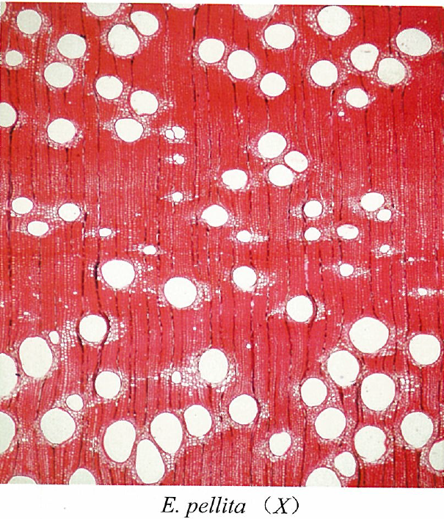
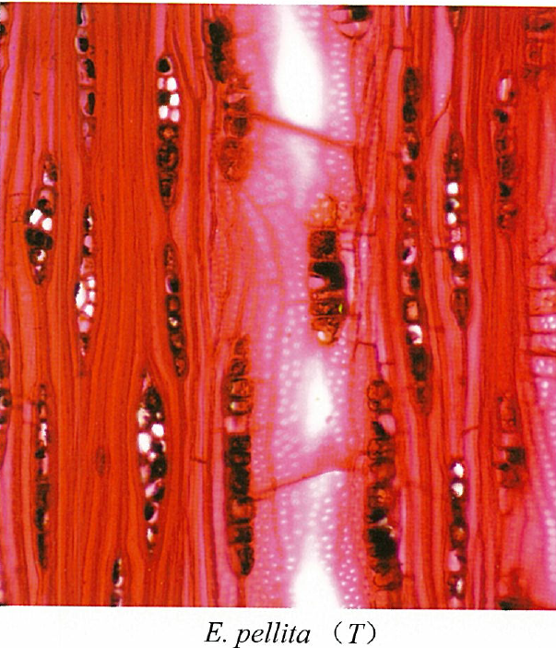
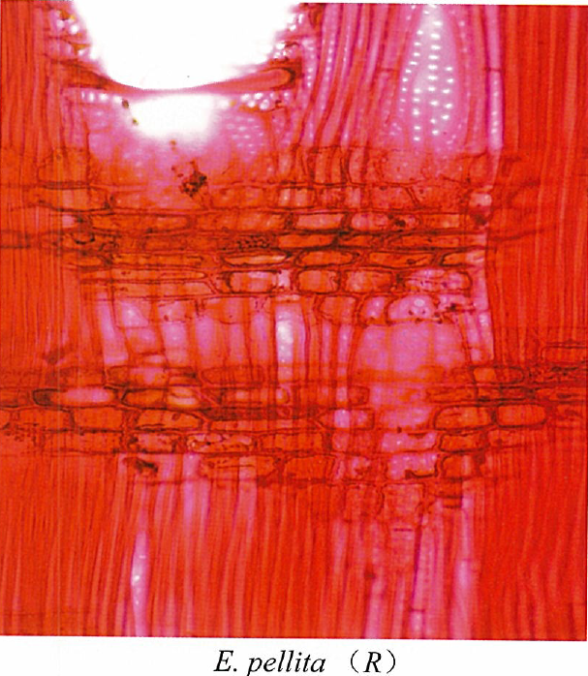
A
B
C

Figure 1: Shows the microscopic images of Eucalyptus pellita; cross-section (A), radial section(B), and tangential section (C) (Source: Chinese Academy of Forestry, September 2006.

2.2.3 Physical and mechanical properties of Eucalyptus Pellita
Eucalyptus pellita, one of the fast-growing species of eucalyptus, has been gaining prominence in recent years due to its great potential for application in the wood products industry, particularly in plywood manufacturing. This section of the literature reviews the properties of Eucalyptus pellita that make it suitable for plywood production. The properties include the physical and mechanical properties.

2.2.3.1 Physical Properties Eucalyptus pellita
Dimensional stability affects how a panel shrinks or swells when exposed to heat or direct water. Tropical Eucalyptus pellita demonstrates good to moderate stability. In a study by Falade et al. (2025), the species showed tangential shrinkage ranging from 2.16 - 5.15% and radial shrinkage of 1.15 – 2.33%. These factors strongly influence how well the species performs in plywood applications. Studies have shown that the density of Eucalyptus pellita ranges between 590-630 kg/m³, which is very much comparable to other species used in plywood production, for instance, birch wood has a density range of 447-538 kg/m³. (Yuniarti & Nirsatmanto, 2018, and Jakubowski et al., 2020). According to Bomba et al., (2014), the moisture content of the species significantly impacts the veneer adhesive applications, usually evident during the bonding process. According to the researcher, the ideal moisture content for good bonding should be below 10%. Research conducted by Yuniarti & Nirsatmanto (2018) observed that Eucalyptus pellita exhibits good dimensional stability. This is important because it helps to improve the stability of the plywood and maintain its integrity over time, particularly when exposed to moisture either directly or indirectly.

2.2.3.2 Mechanical Properties of Eucalyptus pellita
The structural integrity of construction materials is often determined mainly by their mechanical properties, particularly the MOE, MOR, and several others. In the plywood industry, mechanical properties such as bending strength (MOR), modulus of elasticity (MOE), and shear strength are crucial in the evaluation of the performance of plywood. A study conducted by (Japarudin, Meder, et al., 2021) reported an MOE between 11,700-15500 N/mm² and MOR of 96.30-120.10 N/mm² for Eucalyptus pellita, this is comparable to Birch wood with a range of 11,000-15000 N/mm² and 85-117 N/mm² for MOE and MOR, respectively (Kretschmann, 2010). Studies have shown that Eucalyptus pellita wood has high bending strength, making it ideal for structural applications. A study conducted by Iwakiri et al. (2013) established that Eucalyptus pellita used in plywood production exhibited ideal results in glue line shear testing and bending tests. This is an indication of its potential to be used for the production of plywood, which is meant for outdoor applications. Also, Crespo et al. (2020) emphasized that the mechanical properties of plywood produced from Eucalyptus is comparable to other highly rated plywood produced from hardwood species like beech and poplar. The researcher further opined that Eucalyptus pellita can be considered for effective utilization in the plywood industry without compromising on its mechanical performance, especially its mechanical strength. Furthermore, a study by Miao et al. (2022)emphasized that plywood produced from eucalyptus demonstrates high withdrawal strength, which is a good measure for furniture producers.

2.2.3.3 Adhesive Compatibility
Research has indicated that Eucalyptus pellita may be used efficiently in the manufacturing of plywood and veneer sheets, with good results in glue line shear testing and static bending tests (Iwakiri et al. 2013;Belleville et al., 2018; Japarudin et al., 2021). These findings show that, despite its high density, the wood's intrinsic characteristics may be improved for adhesive applications using the right processing.
According to research, the isocyanate index (NCO/OH ratio) has a considerable impact on the biodegradability and adhesive qualities of PU films containing Eucalyptus pellita wood polyol (Nurul Hazwani Abd Hilmi et al., 2023). This demonstrates the possibility of developing ecologically friendly adhesive systems that exploit Eucalyptus pellita's unique properties. Eucalyptus pellita has been used in breeding efforts to improve wood quality and growth characteristics because of its genetic variety and disease resistance (Indrayadi, 2023). The species is a viable option for hybridization, which can further increase its adhesive compatibility and overall performance in industrial applications. The use of genetic markers from other Eucalyptus species has also been proposed to aid in the identification of features associated with adhesive performance and disease resistance. (Indrayadi et al., 2023)

2.2.3.4 Applications and Future Prospects
Given its favourable physical and mechanical properties, particularly the modulus of elasticity and modulus of rupture, Eucalyptus pellita is increasingly becoming a considered choice for various applications in the wood industry, especially in the production of plywood. The species is also being explored for potential use as engineered wood products, including laminated veneer lumber (LVL) and cross-laminated timber (CLT)(Corpataux et al., 2020). As the demand for sustainable and high-performance wood products keeps rising, Eucalyptus pellita presents as a viable option for wood product manufacturers seeking diversification in their raw material source.

2.3 Production Process

2.3.1 MIRO Plywood Production Model
The production processes for industrial plywood construction are fundamentally identical across all species. Each layer of plywood is made up of one or more veneer sheets and has a symmetrical structure, usually resulting from an odd number of layers. By combining veneers of different thicknesses and densified and non-densified veneers, plywood manufacturers can produce panels with a range of strength characteristics (Bekhta, Salca, et al., 2020). At MIRO Timber Products Ltd., the production model deviates from the conventional plywood processes due to the diameter of the logs and the moisture content of the logs. Figure 2 shows the production model used at MIRO Timber Products Ltd.

The quality of the result is not significantly impacted by any of the procedures, but the peeling and drying processes fundamentally alter the veneer production process's surface characteristics, both chemically and physically.

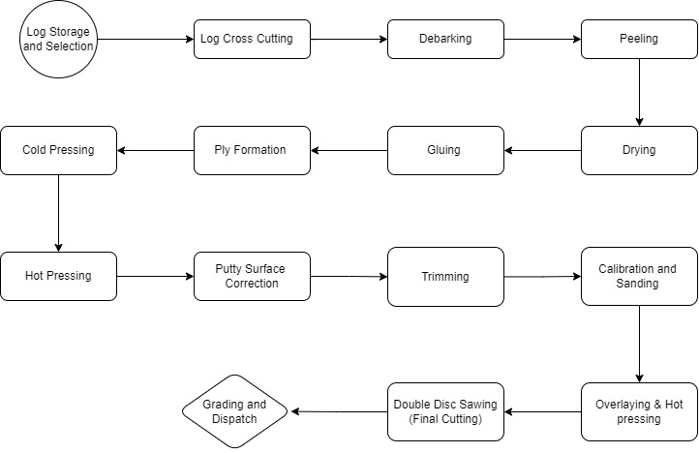

Figure 2: MIRO Timber Products Ltd.’s Plywood Manufacturing Model

2.3.2 Functions of the MIRO plywood manufacturing model
The MIRO plywood manufacturing model starts from the log storage selection to the grading and dispatch section. The modified industrial process is a modification of the normal plywood manufacturing procedures, as stated in several studies and plywood quality manuals. Table 1 explains the stages of the manufacturing process in the model.

Table 1 Details of the MIRO Plywood Manufacturing Model
Step | Process | Functions
1 | Log Storage and Selection | The logs are stored in the log yard upon arrival at the mill. They are neither sprinkled nor kept in water ponds. The logs are selected based on their straightness and diameter. All logs are extracted from MIRO’s 20,000 hectares, which is an FSC-certified plantation. The logs are harvested within 5-6 years.
2 | Log Cross-Cutting  (long Taihao) | The selected logs are then crosscut using large saws. This step ensures that the logs are of uniform length, which is crucial for the subsequent peeling process. According to the design of the equipment, 4ft.
3 | Debarking  (long Taihao) | Preparation of the logs for production by removing the bark; this process also serves as a cleaning process of the logs from filth.
4 | Peeling | The stage where logs are sliced into thin sheets of wood is called veneering. This is done by clamping peelers to a lathe, which rotates against a stationary knife. The process produces a specific thickness of veneer as required by the production. The MC of Eucalyptus pellita logs before peeling is usually around the average of 30% with a minimum of 25% and a maximum of 32%.
5 | Dryer- 4 deck Roller Veneer dryer  (long Taihao) | After peeling, veneer sheets typically have a high moisture content, which needs to be reduced to a suitable moisture content for further processing. The veneer is dried at a temperature of 125 – 130 ºC depending on the thickness of the veneer.
6 | Gluing | The dried veneer sheets are coated with adhesive. The adhesive is evenly spread on veneer sheets using roller systems to ensure uniform coating.
7 | Ply Formation  (Convey belt system) | At this stage, the glued veneer is arranged according to the transverse and longitudinal orientation, which forms the architecture of the plywood.
8 | Cold Pressing  (long Taihao) | Used in preparing the veneer lay-up to stick together before the final hot pressing. The pressure used for this process is 17/15 kg/cm2, which translates to about 11 bars for 30 minutes.
9 | Hot Pressing  (long Taihao, RY-20G) | The pre-pressed lay-up is placed between heated platens in a hydraulic press. The heating is generated from oil. The press applies both heat and pressure to cure the adhesive and bond the veneer layers together. The parameters for PF and MUF, shown below.  PF  MUF
  Panel Thickness  (mm) | Pressure  (kg/cm²) | Temp.  (ºC) | Time  (min)
  9 | 15/13 | 135 | 12
  12 | 16/14 | 135 | 15
  15 | 17/15 | 135 | 18
  18 | 17/15 | 135 | 21
  21 | 18/16 | 135 | 24
  Panel Thickness  (mm) | Pressure  (kg/cm²) | Temp.  (ºC) | Time  (min)
  9 | 16/14 | 135 | 10
  12 | 16/14 | 135 | 13
  15 | 17/15 | 135 | 16
  18 | 18/16 | 135 | 19
  21 | 20/18 | 135 | 23
10 | Putty Surface Correction | Putty fills defects like cracks, voids, or knots to create a smooth and uniform surface.
11 | Trimming  (long Taihao) | Cutting the plywood to a specified dimension to meet specific size requirements and quality standards.
12 | Calibration and Sanding  (long Taihao) | Fine-tuning of the dimensions of the plywood sheet during or after its production. Calibration is done to ensure thickness consistency, Dimensional accuracy, and Quality control. The process involves measurement, adjustment, and verification. The sanding is carried out to remove the rough surfaces that may exist on the final product.
13 | Overlaying Hot Pressing  (long Taihao) | Applying a decorative or protective layer to the surface of the core ply. They could be engineered veneer or phenolic film. A pressure of 17/15 kg/cm³ at a temperature of 125 to 135 °C, depending on the density of the phenolic film, for 7 minutes.
14 | Double Disk Saw Cutting  (long Taihao) | It is a precision and efficient cutting technique that cuts plywood to the final dimensions. It uses specialized saws designed to cut from both sides of the panel simultaneously, ensuring accuracy and reducing material waste.
15 | Grading and Dispatch | Grading is the classification of plywood based on its quality, appearance, and structural integrity. This classification helps identify defects, assess usability for various applications, and determine compliance with industry standards. The final stage is dispatch, where the plywood is packaged and prepared for shipment to customers.

2.3.3 Advances in Plywood Production and Technologies
Innovations in adhesive formulas, manufacturing techniques, and material qualities have had a major impact on advancements in plywood production and technologies. For the wood-based panel sector to improve product performance, sustainability, and cost-effectiveness, plywood technology must advance. The creation of bio-based adhesives, which are intended to take the place of conventional formaldehyde-based adhesives, is one of the noteworthy developments in the plywood industry. For example, an Investigation conducted on adhesives produced from soybean meal and bark, which offered an eco-friendlier substitute while resolving the drawbacks of their high viscosity and low solids content that limit their use in the production of plywood (Huzyan et al., 2021).
Moreover, Pang et al. (2021) researched to improve the overall performance of plywood products by introducing a unique bionic soy protein-based adhesive that has outstanding prepressing adhesion, flame retardancy, and mildew resistance. These bio-based adhesives enhance the mechanical qualities of the finished goods while also lessening the environmental impact of plywood production. Plywood technology has benefited greatly from improvements in manufacturing techniques in addition to adhesive developments. Also, Lavalette et al. (2016) investigated the usage of green-gluing technology and showed that it may be used to create plywood with better mechanical qualities.

Vacuum molding technology has been demonstrated to improve the adhesive migration through wood cells, resulting in stronger bonds and improved product quality (Zuo et al., 2023). Originally developed for the boating and aviation industries, this technique has found its way into plywood production, demonstrating the versatility of modern manufacturing methods. Additionally, the use of wet veneers, which can result in energy savings and reduced material degradation during processing, has been made possible by this method. Thermal alteration of birch veneer, combined with ultraviolet treatment, produces plywood with better adhesive interaction and more water resistance (Bekhta & Sedliacik, 2015; Krivorotova & Orlov, 2020). This method tackles a significant obstacle in the manufacturing of plywood, especially for uses that call for high durability in damp conditions. Research has also focused on the technological and economic characteristics of the many wood species utilized to make plywood. When comparing birch and beech wood, Hu et al. found that birch wood had major advantages in terms of cost-effectiveness and technological qualities for making plywood (Hu et al., 2015). This study emphasizes how crucial it is to choose the right raw materials to improve the productivity and sustainability of plywood production operations.

2.4 Environmental Impact and Sustainability Considerations
The wood products sector is increasingly focusing on the sustainability of plywood production due to consumer demand for eco-friendly materials, regulatory challenges, and environmental concerns. This literature review highlights key elements of sustainability in plywood production, such as life cycle assessments, the use of bio-based adhesives, waste management, and creative production processes, by synthesizing findings from multiple studies. Environmental laws significantly influence how the plywood sector is shaped.

The US, Australia, and the EU have implemented strict procedures to stop illegal timber from entering their markets. Masiero et al. point out that laws like the USA's Lacey Act and the EU Timber Regulation (EUTR) are designed to guarantee that plywood and other wood products are supplied lawfully and responsibly (Johnson & Laestadius, 2011). In addition to encouraging ethical sourcing, these rules also push the business to embrace sustainable methods.
Environmental rules frequently concentrate on lowering emissions related to plywood manufacture, in addition to legality. The industry is looking into alternative adhesives and production techniques because of stricter regulations on formaldehyde emissions. According to (Popović et al., (2020) their research on bio-based adhesives as substitutes for conventional amino-based adhesives is being fueled by consumers' increasing interest in sustainable materials. This change is essential to coordinating plywood manufacturing with the objectives of environmental sustainability.

2.4.1 Life Cycle Assessment (LCA)
A vital instrument for assessing the environmental effects of plywood manufacture, from the extraction of raw materials to the disposal of end-of-life materials, is life cycle assessment, usually abbreviated as LCA. A thorough life cycle assessment (LCA) of the plywood production process pinpointed important areas for environmental enhancement, like the use of adhesives based on bio-oil and the optimization of veneer drying procedures (Jia et al., 2019). According to their findings, switching to other scenarios can greatly lower pollutants and improve the sustainability of plywood production. Throughout the plywood supply chain, stakeholders can make well-informed decisions that support environmental sustainability by analysing variables like energy usage, emissions, and resources at each stage. In the end, the comprehensive strategy not only helps the environment but also makes plywood goods more marketable by matching them with the rising demand from consumers for environmentally friendly materials (Anderson & Hansen, 2004; Thompson et al., 2010). In addition to possible cost savings through more effective resource management, alignment with sustainability trends can boost customer loyalty and trust. Manufacturers may maintain their competitiveness in a changing market by implementing cutting-edge technology and techniques, such as using renewable energy sources and streamlining manufacturing processes, to further advance sustainability initiatives.

The first step in making plywood is harvesting timber, which has a big impact on the environment. According to studies like Dias et al. (2022), sustainable forestry methods are crucial for reducing negative effects like deforestation and biodiversity loss. Both the geographical origin of the timber and the type of wood used, such as birch, pine, or eucalyptus, have an impact on the environmental imprint.

Energy-intensive processes like peeling, drying, and applying adhesive are required to process logs into veneers and then plywood. Energy use during manufacturing is a significant source of greenhouse gas (GHG) emissions, according to several studies, including (Puettmann & Wilson, 2005). Because of their non-renewable sources and their toxicity, the choice of adhesives, especially formaldehyde-based resins, has a considerable impact on plywood's environmental profile. A further crucial stage in the plywood life cycle is transportation. (Eštoková et al., 2023) research emphasizes how the carbon footprint of plywood goods can be significantly impacted by transportation routes, modes (such as trucks and ships), and fuel economy. To reduce these effects, local raw material sourcing is frequently advised.

Plywood’s use phase has less of an influence on the environment than its manufacturing phase. However, the total LCA may be influenced by factors such as application context, maintenance requirements, and product durability. An extended product lifespan, for example, lowers cumulative environmental consequences by reducing the frequency of replacement (Hummen et al., 2023). Plywood's overall environmental performance is significantly influenced by end-of-life management choices, including recycling, energy recovery, and landfilling. Research like that of (Cesprini et al., 2020) shows that energy recovery and recycling are more environmentally friendly than landfilling. Nevertheless, there are still issues with separating wood fibers from adhesives and coatings during recycling procedures.

The LCA of plywood has been compared by several studies with that of substitute materials such as steel, MDF, and particleboard. If sustainable forestry and effective production methods are used, the results generally show that plywood has a smaller carbon footprint because it is made from renewable raw materials (Puettmann & Wilson, 2005)
The scope and technique of LCA studies on plywood differ. Important methodological distinctions include the selection of system boundaries (cradle-to-gate vs. cradle-to-grave), impact assessment techniques (e.g., ReCiPe, CML), and data sources (primary vs. secondary). These criteria must be harmonized for valid cross-study comparisons.

2.4.2 Bio-Based Adhesives
Improving the sustainability of plywood production requires the creation and use of bio-based adhesives. To simplify production and lessen dependency on formaldehyde-based adhesives, Huo et al. reported on the creation of environmentally friendly glueless plywood(Huo et al., 2023; Z. Wu et al., 2023). This strategy responds to formaldehyde emissions-related indoor air quality issues while meeting the rising demand for environmentally friendly building materials. For plywood manufacturing, aqueous polymer isocyanate adhesives may be employed as a formaldehyde-free and flame-retardant substitute (Wen et al., 2020). Stricter rules on formaldehyde emissions and growing customer interest in sustainable materials are the main drivers of the move to bio-based adhesives (Hemmilä et al., 2017).

2.4.3 Waste Management and Resource
Making use of improved waste management procedures is crucial to making plywood production more sustainable. The use of waste materials in adhesive mixes has the potential to lessen the environmental impact of plywood production, according to (Réh et al., 2019). Manufacturers can reduce waste production and improve resource efficiency by utilizing wood processing by-products. Additionally, a study emphasizes the significance of assessing wood quality through sustainable practices, stressing the necessity of creative methods to efficiently use wood resources (Macak et al., 2020). A circular economy can be promoted by including waste management techniques in the plywood manufacturing process, which will maximize resource utilization and reduce environmental effects.

2.4.4 Innovative Production Techniques
Enhancing the sustainability of plywood manufacture is largely dependent on innovative production processes. Miao et al.'s study on staple holding strength in plywood furniture frame joints highlights how crucial it is to maximize mechanical qualities to minimize material waste (Miao et al., 2022). Manufacturers can reduce the quantity of raw materials required for production by enhancing the performance of plywood goods. Furthermore, a discussion of glueless plywood production techniques offers a viable way to lessen the negative environmental effects of adhesive use (Huo et al., 2023). These developments help make plywood manufacturing more sustainable overall, in addition to streamlining the production process.

2.4.5 Quality Assurance Standards
Standards for quality assurance are necessary to guarantee that plywood products fulfill performance requirements. The mechanical and physical characteristics of plywood are governed by several national and international standards. European standards, such as EN 314 (Study of Rice Straw Biocomposite and a Comparative Study of Flexural Strength of Various Biocomposite Plywood Materials), define criteria for adhesive types and mechanical qualities, as well as bonding quality and performance requirements. Similar to this, the American National Standards Institute (ANSI) has set plywood standards, such as ANSI/HPVA (High-Performance Veneer Association) standards, which cover topics including structural integrity and moisture resistance. Kallakas et al. assessed plywood's mechanical qualities by current standards, stressing the significance of following set rules to guarantee product quality (Kallakas et al., 2020). By guaranteeing that goods fulfill the required quality requirements, these norms not only improve the dependability of plywood products but also make international trading easier.
Due to health and safety regulations, internationally plywood products must conform to the minimum safety standards to serve as assurance to human health. In this regard, plywood with the American and European market as targets must conform to the California Air Resources Board (CARB) requirements, must limit formaldehyde emissions in line with CARB Phase 2 rules, as described in Title 17 of the California Code of Regulations (§93120) (California Air Resources Board, 2007) Considering the European Union, plywood must comply with the Registration, Evaluation, Authorisation and Restriction of Chemicals
(REACH) Regulation, which restricts hazardous substances and requires registration and communication for any material containing substances of very great concern (Regulation REACH No, 1907/2006). Together, CARB and REACH certification frameworks guide manufacturers toward cleaner adhesives, transparent supply chains, and safer indoor air environments across the global building and furniture sectors.

2.5 Market Dynamics

2.5.1 Overview of the Plywood Market
The plywood market is characterized by a complex interaction of factors influencing growth, demand, and supply dynamics. This review examines existing literature and provides an overview of the plywood market, concentrating on market trends, competitive regulatory frameworks, and sustainability considerations. The plywood market has grown significantly, rising from $121.13 billion in 2023 to $128.83 billion in 2024, with a compound annual growth rate (CAGR) of 6.4% over the same time. This rise is being fueled by emerging market expansion, rising global population, increased residential construction activity, and low lending rates. The market is projected to reach around $162.46 billion by 2028, with a CAGR of 6.0%. This expansion is aided by government assistance, increased remodeling operations, rising urbanization, and rising demand for timber furnishings. Major trends in the projection period include technological improvements, product innovations, usage of biodegradable chemicals for wood preservation, creation of termite-free and waterproof plywood, manufacturing of fire-resistant plywood, new plant expansions, strategic collaborations, and acquisitions. (Plywood Global Market Report, 2024). The predicted increase in construction activities is expected to propel the plywood market forward. Plywood, which is vital for structural stability, adaptability, and cost-effectiveness in building, is in high demand. Stats NZ Tatauranga Aotearoa reported a 3.7% increase in building activity in New Zealand in March 2021, with a 4.3% increase in residential activities in 2021 over 2020. Additionally, the US Census Bureau reported a 10.2% increase in building activity, with the value rising from $1,626.4 billion in 2021 to $1,792.9 billion in 2022. (Plywood Market Size to Reach USD 162.66 Billion by 2034,)

2.5.1.1 Market Trends
The global plywood industry has grown significantly in recent years, owing to increased demand from the construction and furniture industries. According to Soti et al, demand for plywood, particularly non-structural plywood, is approaching saturation, signalling increased rivalry in the market (Soti et al., 2021). In contrast, demand for structural products such as laminated veneer lumber (LVL) is increasing, indicating a shift in customer preferences toward engineered wood products with improved performance characteristics (Romero & Odenbreit, 2023). Emerging regions, particularly in Asia and Africa, are experiencing increasing urbanization and infrastructural development, which is driving up demand for plywood. According to Nakayasu, (2013) Japan and China are the most prospective markets for Indonesian plywood, showing a geographic change in demand. This trend emphasizes the value of understanding regional market dynamics and consumer preferences.

2.5.1.2 Competitive Landscape
The plywood market is highly competitive, with numerous competitors operating both locally and internationally (Malau et al., 2022). The authors examined the dynamics of global and Indonesian markets, emphasizing the significance of knowing commodity structures and trade patterns. According to the study, production volume, exports, imports, and local consumption all have an impact on the competitiveness of plywood goods.
Tropical wood, particularly plywood, is competitive in the international market. Souza et al. stated that Brazilian plywood exports have been successful, owing to the country's great biodiversity and sustainable forestry practices. However, the market confronts obstacles, including competition from alternative materials and the need to comply with severe environmental standards. (Souza et al., 2018)

2.5.1.3 Regulatory Framework
The regulatory environment around plywood production has a substantial impact on market dynamics. Environmental rules, such as the EU Timber Regulation (EUTR) and the Lacey Act in the United States, are intended to ensure that timber products, including plywood, are supplied responsibly and legally(Kim et al., 2023). Compliance with these standards is critical to retaining market access and competitiveness. Furthermore, new limitations on formaldehyde emissions have forced the industry to research alternative adhesives and manufacturing methods(Popović et al., 2020). According to Hidayat et al., the transition to eco-friendly adhesives is being driven by regulatory demands and shifting customer preferences for sustainable materials. This transformation is critical for connecting plywood production with environmental sustainability objectives(Nakos et al., 2016).

In Ghana, the regulatory framework is crucial to maintaining long-term practices and international compliance. The Ghana Forestry Commission regulates the timber business by implementing regulations that combat illicit logging and encourage sustainable forestry practices(Oduro et al., 2011). Oduro et al underlined that unlawful chainsaw milling has serious consequences for the country's forestry resources, including the loss of biodiversity and forest cover. Furthermore, compliance with international standards, such as Forest Stewardship Council (FSC) certification, is becoming increasingly vital for entering global markets. The FSC accreditation ensures that timber products are obtained sustainably, which might increase Ghanaian plywood's international marketability (Kaplinsky, 2010).

Chapter 3. Mechanical Properties: Modulus of Elasticity and Modulus of Rupture

3.1 Background
Plywood remains one of the most widely used wood-based panels in the construction and furniture industries due to its design and properties. The balanced construction ensures a symmetrical arrangement, which increases the product's strength and stability. Different species behave differently, affecting the characteristics of their veneers as well as the strength and durability of the plywood (Parthiban et al., 2019). Eucalyptus has attracted significant interest among the various wood species used in plywood manufacturing due to its rapid growth and development, environmental friendliness, and excellent mechanical properties (Iwakiri et al., 2013; Seidu et al., 2023; Seng Hua et al., 2022). Evaluating the mechanical characteristics of the different thicknesses of eucalyptus plywood is essential for determining their suitability for structural and other industrial applications, for domestic usage in Ghana, and for export, meeting the high demand for premium plywood in both the domestic and international markets.
Traditionally, large logs from native wood species sourced from Ghana’s natural forests have been used in the manufacturing of plywood. However, the depletion of large-diameter logs hitherto used for plywood production is creating a gap in the supply of raw material. This calls for alternative options, such as high-yielding eucalyptus, which are increasingly becoming necessary to explore (Kaba, 2024). Native to Australia, Eucalyptus pellita has emerged as one of the most viable alternatives for plywood manufacturers due to its mechanical properties and availability (Hii et al., 2017; Iwakiri et al., 2013; Japarudin, Meder, et al., 2021). With its rapid growth, the species could serve as an effective substitute for the declining native species typically utilized in plywood production (Dwi Sulichantini et al., 2014; Hegde et al., 2013).
Analyzing the mechanical qualities of eucalyptus plywood produced in Ghana requires knowledge of how variables such as species characteristics, glue type, and panel thickness affect these qualities. Studies suggest that the mechanical strength of plywood is significantly influenced by its thickness(Bekhta et al., 2020; Sycz & Kowaluk, 2019). Due to a decreased panel density, the modulus of rupture (MOR) and modulus of elasticity (MOE) often decline with increasing panel thickness. Results indicating that the overall density of the plywood decreases as veneer thickness increases support this conclusion, thereby reducing mechanical strength (El Haouzali et al., 2020; Kūliņš et al., 2021)
According to Naresh et al. (2023) lesser thickness designs show strong flexural characteristics, confirming the general assertion of inverse correlation between panel thickness and bending properties. These characteristics are strongly influenced by the arrangement and quantity of veneer layers; so, optimal layer designs should improve mechanical performance independent of veneer thickness. Moreover, the mechanical performance of plywood has also been proven to be influenced by the type of adhesive and the quality of adhesion (Setter et al., 2021). Research shows that various adhesives, including phenol-formaldehyde and melamine urea-formaldehyde, greatly affect bond strength and, to a large extent, the MOE and MOR characteristics (Bal & Bektaş, 2014).
This study evaluates the mechanical characteristics of eucalyptus plywood produced in Ghana, with a focus on the influence of panel thickness and glue type on its strength and durability. This is aimed at determining the suitability of eucalyptus plywood for structural and industrial applications, considering the rising demand for premium plywood in both domestic and international markets. By analyzing the mechanical properties such as modulus of rupture (MOR) and modulus of elasticity (MOE), the research will provide insights into the optimal panel thickness and adhesive combinations that enhance the performance of eucalyptus plywood.

3.2 Materials and Methods
In all, 3 plywood samples were randomly selected within 3 months of production, 1 panel per month. This was to allow for consistency in plywood production. The sizes considered for this study include 9 mm, 12 mm, 15 mm, 18 mm, and 21 mm. This means 3 plywood panels were sampled for each thickness within the sampling period. Two types of resin were considered for this all-thickness, the Melamine Urea Formaldehyde (MUF) and the Phenol Formaldehyde (PF). The MUF used was milky white with a viscosity of 90 cps at 30 °C, it was within a pH of 7.0 – 8.0, and a gel time of 140 min, also it had a specific gravity of 1,190 g/cm3. The specifications of the PF glue were reddish-brown for colour, a viscosity of 120 cps with a pH range of 11.5 – 12.5 at a specific gravity of 1168 g/cm3 and a gelling time of 15 min. The mechanical tests considered for this study were modulus of elasticity (MOE), Modulus of rupture (MOR), and tension parallel to the grain. The details of the testing parameters are explained in the sub-sections Bending test.

3.2.1 Bending test

3.2.1.1 Sample Preparation
The three samples, for each thickness, were prepared according to EN 326-1:1994 (Wood-based panels; sampling, cutting, and inspection Part 1: Sampling and cutting of test pieces and expression of test results) and EN 310:1993 (Wood-based panels — Determination of modulus of elasticity in bending and of bending strength). For each panel, 20 specimens were prepared, 10 each for the panel's longitudinal and transverse orientations. The dimensions of the samples were determined according to the formula.
l₁ = 20 t Equ. 1
l₂ = l₁ + 50 Equ. 2
where l₁ is the testing span, l_{2,} the full length of the sample, and t, is the thickness of the panel measured using Mitutoyo Veneer Calliper. Based on equations 1 and 2, the dimensions are as follows: 9 mm x 50 mm x 230 mm, 12 mm x 50 mm x 290 mm, 15 mm x 50 mm x 350 mm, 18 mm x 50 mm x 410 mm, 21 mm x 50 mm x 470 mm. The thicknesses of the panels were within the tolerance set according to EN 315:2000 (Plywood – Tolerances for dimensions).
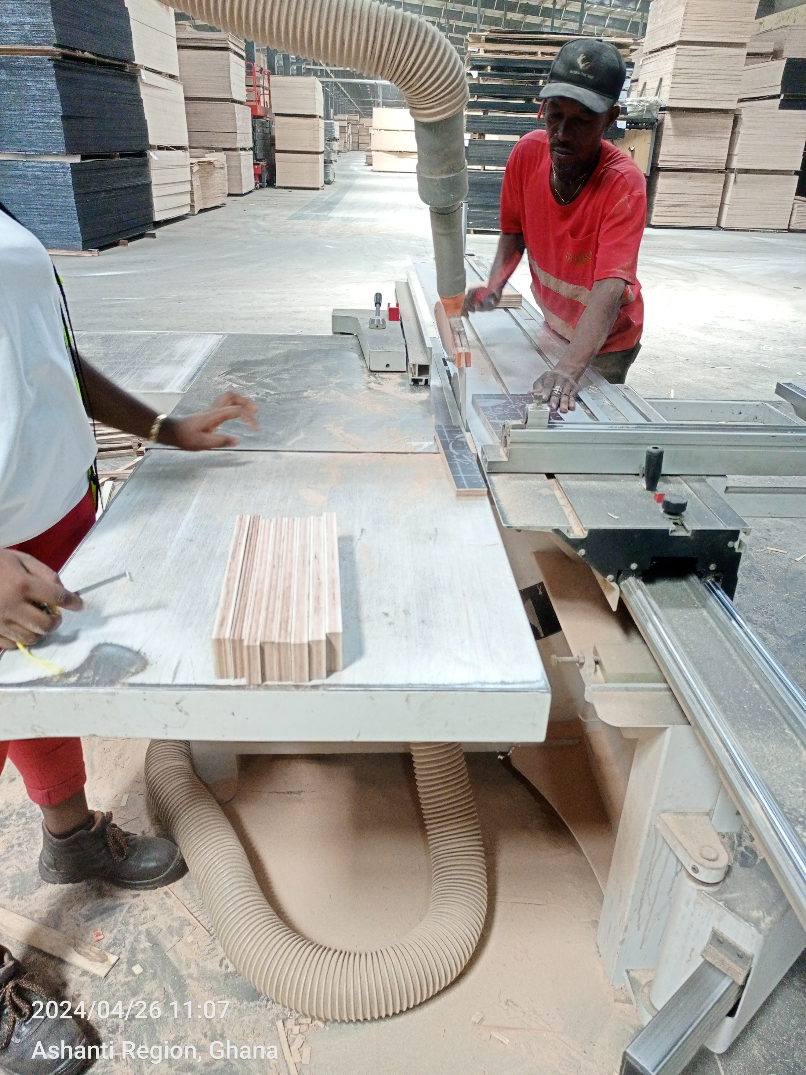

Figure 3: Shows bending samples being prepared using a dimensional saw (MJ320 M Model). (Source: MIRO Timber Products Ltd. Workshop)

3.2.1.2 Conditioning of Samples
The test pieces were conditioned in a climate chamber until they attained a constant mass according to EN 310: 1993. The chamber was set to a relative humidity of (65 ± 5) % and a temperature of (20 ± 2)ºC. A constant mass was reached when the results of two successive weightings in an interval of 24 hours did not differ by more than 0.1% of the test piece's mass. The conditioning of the samples is supposed to be at a moisture content of 12%. This means that the moisture content of the samples will be uniform across the length of the sample.

3.2.1.3 Testing Procedure
The samples were placed flat on the supports with their longitudinal axis at right angles to those of the supports, with the centre point under the load. The loads were applied at a crosshead speed, so failure will occur at maximum load within 60 ± 30 s. The support must have rounded tips of 15 ± 0.5 mm in diameter, and the force applicator should have a rounded tip of 30 ± 0.5 mm. Figure 4 shows a schematic diagram of the dimensions of the testing procedure, especially how the samples are placed on the supports, and Figure 5 shows plywood samples being tested using a Hegewald and Peschke universal testing machine with a load cell capacity of 50 KN.

Figure 4: Illustration of a 3-point bending test setup according to EN 310: 1993 (Source: EN 310:1993)

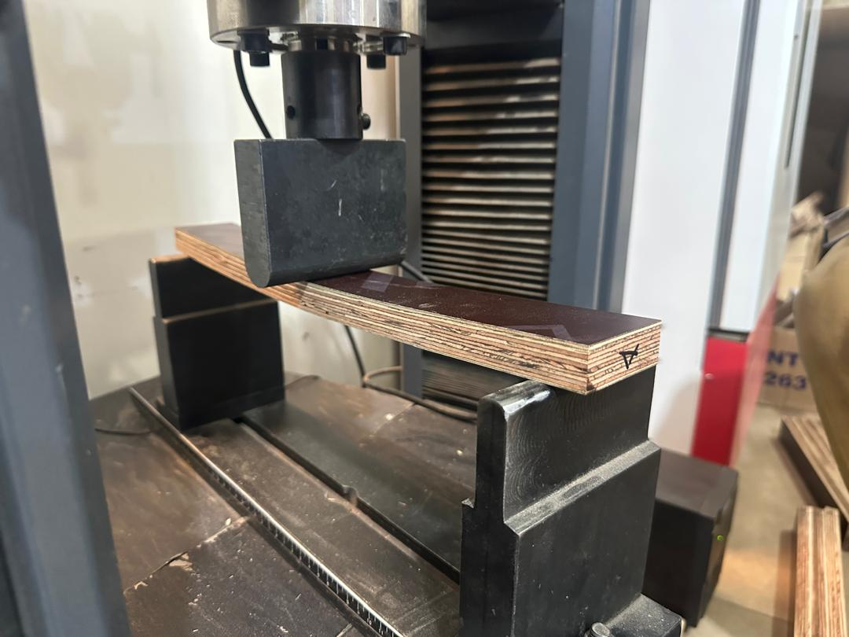

Figure 5: Plywood sample undergoing a 3-point bending test (Hegewald & Peschke UTM)

The moduli of elasticity and rupture are calculated using the formulae as presented in equations 2 and 3, respectively.

$E_{m}=\frac{{l1}^{3}(F_{2}-F_{1})}{{4bt}^{3}(a_{2}-a_{1})}$ Equ. 3

$f_{m}= \frac{{3 F}_{\max{ }}l_{1}}{{2 bt}^{2}}$ Equ. 4

3.2.1.4 Data Analysis
After the testing, the data retrieved was processed and analysed using Microsoft Excel and Origin Pro data analysis software. The graphs representing the data were plotted using the software.

3.3 Results and Discussion

3.3.1 Mean Modulus of elasticity and Rupture of PF and MUF-bonded plywood for different thicknesses.
The figure shown in Figure 6 illustrates the mean values of MOE and MOR for the longitudinal and transverse orientations of various thicknesses ranging from 9 mm to 21 mm. The results also reflect the adhesives used in bonding the veneers during the manufacturing process, specifically phenol formaldehyde (PF) and melamine urea formaldehyde (MUF). Tests were conducted at 12% moisture content. The mean values generally followed a pattern indicating that MOE and MOR decrease as thickness increases across orientations, thicknesses, and adhesive types. For the PF adhesive, the MOE for the longitudinal orientation recorded a mean value of 7096 (±1567) N/mm² for 9 mm thick plywood and a value of 4627 (±842) N/mm² for the 21 mm thick plywood. However, the transverse orientation recorded mean values of 6554 (±433) N/mm² for the 9 mm panels and 4227 (±419) N/mm² for the 21 mm panels. The mean values for longitudinal MOR were 59.85 (±7.62) N/mm² and 39.36 (±2.66) N/mm² for the 9 mm and 21 mm thicknesses, respectively. For the transverse orientation, mean values ranged from 50.59 (±8.53) N/mm² to 39.29 (±14.10) N/mm² for the 9 mm and 21 mm panels, respectively. The MUF bonded panels recorded mean MOE values of 6093 (±324) N/mm² and 4155 (±316) N/mm², with mean MOR values of 51.63 (±7.24) N/mm² and 42.92 (±4.86) N/mm² for the 9 mm and 21 mm plywood, respectively, in the longitudinal orientation. The transverse orientation recorded values ranging from 5118 (±1429) N/mm² to 4177 (±4177) N/mm² for the 9 mm and 21 mm panels, respectively, with mean MOR values of 45.15 (±2.84) N/mm² for the 9 mm panel and 29.21 (±3.99) N/mm² for the 21 mm panel.

MOE, N/mm²
MOR, N/mm²
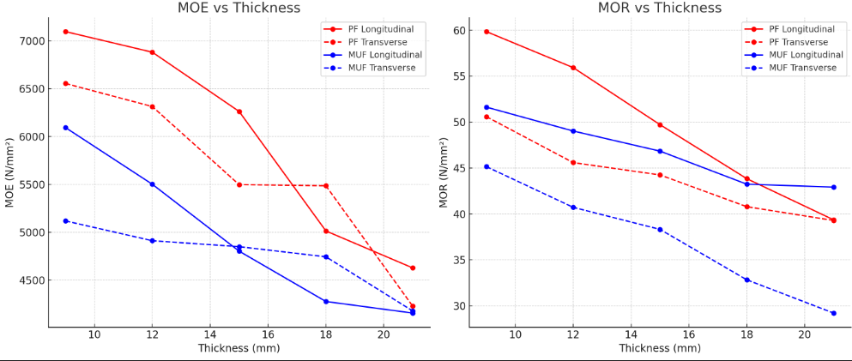
Figure 6: Plot of MOE and MOR, mean longitudinal and transverse orientation results at 12% moisture content for varied thickness bonded by PF and MUF adhesives.

3.3.2 Influence of Adhesive Type and Veneer Orientation on MOE and MOR
The mechanical performance of plywood is significantly influenced by the orientation of loading and the type of adhesive used in the manufacturing of the plywood. This study investigates the modulus of elasticity (MOE) and modulus of rupture (MOR) of panels bonded with phenol formaldehyde (PF) and melamine-urea-formaldehyde (MUF), evaluated in both longitudinal (L) and transverse (T) directions for various thicknesses (9–21 mm). Analysis of Variance (ANOVA) with post-hoc Tukey test was used to determine the influence of adhesive and the orientation of loading on the various panel thicknesses as shown in Table 1.
Normality test (Shapiro-Wilk) was successful, regarding MOE for PF bonded panels, 9 mm (W=0.9633; p=0.0685; normal), 12 mm (W: 0.9275; p = 0.0724; normal), 15 mm (W = 0.9089; p=0.0551; borderline normal), 18 mm (W = 0.9879; p = 0.8185; normal) and 21 mm (W = 0.9759; p = 0.2796; normal). Normality test for MUF bonded panel thicknesses was as follows 9 mm (W=0.8643; p= 0.0824; normal), 12 mm (W=0.9496; p= 0.3562; normal), 15 mm (W = 0.8773; p = 0.0894; normal), 18 mm (W= 0.9465; p = 0.1054; normal), 21 mm (W= 0.9341; p= 0.728; normal). The MOR normality test was normal in both PF (W= 0.9330 – 0.9663; p = 0.6011- 0.4431; normal) and MUF (W= 0.8850 – 0.9663; p = 0.1371- 0.6682; normal).
The ANOVA results, as indicated in tab.4 for modulus of elasticity (MOE) and modulus of rupture (MOR) in plywood panels bonded with phenol formaldehyde (PF) and melamine urea formaldehyde (MUF) adhesives, reveal statistically significant effects of grain orientation and panel thickness on mechanical performance. Considering the MOE, significant differences (p < 0.01) were observed between longitudinal and transverse orientations across all thicknesses, with F-values ranging from 6.33 to 14.54.

Table 2: Longitudinal and transverse orientation comparison for both the PF and MUF (n=30 in each orientation)
Properties | Source of  Variation | Sum of Square | DF | Mean Sum of Square, MSS | F-value | Tukey  p-value | Sig
Phenol Formaldehyde bonded panels
MOE (N/mm²) | 9L - 9T | 15,079,994.95 | 1 | 15,079,994.95 | 11.77 | ** p<0.01 | 1
MOE (N/mm²) | 12L - 12T | 28,542,687.43 | 1 | 28,542,687.43 | 13.29 | ** p<0.01 | 1
MOE (N/mm²) | 15L - 15T | 31,975,460.02 | 1 | 31,975,460.02 | 14.54 | ** p<0.01 | 1
MOE (N/mm²) | 18L -18T | 8,138,693.40 | 1 | 8,138,693.40 | 6.33 | * p<0.05 | 1
MOE (N/mm²) | 21L - 21T | 3,337,828.12 | 1 | 3,337,828.12 | 8.26 | ** p<0.01 | 1
MOR (N/mm²) | 9L - 9T | 1,286.21 | 1 | 1.286.21 | 19.66 | ** p<0.01 | 1
MOR (N/mm²) | 12L - 12T | 1,602.59 | 1 | 1,602.59 | 31.88 | ** p<0.01 | 1
MOR (N/mm²) | 15L - 15T | 448.87 | 1 | 448.8.7 | 4.79 | * p<0.05 | 1
MOR (N/mm²) | 18L -18T | 131.66 | 1 | 136.66 | 1.89 | p>0.05 | 0
MOR (N/mm²) | 21L - 21T | 0.06 | 1 | 0.06 | 0.0006 | p>0.05 | 0
Melamine Urea Formaldehyde bonded panels
MOE (N/mm²) | 9L - 9T | 30,947,446.45 | 1 | 30,947,446.45 | 27.76 | ** p<0.01 | 1
MOE (N/mm²) | 12L - 12T | 29.471.684.72 | 1 | 29.471.684.72 | 15.50 | ** p<0.01 | 1
MOE (N/mm²) | 15L - 15T | 6,308,283.75 | 1 | 6,308,283.75 | 7.69 | p<0.01 | 1
MOE (N/mm²) | 18L -18T | 8.274,049.35 | 1 | 8.274,049.35 | 7.78 | ** p<0.01 | 1
MOE (N/mm²) | 21L - 21T | 37,242.81 | 1 | 37,242.81 | 0.27 | p>0.05 | 0
MOR (N/mm²) | 9L - 9T | 631.02 | 1 | 631.02 | 20.89 | ** p<0.01 | 1
MOR (N/mm²) | 12L - 12T | 1,036.92 | 1 | 1,036.92 | 8.62 | ** p<0.01 | 1
MOR (N/mm²) | 15L - 15T | 1,090.48 | 1 | 1,090.48 | 9.48 | ** p<0.01 | 1
MOR (N/mm²) | 18L -18T | 1,608.08 | 1 | 1,608.07 | 170.28 | ** p<0.01 | 1
MOR (N/mm²) | 21L - 21T | 2,820.56 | 1 | 2,820.56 | 142.73 | ** p<0.01 | 1
L- longitudinal, T- transverse, 1-significant difference, 0- insignificant difference, DF- degree of freedom
The results align with established findings that the longitudinal orientation aligns with the surface veneer grain direction, exhibits higher stiffness due to the orientation of cellulose microfibrils, which dominate elastic behaviour in wood-based panels, particularly in plywood(Donaldson 2019; Guo et al. 2020; Merhar 2020). The MOR demonstrated significant differences among the lower thicknesses (9–15 mm), but not among 18 mm and 21 mm (p > 0.05), despite the longitudinal mean values being slightly higher than the transverse orientation. This suggests that as panel thickness increases, the influence of surface veneer orientation on bending strength diminishes, possibly due to the averaging effect of multiple veneer layers(Barnes 2002; Sycz & Kowaluk 2019). The phenomenon of the averaging effect is experienced as multiple veneers with their grain direction at 90 ° to each other; the stresses, defects, and weaknesses in individual layers tend to average out across the entire panel(Wu et al. 2020). Several researchers have reported similar trends in studies examining the mechanical homogenization of thicker plywood panels.

Except for 21 mm, all thicknesses showed significant orientation effects. Considering the 9 mm panels, the highest F-value (27.76) was observed, suggesting a significant anisotropic response in thinner panels. As observed in previous adhesive performance studies, the lack of significance at 21 mm might be the result of decreased adhesive penetration or bonding efficiency in thicker assemblies. With F-values ranging from 8.62 to 170.28, all thicknesses displayed highly significant differences (p < 0.01). The bending strength of MUF-bonded panels may be more susceptible to orientation effects than that of PF-bonded panels, as indicated by the exceptionally high F-values at 18 and 21 mm. This might be explained by MUF adhesives' reduced brittleness and water resistance, which could make stress concentrations at veneer interfaces worse. These results support plywood's anisotropic properties and the crucial part that adhesive chemistry plays in mechanical performance(Kuwamura 2010). PF adhesives seem to offer more uniform mechanical qualities across thicknesses because of their exceptional resistance to heat and moisture, which is in line with a study by (Wang et al. 2017). Although MUF adhesives are widely used and reasonably priced, their decreased durability and bond strength under stress may result in increased variability, confirming the accession of (Knorz et al. 2016). The outcomes of plywood made from young eucalyptus are in line with the larger body of research on engineered wood products, which highlights how crucial veneer alignment and adhesive choice are to maximising structural performance.

3.3.3 Conclusion
This study examined the mechanical characteristics of eucalyptus plywood bonded with phenol formaldehyde (PF) and melamine-urea-formaldehyde (MUF) adhesives in various thicknesses, ranging from 9 mm to 21 mm. It concentrated on the modulus of elasticity (MOE) and modulus of rupture (MOR) in both longitudinal and transverse orientations of the surface veneer. According to the findings, panel thickness and mechanical strength are consistently inversely correlated, with thinner panels exhibiting higher values of MOE and MOR. Reiterating the impact of adhesive type on mechanical performance, PF-bonded plywood typically recorded higher values than MUF-bonded plywood, especially in the longitudinal orientation. For most thicknesses, statistical analysis showed significant (p < 0.01) differences in MOE and MOR between longitudinal and transverse orientations, demonstrating the anisotropic nature of plywood. Thicker panels (18–21 mm) exhibited less of this effect, most likely due to stress homogenization across several veneer layers. More sensitivity to orientation effects was observed in MUF-bonded plywood, particularly in terms of bending strength, indicating that adhesive qualities have a significant impact on structural performance. Particularly for applications that require high strength-to-weight ratios, these results support the feasibility of eucalyptus plywood as a sustainable alternative to conventional hardwood plywood. Thicker PF-bonded panels may be suitable for applications where dimensional stability is more important than maximum strength. However, thinner panels are recommended for optimal results in structural and industrial applications.

3.3.4 Acknowledgment
The researchers are most grateful to MIRO Timber Products Ltd for providing the plywood for this study. Also, profound gratitude to the NRRC laboratory of the University of Sopron, Hungary. They are grateful to Esther Brago, Martha Ayisi, and Edmund Larbi for testing and the samples.

Chapter 4. Physical Properties: Density and Thickness Swelling

4.1 Background
Manufacturing plywood from juvenile Eucalyptus pellita, particularly in Ghana, presents an opportunity to utilize rapidly renewable and sustainable timber resources. This assessment evaluates the density, moisture content, and dimensional stability of Eucalyptus plywood, which are critical factors affecting the performance and durability of plywood products. Density is an important characteristic that affects the mechanical strength and lifespan of plywood (Kūliņš et al., 2021). Higher density often correlates with improved mechanical properties, such as modulus of rupture (MOR) and modulus of elasticity (MOE) (Bal & Bektaş, 2014b; Niklas & Spatz, 2010). Research has shown that the density of veneers in Eucalyptus plywood significantly affects the overall density of the plywood panels, thereby influencing their strength and dimensional stability (Alam et al., 2012; M. T. Müller et al., 2015; Ranjan et al., 2022). Studies reveal that the density of juvenile Eucalyptus pellita can vary based on growth conditions, which is a factor among several parameters in determining the final density of plywood produced from the species. (Fadwati et al., 2023; Ramadan et al., 2018).
Research has shown that plywood constructed from higher-density veneers offers good and reliable mechanical strength and dimensional stability (Kūliņš et al., 2021). The density of veneers is affected by their moisture content, with lower moisture content often leading to increased density values (Choo et al., 2011). This inverse correlation highlights the need to control moisture during the drying process of the veneer, as this eventually affects the density of the final plywood(Aydin & Colakoglu, 2005). Moisture content is a crucial factor affecting the dimensional stability of plywood, which is a critical property in the construction industry(Sargent, 2019). High moisture content can result in swelling and warping, significantly affecting the plywood's structural integrity (Böhm et al., 2019). According to Bekhta et al. (2020), the equilibrium moisture content (EMC) of plywood is affected by the adhesive used in bonding, the wood species, and environmental factors. For plywood made from Eucalyptus pellita, it is essential to maintain an optimal moisture level to ensure dimensional stability, especially in humid regions like Ghana.
Heat modification has been used as a technique to enhance the dimensional stability of plywood, it reduces the equilibrium moisture content and improves the resistance to biological degradation (Aro et al., 2014; Yang & Jin, 2021) The type of adhesive used in the bonding process can affect the moisture resistance which eventually affect the durability of the plywood under varying humidity conditions(Luo et al., 2016). It has been proven that plywood bonded with phenol-formaldehyde resin demonstrates greater moisture resistance compared to other adhesives, resulting in better dimensional stability (Irribarra et al., 2021). The production environment and conditions of plywood, such as veneer drying and adhesive application, have been found to significantly impact the final properties of the plywood. It has been proven that the variations in the moisture content of veneer before pressing affect bonding quality and, consequently, the mechanical properties of plywood (Cīrule et al., 2018). Furthermore, using densified veneers has shown improvements in both the strength and dimensional stability of plywood products. In Ghana, the increasing prevalence of eucalyptus plantations requires optimizing processing conditions to produce high-quality plywood that meets market expectations through adherence to international standards. The use of advanced adhesive technologies and critical control of moisture content during manufacturing may enhance the performance characteristics of Eucalyptus plywood, making it a viable alternative to traditional hardwood species.
This study aims to investigate the physical properties of the juvenile eucalyptus plywood produced from Eucalyptus pellita, focusing on its density, moisture content, and the dimensional stability, specifically, thickness swelling... These attributes are crucial in assessing the performance and durability of plywood products. The study will specifically evaluate the properties, taking into consideration the impacts of phenol formaldehyde and melamine urea formaldehyde. Additionally, the study examines the impact of moisture content on dimensional stability, including potential swelling and warping in humid conditions.

4.2 Materials and Methods

4.2.1 Density

4.2.1.1 Sample Preparation
The samples for densities were prepared according to EN 326-1 (Wood-based panels- Sampling, cutting and inspection. Part 1: Sampling and cutting of test pieces and expression of test results), which spells out guidance on the panel from which to cut the samples. The densities of the plywood were determined based on EN 323:1993 (Wood-based panels- Determination of density). The standard specifies the dimensions as 50 mm x 50 mm x t, where t is the thickness of the panel. However, the dimension of each sample was measured to get the actual width, length, and thickness to minimize measurement uncertainties.

4.2.1.2 Conditioning
The test pieces were conditioned in a climate chamber under an operating humidity of (65 ± 5) % and a temperature of (20 ± 2)ºC till they attained a constant mass after 3 days in the controlled chamber.

4.2.1.3 Measurement
The parameters for calculating the density were measured using the vernier calliper, weighing balance as shown in Figure 6. The length and width were measured following EN 325: 1993 (Wood-based panels- Determination of dimensions of test piece). The Equ. 5 is used for the calculation of density from the parameters measured.

$ρ= \frac{m}{b_{1}x b_{2 }x t} x {10}^{6}$ Equ. 5
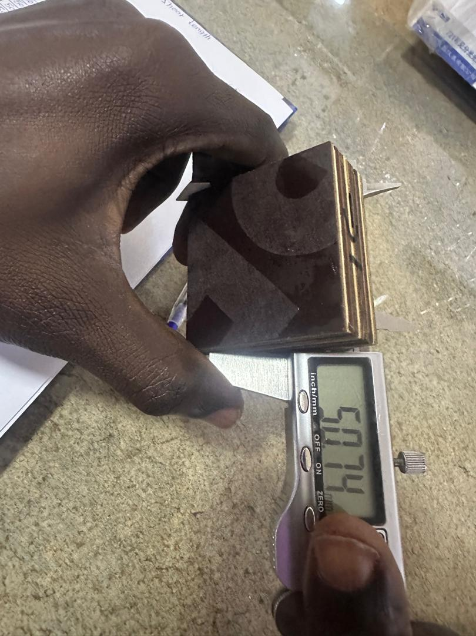
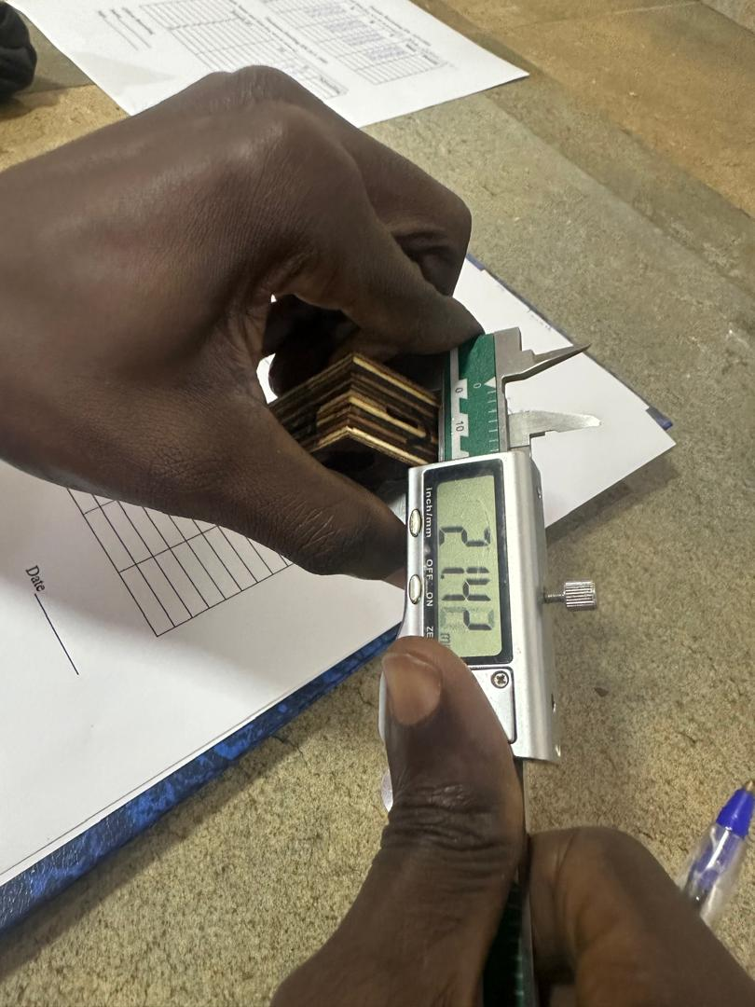
A
B

Figure 6: Measuring the width shown in ‘A’ and the thickness in ‘B’ using Mitutoyo Veneer. Calliper

Where m is the mass of the sample, b₁ and b₂ are the width and length, respectively. The results are expressed in kg/m³.

4.2.2 Thickness Swelling

4.2.2.1 Sample Preparation
The sample preparation follows section 2.1.1 (density sample preparation). The dimensions of the test piece are 50 x 50 x t, where t is the thickness of the test piece.

4.2.2.2 Conditioning
The conditioning of the samples follows the conditioning procedure as described under density in 2.1.2 above.

4.2.2.3 Immersion
In determining the dimensional stability of the plywood, samples were exposed to water with a pH of 7 and a temperature of (20 ± 1) º C in a water bath (Wincom) to determine the percentage of swelling. After 24 hours in the water, the samples were removed and placed on tissue paper to absorb the dripping water. The swelling thickness of each test piece, S_{t} expressed as a percentage of the original thickness, shall be calculated according to EN 317:1993. It is determined by Equation 6

$S_{t}= \frac{t_{2 }-t_{1}}{t_{1}} x 100$ Equ. 6

Where t₁ and t₂ are the initial thickness and wet thickness, respectively. The results of the calculations are expressed in percentages (%).

4.2.3 Data Analysis
After the testing, the data retrieved was processed and analysed using Microsoft Excel and Origin Pro data analysis software. The graphs representing the data were plotted using the software. MS Excel was used in the data-cleaning process, while Origin Pro analysis software was used in establishing the correlation between variables.

4.3 Results and Discussion

4.3.1 Mean densities and thickness swelling description.
Table 1 presents the mean density and thickness swelling properties of plywood panels bonded with Phenol Formaldehyde (PF) and Melamine Urea-Formaldehyde (MUF) adhesives across varying thicknesses (9 - 21 mm). A consistent decrease in density was observed as the thicknesses of the panels increased in both the PF and MUF adhesives. The PF-bonded panels indicated higher average densities than MUF-bonded plywood at all thickness levels, indicating better compaction and possibly stronger structural performance, as PF-bonded panels are known for it was established in a study conducted by (Laskowska, 2024). However, the standard deviation in PF densities increases significantly in thicker panels, particularly at 18 mm and 21 mm. The variation could be caused by glue spread inconsistency, core layer variations, as well as veneer quality differences.

Table 3: Mean densities and thickness swelling of PF and MUF bonded plywood for varied thicknesses.
Property | 9mm | 12 mm | 15 mm | 18 mm | 21 mm
Phenol Formaldehyde (PF)

Density (kg/m³) | 785  ±14.69 | 746  ±30.66 | 727  ±18.61 | 722  ±63.20 | 709  ±59.54
Thickness Swelling (%) | 5.90  ±0.70 | 5.67  ±1.39 | 5.19  ±0.83 | 4.55  ±1.12 | 3.62  ±0.93
Melamine Urea-Formaldehyde (MUF)

Density (kg/m³) | 731  ±17.42 | 674  ±20.85 | 673  ±9.32 | 654  ±11.9 | 648  ±42.76
Thickness Swelling (%) | 7.92  ±1.16 | 5.57  ±0.59 | 3.85  ±0.44 | 3.82  ±0.37 | 3.11  ±0.51

Regarding thickness swelling, panels bonded by PF adhesive exhibited better dimensional stability across all thicknesses, with swelling percentages decreasing steadily from 5.90% for the 9 mm panel to 3.62% for the 21 mm panel. This confirms the findings of Irribarra et al. (2021), Swanto et al. (2019), and Kojima et al. (2009), who concluded in their studies that MUF-bonded panels experienced lower thickness swelling than other adhesives. The MUF-bonded plywood indicated reduced swelling with increasing thickness, and all five thicknesses consistently swell more than those bonded with PF adhesive. The highest swelling was seen in 9 mm MUF panels (7.92%), indicating lower moisture resistance.
The mean data of the density and thickness swelling, with their standard deviations, are represented graphically in the box plot in Figure 7

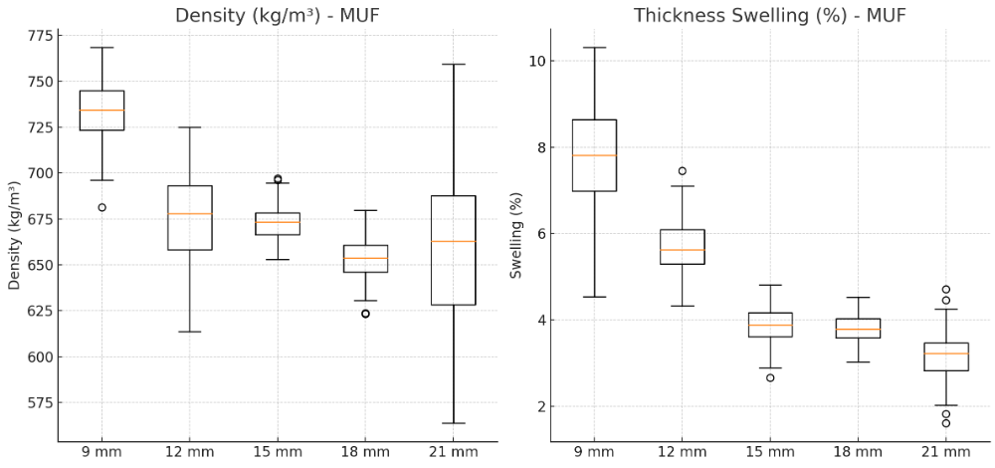
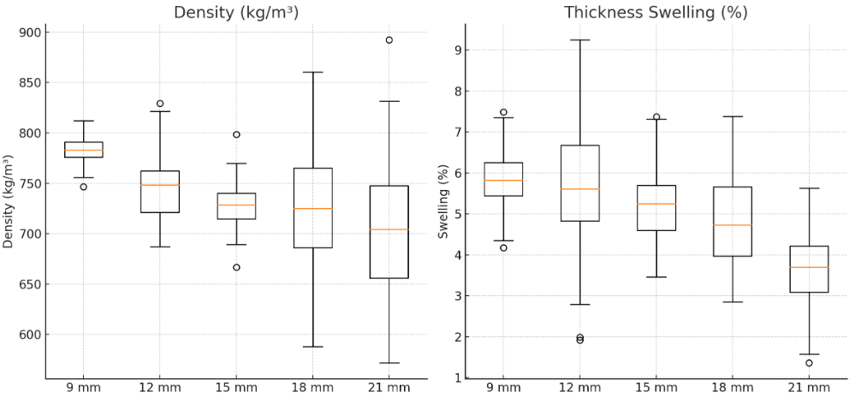
A
B
Panel thickness (mm)
Panel thickness (mm)

Figure 7: Box plot of mean values of density and thickness swelling. ‘A’ and ‘B’ represent the PF and MUF bonded panel, respectively.

4.3.2 ANOVA analysis on the thickness variation and adhesive type on plywood density
According to the ONE-WAY ANOVA, the thickness of plywood has a significant influence on its density. In this study, the phenol formaldehyde (PF) or the melamine urea formaldehyde (MUF) used in bonding the two sets of plywood demonstrated different effects on the density. Considering the PF adhesive, the density variations between the 9 mm thick panel and the other thicknesses, that is, 12 mm, 15 mm, 18 mm, and 21 mm panels, were found to be highly significant (**p < 0.01). This indicates that the pressing and curing conditions associated with PF resins have a different effect on thinner panels. However, beyond 12 mm, the density differences became insignificant (p > 0.05) in most pairwise comparisons. This indicates that PF adhesives facilitate the more even distribution of density in medium-to-thick panels by facilitating the easier passage of resin and heat through them during hot pressing. When the 12 mm and 21 mm panels were compared, the results remained statistically significant in the higher thickness range. This indicates that the average density of the 21 mm panel is lower than that of the 12 mm panel, which has a smaller core volume, because the 21 mm panel's core volume is larger and less compressed.
The MUF-bonded panels showed a more noticeable and extensive pattern of density change in every thickness comparison. The significantly larger F-values in all pairwise comparisons with 9 mm panels (**p < 0.01) indicate that thickness had a greater impact on density when it came to MUF adhesive bonding conditions. Additionally, the densities of MUF panels varied more; for instance, comparing the 12 to 18mm, 15 to 18 mm, and 15 to 21 mm, revealed statistically significant differences (**p < 0.01). This may be attributed to MUF resins curing more quickly and being more susceptible to moisture, which can lead to uneven resin spread and altered compaction, particularly as thickness increases. The only insignificant differences were found between 12 and 15 mm and between 18 and 21 mm, suggesting that there were few areas of density stability. These results indicate that MUF can help speed up production cycles, but more stringent process control may be required to ensure that the product quality remains consistent across thicknesses.

Table 3: Analysis of Variance (ANOVA) for Density Differences in Plywood Bonded with PF and MUF Adhesives Across Thickness Ranges
Properties | Source of Variation | Sum of Squares | DF | Mean Sum of Square, MSS | F-Value | Tukey  p-value
Phenol Formaldehyde (PF)
Density (kg/m³) | 9-12 | 22,041.67 | 1 | 22,041.67 | 38.14 | **p<0.01
Density (kg/m³) | 9- 15 | 49,824.02 | 1 | 49,824.02 | 177.18 | **p<0.01
Density (kg/m³) | 9 -18 | 59,787.27 | 1 | 59,787.27 | 28.40 | **p<0.01
Density (kg/m³) | 9 -21 | 85,654.82 | 1 | 85,654.82 | 45.55 | **p<0.01
Density (kg/m³) | 12-15 | 5,587.35 | 1 | 5,587.35 | 8.69 | p> 0.05
Density (kg/m³) | 12- 18 | 9,225.60 | 1 | 9,225.60 | 3.74 | p> 0.05
Density (kg/m³) | 12- 21 | 20,794.82 | 1 | 20,794.82 | 9.27 | **p<0.01
Density (kg/m³) | 15-18 | 453.75 | 1 | 453.75 | 0.21 | p> 0.05
Density (kg/m³) | 15-21 | 4,824.07 | 1 | 4,824.07 | 2.48 | p> 0.05
Density (kg/m³) | 18-21 | 2,318.82 | 1 | 2,318.82 | 0.62 | p> 0.05
Melamine Urea Formaldehyde (MUF)
 | 9-12 | 47,489.07 | 1 | 47,489.07 | 128.73 | **p<0.01
 | 9- 15 | 49,249.35 | 1 | 49,249.35 | 252.48 | **p<0.01
 | 9 -18 | 88,243.35 | 1 | 88,243.35 | 396.79 | **p<0.01
 | 9 -21 | 102,258.82 | 1 | 102,258.82 | 95.83 | **p<0.01
Density (kg/m³) | 12-15 | 16.02 | 1 | 16.02 | 0.06 | p> 0.05
 | 12- 18 | 6,262.82 | 1 | 6,262.82 | 21.74 | **p<0.01
 | 12- 21 | 10,375.35 | 1 | 10,375.35 | 9.16 | **p<0.01
 | 15-18 | 5,645.40 | 1 | 5,645.40 | 49.44 | **p<0.01
 | 15-21 | 9,576.07 | 1 | 9,576.07 | 9.99 | **p<0.01
 | 18-21 | 516.27 | 1 | 516.27 | 0.52 | p> 0.05
DF-Degree of Freedom

4.3.3 ANOVA analysis on the thickness variation of thickness swelling and adhesive type of plywood
Table 4 shows the Analysis of Variance (ANOVA) conducted primarily to assess statistically how the different panel thickness affects thickness swelling (%) in plywood bonded with the two types of adhesives, Phenol Formaldehyde (PF) and Melamine Urea Formaldehyde (MUF). The ANOVA on the thickness swelling (TS) in PF-bonded plywood shows that swelling is significantly influenced by differences in panel thickness, especially as the gap between comparing thickness categories widens. For instance, comparisons involving the extremes, such as 9 and 18 mm (F = 31.43, p < 0.01) and 9 and 21 mm (F = 114.69, p < 0.01), produced very high F-values with statistically significant p-values at the 1% level, indicating a notable increase in thickness swelling with increasing panel thickness. However, the differences between the smaller thickness panels, such as 9 and 12 mm (F = 0.65, p > 0.05) and 12 and 15 mm (F = 2.59, p > 0.05), were not statistically significant. This suggests that PF-bonded plywood remains dimensionally stable across smaller thicknesses. This is in line with the findings of Irribarraet al. (2021) that PF-bonded plywood remains largely dimensionally stable compared to other adhesive types. The pattern highlights the moisture resistance and structural rigidity of PF resins, known for forming thermosetting, water-resistant bonds (Myers et al., 1991; Zhao et al., 2019). This phenomenon, therefore, indicates that the significant difference between thinner and thicker panels is likely related to mechanical stresses caused by panel thickness rather than adhesive deterioration, confirming that PF panels are relatively durable but not entirely immune to dimensional changes as thickness increases. This accession is held by Youssef et al. (2009), who concluded that thicker plywood panels may absorb more moisture due to mechanical stresses, as stress-dependent moisture diffusion can alter the diffusion properties of composite materials over time.
On the other hand, MUF-bonded plywood shows noticeably higher sensitivity to thickness variation across nearly all comparisons, with F-values significantly surpassing those of PF-bonded panels. Notably, considerable swelling was observed even at moderately spaced thicknesses comparisons, such as 12 and15 mm (F = 165.76, p < 0.01) and 12 and 18 mm (F = 188.79, p < 0.01), and it was most evident in comparisons involving the thinnest and thickest panels, like 9 and21 mm, which resulted in an F-value of 429.92 (p < 0.01) showing a statistically difference between the two. This is an indication of extreme swelling due to thickness-related stresses. The only exception was between 15 and 18 mm (F = 0.06, p > 0.05), where swelling behaviour appears relatively constant. Overall, the heightened sensitivity in MUF-bonded plywood may arise from the hydrophilic nature and lower cross-linking density of MUF adhesives, making them more prone to moisture absorption and dimensional instability. Due to these hydrophilic behaviours of MUF bonds, particularly in plywood, there have been several studies to deal with the phenomenon of soyabean flour to improve the water resistance ability of the MUF adhesives(Q. Gao et al., 2012). These findings reinforce the conclusion that MUF resins, though cost-effective and common in interior-grade panels, do not provide the same level of dimensional resilience as PF adhesives under varying panel thicknesses, a vital factor in product design and applications where swelling tolerance is critical.
Test of normality conducted on thickness swelling data set using Shapiro-Wilk Test for PF (W= 0.9929; p-value = 0.6710), and MUF (W= 0.9857; p-value = 0.6710) indicates that the residuals were normally distributed (p > 0.05) and no violation of ANOVA assumptions for both PF and MUF. Regarding density, PF the Shapiro-Wilk test indicated 9 mm (W = 0.9791; p-value = 0.8018), 12 mm (W = 0.9362; p-value = 0.1720), 15 mm (W = 0.9308; p-value = 0.0516), 18 mm (W = 0.9202; p-value = 0.1271), 21mm (W = 0.9471; p-value = 0.1413) and interpreted as Normal, Borderline normal, normal and normal respectively. The MUF normality test were as follows 9 mm (W = 0.9188; p-value = 0.1249; normal), 12 mm (W = 0.9607; p-value = 0.3220; normal), 15 mm (W= 0.9528; p-value = 0.2011; normal), 18 mm (W = 0.9620; p-value = 0.3479; normal), 21 mm (W = 0.9175; p-value = 0.2141; normal).

Table 4: Analysis of Variance (ANOVA) for Thickness Swelling Differences in Plywood Bonded with PF and MUF Adhesives Across Thickness Ranges (n=30)
Properties | Source of Variation | Sum of Squares | DF | Mean Sum of Square, MSS | F-Value | Tukey  p-value
Phenol Formaldehyde (PF)
Thickness Swelling (%) | 9mm-12mm | 0.78 | 1 | 0.78 | 0.65 | p>0.05
Thickness Swelling (%) | 9mm- 15mm | 7.43 | 1 | 7.43 | 12.65 | **p<0.01
Thickness Swelling (%) | 9mm -18mm | 27.32 | 1 | 27.32 | 31.43 | **p<0.01
Thickness Swelling (%) | 9mm -21mm | 78.04 | 1 | 78.04 | 114.69 | **p<0.01
Thickness Swelling (%) | 12mm-15mm | 3.39 | 1 | 3.39 | 2.59 | p>0.05
Thickness Swelling (%) | 12mm- 18mm | 18.85 | 1 | 18.85 | 11.88 | **p<0.01
Thickness Swelling (%) | 12mm- 21mm | 63.18 | 1 | 63.18 | 45.19 | **p<0.01
Thickness Swelling (%) | 15mm-18mm | 6.25 | 1 | 6.25 | 6.48 | *p<0.05
Thickness Swelling (%) | 15mm-2mm | 35.33 | 1 | 35.33 | 45.48 | **p<0.01
 | 18mm-21mm | 13.01 | 1 | 13.01 | 12.29 | **p<0.01
Melamine Urea Formaldehyde (/MUF)
Thickness Swelling  (%) | 9mm-12mm | 82.74 | 1 | 82.74 | 97.25 | **p<0.01
Thickness Swelling  (%) | 9mm- 15mm | 248.51 | 1 | 248.51 | 321.29 | **p<0.01
Thickness Swelling  (%) | 9mm -18mm | 251.78 | 1 | 251.78 | 336.56 | **p<0.01
Thickness Swelling  (%) | 9mm -21mm | 346.75 | 1 | 346.75 | 429.92 | **p<0.01
Thickness Swelling  (%) | 12mm-15mm | 44.46 | 1 | 44.46 | 165.76 | **p<0.01
Thickness Swelling  (%) | 12mm- 18mm | 45.85 | 1 | 45.85 | 188.79 | **p<0.01
Thickness Swelling  (%) | 12mm- 21mm | 90.72 | 1 | 90.72 | 301.09 | **p<0.01
Thickness Swelling  (%) | 15mm-18mm | 0.01 | 1 | 0.01 | 0.06 | p>0.05
Thickness Swelling  (%) | 15mm-2mm | 8.16 | 1 | 8.16 | 36.45 | **p<0.01
Thickness Swelling  (%) | 18mm-21mm | 7.58 | 1 | 7.58 | 38.19 | **p<0.01

4.3.4 Regression analysis of factors affecting thickness swelling
The regression analysis was conducted to establish a relationship between plywood thickness, density, and thickness swelling, as shown in Table 4. This model measures the strength and direction of these relationships for both PF and MUF adhesives. The multiple regression model, which included adhesive type, panel density, and thickness, explained approximately 69.9% of the variation in thickness swelling (R² = 0.699, p < 0.001). Both main effects (density and thickness) and their interactions with adhesive type were statistically significant (p < 0.001), indicating that swelling is affected not only by each factor individually but also by their interactions. This is in line with studies (Geng et al., 2006; Sari et al., 2013), which have concluded that thickness swelling is influenced by interacting factors such as panel density, which significantly affects internal bonding, mechanical properties, and swelling behaviour. The coefficient for density (0.0544) shows that swelling increases with density for MUF-bonded panels. However, the negative interaction between density and PF adhesive (−0.0605) suggests this trend is reversed in PF-bonded panels, where higher density leads to less swelling. Thickness had a positive effect on MUF panels (1.7042), but a strong negative effect on PF panels (−1.9943). This indicates that the two adhesives respond differently to changes in thickness and other parameters. The complexity of the relationship among adhesives, density, and thickness in determining the swelling behaviour of wood-based panels has been confirmed by several studies (Geng et al., 2006; Saldanha & Iwakiri, 2009; Ustaomer & Usta, 2012).

The interaction between density and panel thickness (−0.0030, p < 0.001) shows that swelling usually decreases as both parameters increase. However, this effect is negated in PF panels by the positive three-way interaction (0.0031, p < 0.001). This indicates that in PF adhesives, increasing both density and thickness does not reduce swelling as much as in MUF adhesives. This is partially corroborated by studies conducted by Sarmin et al. (2013 and Shi & Gardner, (2006) concluded that higher density generally leads to increased thickness swelling. These findings suggest that the adhesive influences how structural factors like density and panel thickness impact dimensional stability

Table 5: Multiple Regression Coefficients for the Effects of Adhesive Type, Density (kg/m³), and Thickness (mm) on Thickness Swelling (%) of Plywood
Predictor | Coefficient | Std.  Error | t-Statistics | p-value
Intercept | 12.7676 | 5.5982 | 2.2807 | 0.0233
Adhesive (MUF=1, PF=0) | -40.6211 | 7.4511 | -5.4517 | <0.0001
Density | -0.0061 | 0.0073 | -0.8379 | 0.4027
Adhesive x Density | 0.0605 | 0.0101 | 5.9973 | <0.0001
Thickness | -0.2901 | 0.3067 | -0.9460 | 0.3449
Adhesive x Thickness | 1.9943 | 0.4211 | 4.7356 | <0.0001
Density x Thickness | 0.0001 | 0.0004 | 0.2451 | 0.8065
Adhesive x Density x Thickness | -0.0031 | 0.0006 | -5.2480 | <0.0001
R² | 0.6990
Adjusted R² | 0.6918

The multiple linear regression model used in the regression analysis is explained below.
$Y$= Thickness Swelling (%)
$A$= Adhesive Type (coded as MUF = 1, PF = 0)
$D$= Density (kg/m³)
$T$= Thickness (mm)
Then the fitted multiple linear regression equation is:
$$\begin{matrix}Y & =β_{0}+β_{1}A+β_{2}D+β_{3}(A×D)+β_{4}T+β_{5}(A×T)+β_{6}(D×T)+β_{7}(A×D×T)+ε\end{matrix}$$
Substituting the estimated coefficients from the table:
$$\begin{matrix}\hat{Y} & =12.7676-40.6211A-0.0061D+0.0605(AD)-0.2901T+1.9943(AT)+0.0001(DT)-0.0031(ADT)\end{matrix}$$
Where,
$\hat{Y}$= predicted thickness swelling (%),
$ε$= random error term.
Model Fit Statistics
$$R^{2}=0.6990$$
Adjusted $R^{2}=0.6918$
This means approximately 69.9% of the variation in thickness swelling is explained by the adhesive type, density, and panel thickness.
The Adhesive Type (MUF vs PF) has a significant adverse primary effect on swelling ($p<0.0001$), meaning MUF generally reduces swelling compared to PF.
Significant interaction terms ($A×D$, $A×T$, and $A×D×T$) indicate that the effect of adhesive type on swelling depends strongly on both density and thickness.
Main effects of Density and Thickness alone are not statistically significant ($p>0.05$).

4.0 Conclusion
The study shows that the physical performance of juvenile Eucalyptus pellita plywood is significantly influenced by panel thickness, density, and the type of adhesive used for bonding the veneers. According to the analysis, phenol-formaldehyde (PF) adhesives produced panels with higher average densities and less swelling when exposed to moisture. This indicates that they are suitable for applications requiring better dimensional stability and durability over time. In contrast, melamine urea-formaldehyde (MUF) adhesives resulted in more variable densities and were more prone to swelling, especially in thinner panels, when exposed to moisture. This is because MUF-bonded panels are less suitable for conditions involving temperature, humidity, and moisture. Statistical tests such as ANOVA and regression modelling reveal that both density and thickness significantly affect swelling behaviour, with an interactive effect. The type of adhesive also plays a crucial role in these outcomes. These findings highlight the importance of carefully controlling veneer moisture content, adhesive formulation, and pressing conditions to produce high-quality plywood. Overall, the study suggests that juvenile Eucalyptus pellita could serve as a sustainable raw material for plywood production, provided that advanced adhesive technologies and standardized process optimisation are adopted to meet international standards for structural and industrial applications.

5.0 Acknowledgment
The research team is grateful to MIRO Timber Products Ltd. For providing the samples and also making their laboratory available for the experiment. Also, the team is grateful to Esther Birago for the help during the laboratory work.

Chapter 5. Bonding Quality

5.1 Background
The performance and strength of the adhesive used in plywood production define most of its quality. The type of adhesive selected for the production process largely determines the bonding strength. The choice of resin not only affects the bonding quality but also defines the categorization of the plywood produced. For instance, while phenol-formaldehyde (PF) resin is typically used for exterior-grade plywood due to its superior moisture resistance, melamine urea-formaldehyde (MUF) resin is often employed in the production of semi-external plywood used in places where there is no direct contact with moisture. In applications where environmental exposure and durability are significant considerations, this difference is crucial.

Eucalyptus species plantations are gradually dominating tree plantations in Ghana for plywood manufacturing. The physical properties of juvenile Eucalyptus wood, such as density and growth characteristics, can substantially affect the bonding quality of plywood. Research has demonstrated that the morphological characteristics of young wood, including the ratio of earlywood to latewood, influence adhesive penetration and bonding strength (Irribarra et al., 2021). The adoption of eco-friendly adhesives is increasing, as they diminish environmental impact and improve bonding quality through the use of natural components such as tannins (Hemmilä et al., 2017; Réh et al., 2019). Several elements affect adhesives' effectiveness in plywood manufacture, including solids content, adhesive viscosity, and filler presence. For instance, Hong & Park, (2017) and Jeong & Park, (2019) discovered that the viscosity of UF resins influences adhesion strength; higher viscosity produces better bonding since a tighter network structure is developed during curing.
However, the solids content of the adhesive is crucial, and the ideal adhesive penetration and bonding quality depend on a range of 20–35% solids content (Chandler et al., 2005; Sernek et al., 1999). Extremely high or low solids content might cause poor adhesion and bubble development during the hot-pressing process, therefore compromising the general plywood quality (Lubis et al., 2022). The integration of natural fillers, such as bark or lignin, into adhesive compositions has demonstrated an improvement in bonding quality while decreasing formaldehyde emissions. A study conducted by Réh et al. (2019) established that including bark as a filler in adhesive formulations markedly reduces free formaldehyde emissions, a vital factor in the manufacture of eco-friendly plywood. This corresponds with the findings of Mirski et al. (2020), who indicated that using oak bark powder enhanced the shear strength of plywood, suggesting that the selection of fillers is crucial for improving adhesive efficacy.
Furthermore, the critical parameters in plywood manufacture, such as temperature and duration, are essential for attaining optimal bonding strength (Mirski et al., 2020; Qin & Teng, 2022; Shalbafan et al., 2020). A study conducted by Bekhta et al. (2020b) underscored that superior plywood is produced at optimal pressure settings, which differ based on the adhesive type and wood species. The implementation of thermal compression methods before adhesive application can decrease pressing duration and adhesive usage without sacrificing bonding integrity (Bekhta et al., 2020).

This study aims to assess the bonding strength and wood failure properties of Ghanaian plywood derived from juvenile Eucalyptus pellita. The study specifically seeks to find how several kinds of adhesive, including Phenol-Formaldehyde (PF) and Melamine Urea Formaldehyde (MUF) resins, might affect bonding strength and the proportion of wood failure. Through the analysis of these factors under different pressing situations, the research aims to find ideal bonding methods that improve bonding strength while reducing wood failure, so helping to produce durable and premium Eucalyptus plywood.

5.2 Materials and Methods

5.2.1 Bonding test

5.2.1.1 Sample Preparation
The bonding samples were prepared according to EN 314-1: 2004 (Bonding quality, Part 1: Test method) and EN 326-1, (Wood-based panels- Sampling, cutting, and inspection- Part1: Sampling and cutting of test pieces and expression of test results). The samples were prepared in both longitudinal and transverse orientations according to the surface grain direction using the dimensional sliding table saw (MJ320 M). The samples were cut to the dimensions of (25 x t x 150) mm, and nickings were cut such that each glue line would be tested. Where t, refers to the thickness of the sample, in this case (9, 12, 15, 18, and 21) mm. For easy gripping of the sample during testing, 150 mm was seen to be a convenient length by practice, as the standard is silent on the length. The nickings were made 25 mm apart in the middle. Figure 7 is a schematic diagram showing the nature of the nicking made on the samples.
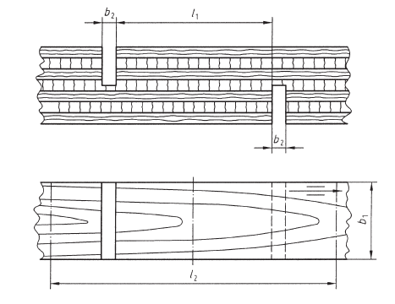

l₁ = 25 mmb₂ = 3 mm

Figure 7: Illustration of nicking on a bonding test piece by shear method (Source: EN 314-1 standard)

5.2.1.2 Pre-treatments
Prior to testing, the samples are prepared according to EN 314-1 and 314-2 (Plywood – Bonding quality – Part 2: Requirements. The pre-treatment is designed to suit the class of plywood, meaning it is adhesive-dependent. The Venticell oven and the Wincom water bath were the equipment used in the pre-treatment.

5.2.1.3 MUF Bonded Plywood Pre-treatment
i) Immersion for 24 hrs in water at (20 ± 3) ºC
ii) Immersion for 6 hrs in boiling water followed by cooling in water at (20 ± 3) ºC, for at least 1 h

5.2.1.4 PF Bonded Plywood Pre-treatment.
i) Immersion for 24 hrs in water at (20 ± 3) ºC
ii) Immersion for 4 hrs in boiling water, then the samples were dried in a ventilated oven for 16 hrs at (60±3) ºC , then the samples were boiled for 4 hrs, after which they were cooled in water at (20 ± 3) ºC for 1 h. During the boiling process, the samples were completely covered by the water, and weights were placed on the samples to prevent them from floating.

5.2.1.5 Test Procedure
Water is wiped from the samples by placing the pre-treated samples on tissue paper, which absorbs the dripping water from the samples, making them ready for testing. The length and width of the shear area were measured before pre-treatment. The shear test piece was fixed in the centre of the clamping devices in such a way that the load can be transmitted from the load cell through the testing machine. Both the upper and lower clamps held 50 mm of the samples from both sides, leaving the required 50 mm at the middle between the tips of the clamps. The load was applied at a constant rate till the sample ruptured between (20-40 s)

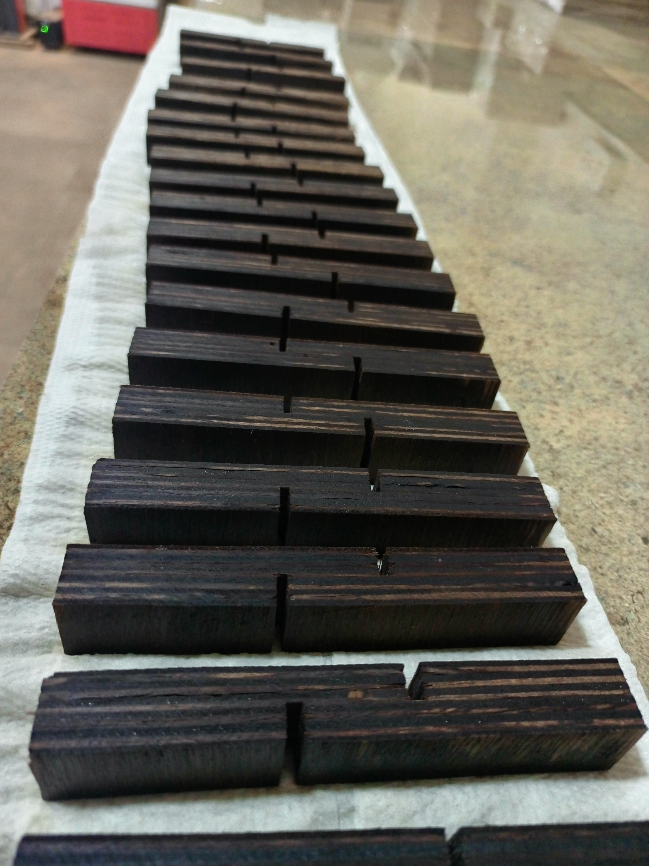

Figure 8: Pre-treated samples were placed on tissue paper to absorb moisture

5.2.1.6 Calculation of Shear Strength and Assessment of Wood Failure
The shear strength was calculated based on Equ. 7, and the apparent cohesive wood failure was determined using the references in Annex A of EN 314-1 and the use of a magnifying glass for the magnification of the wood fibers. Figure 9 A and B show the bonding testing and evaluation setup, respectively.
$f_{v}= \frac{F}{l_{1} x b_{1}}$ Equ. 7
Where F is the failing force of the test piece, in N, l₁ is the length of the shear area in mm, and b₁ is the width of the shear area.

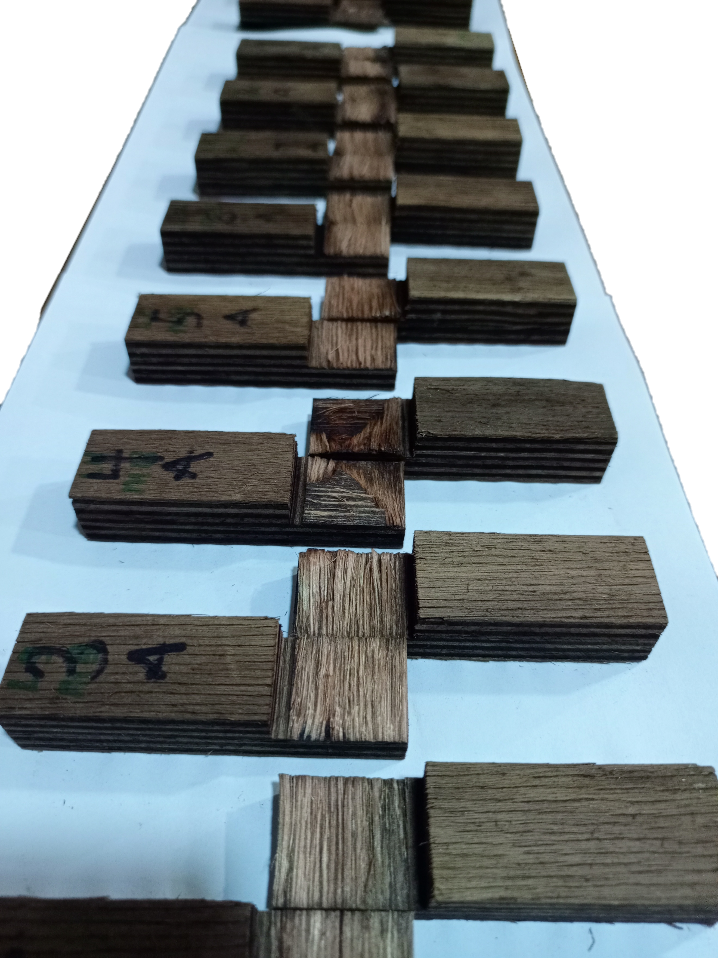
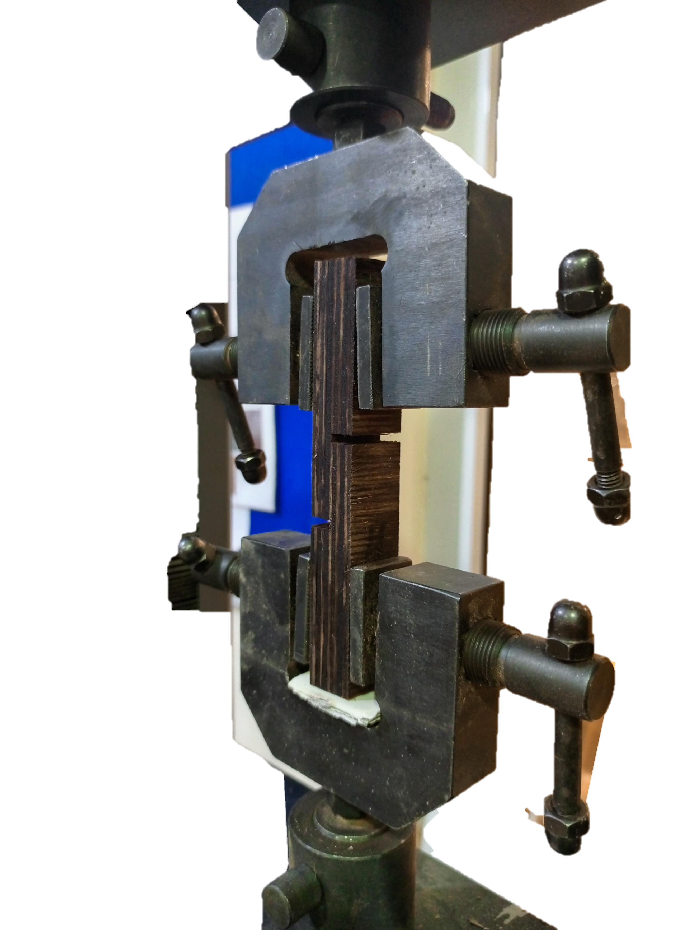
A
B

Figure 9: image ‘A’ shows a shear test piece in a clamp during testing, and ‘B’ displays tested samples showing the shear area.

Data were gathered and processed using Microsoft Excel and OriginPro data analysis software for conducting one-way ANOVA and correlation analysis.

5.3 Results and Discussion

5.3.1 Mean Bonding Strength and Wood Failure Results
The data show that for Phenol Formaldehyde (PF) adhesives, bonding strength (f_{v}) remains relatively consistent in the range of 1.58–1.67 N/mm² for thicknesses of 9–15 mm, but drops sharply to around 1.12–1.13 N/mm² for samples with thicknesses of 18–21 mm. Wood failure percentages for PF are consistently high (78–83%), with low variability, indicating a strong adhesive–wood interaction and cohesive failure within the wood rather than at the bond line. In contrast, Melamine Urea Formaldehyde (MUF) shows more fluctuation in bonding strength, with the lowest value (1.24 N/mm²) at 12 mm and the highest (1.67 N/mm²) at 9 mm. MUF wood failure percentages are notably lower (53–72%) and more variable, indicating weaker adhesion or a higher tendency for bond line failure compared to PF.

Table 6: Mean Bonding Strength and Wood Failure results of various thicknesses for PF and MUF
Thickness  (mm) | N | Phenol Formaldehyde |  | Melamine Urea Formaldehyde
Thickness  (mm) | N | B. Strength, f_{v}  (N/mm²) | Wood Failure  (%) | B. Strength, f_{v}  (N/mm²) | Wood Failure  (%)
9 mm | 30 | 1.62  ±0.24 | 83  ±9.6 | 1.67  ±0.50 | 72  ±19
12 mm | 30 | 1.67  ±0.18 | 82  ±9.2 | 1.24  ±0.37 | 65  ±16
15 mm | 30 | 1.58  ±0.18 | 81  ±9.00 | 1.51  ±0.61 | 62  ±14
18 mm | 30 | 1.13  ±0.24 | 79  ±11 | 1.31  ±0.27 | 60  ±11
21 mm | 30 | 1.12  ±0.23 | 78  ±11 | 1.54  ±0.55 | 53  ±15
B- Bonding, Number of Specimens

Statistically, the standard deviations for MUF bonding strength are larger than those for PF, reflecting less consistency in performance. The high PF wood failure percentages, even as thickness increases, suggest that PF maintains stronger adhesion across various sizes. However, thicker boards (>15 mm) exhibit reduced bonding strength, likely due to limitations in adhesive penetration or curing constraints. MUF’s performance appears more sensitive to thickness, with moderate strengths but significantly lower wood failure percentages, highlighting a generally weaker adhesive–wood bond interface compared to PF. Overall, PF demonstrates superior and more reliable bonding performance, while MUF’s variability and lower wood failure values indicate limitations in structural applications that require high bond integrity. The mean results and their standard deviations are graphically represented in Figure 10.

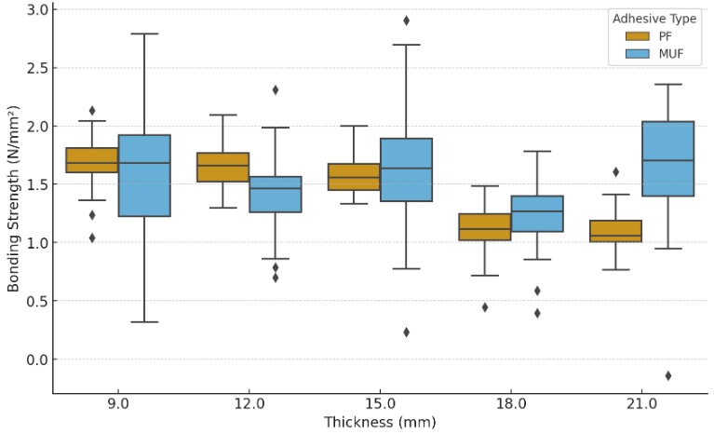
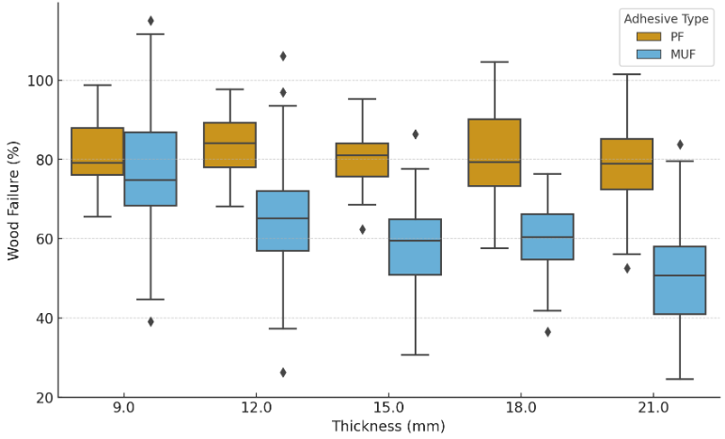

A
B

Figure 10: Box plot of mean values for both PF and MUF bonded panels, ‘A’ and ‘B’ represent Bonding Strength and Wood Failure, respectively.

5.3.2 Comparative Analysis of Bonding Strength in PF and MUF Bonded Plywood for various thicknesses.
This chapter of the study examines the influence of panel thickness on the bonding strength of the Eucalyptus pellita plywood, focusing on Phenol–Formaldehyde (PF) and Melamine–Urea–Formaldehyde (MUF) resins used as adhesives. The one-way analysis of variance (ANOVA) with Tukey's test was used to determine the significant differences among panel thicknesses. The study found that there are significant differences in bonding strength between the different panel thicknesses for Phenol–Formaldehyde (PF) adhesives. The differences were most noticeable between wider thickness gaps, such as 9 mm–18 mm, 9 mm–21 mm, 12 mm–18 mm, and 15 mm–21 mm, all showing very significant differences (p < 0.01). These results demonstrate that PF's crosslinked molecular structure provides outstanding strength and dimensional stability, especially when used in structures (Pizzi & Mittal, 2017). However, there were no significant differences between 9 mm and 12 mm or 9 mm and 15 mm, indicating that bonding variations according to the panel thickness were stable at these thicknesses. Wang et al. 2017) also stated that PF adhesives maintain their strong bond even when exposed to heat up to 200°C, outperforming MUF in durability tests, which has already been established by many researchers in the plywood industry.
The normality of shear strength data for both PF and MUF adhesives was evaluated using the Shapiro–Wilk test. For the PF adhesive, the 12 mm and 15 mm thickness groups were normally distributed (p > 0.05), whereas the 9 mm, 18 mm, and 21 mm groups showed normality at the borderline (p ≤ 0.05). For the MUF adhesive bonded panels, all groups (9 mm to 21 mm) exhibited normal distributions, with p-values exceeding 0.05. The Shapiro–Wilk normality results show that all wood-failure datasets from the PF adhesive exhibit p-values below the borderline (p ≤ 0.05), indicating normal but not perfect distribution across all panel thicknesses. In contrast, the MUF adhesive dataset for the various thicknesses were normally distributed (p>0.05).

Table 7: ANOVA Results for Bonding Strength (f_{v}) of PF and MUF Bonded Plywood at Different Thicknesses
Properties | Source of Variation | Sum of Squares | DF | Mean Sum of Squares, MSS | F-Value | Tukey  p-value
Phenol Formaldehyde (PF)
Bonding Strength, f_{v}  (N/mm²) | 9mm-12mm | 0.04 | 1 | 0.04 | 0.94 | p > 0.05
Bonding Strength, f_{v}  (N/mm²) | 9mm- 15mm | 0.03 | 1 | 0.03 | 0.55 | p > 0.05
Bonding Strength, f_{v}  (N/mm²) | 9mm -18mm | 3.58 | 1 | 3.58 | 60.75 | ** p<0.01
Bonding Strength, f_{v}  (N/mm²) | 9mm -21mm | 3.73 | 1 | 3.73 | 65.71 | ** p<0.01
Bonding Strength, f_{v}  (N/mm²) | 12mm-15mm | 0.13 | 1 | 0.13 | 4.14 | * p<0.05
Bonding Strength, f_{v}  (N/mm²) | 12mm- 18mm | 4.41 | 1 | 4.41 | 96.92 | ** p<0.01
Bonding Strength, f_{v}  (N/mm²) | 12mm- 21mm | 4.58 | 1 | 4.58 | 105.56 | ** p<0.01
Bonding Strength, f_{v}  (N/mm²) | 15mm-18mm | 3.00 | 1 | 3.00 | 66.40 | ** p<0.01
Bonding Strength, f_{v}  (N/mm²) | 15mm-21mm | 3.14 | 1 | 3.14 | 72.92 | ** p<0.01
Bonding Strength, f_{v}  (N/mm²) | 18mm-21mm | 0.0016 | 1 | 0.0016 | 0.03 | p > 0.05
Melamine Urea Formaldehyde (MUF)
Bonding Strength, f_{v}  (N/mm²) | 9mm-12mm | 2.66 | 1 | 2.66 | 13.53 | ** p<0.01
Bonding Strength, f_{v}  (N/mm²) | 9mm- 15mm | 0.37 | 1 | 0.37 | 1.19 | p > 0.05
Bonding Strength, f_{v}  (N/mm²) | 9mm -18mm | 1.90 | 1 | 1.90 | 11.69 | ** p<0.01
Bonding Strength, f_{v}  (N/mm²) | 9mm -21mm | 0.2196 | 1 | 0.2196 | 0.79 | p > 0.05
Bonding Strength, f_{v}  (N/mm²) | 12mm-15mm | 1.0399 | 1 | 1.0399 | 4.05 | * p<0.05
Bonding Strength, f_{v}  (N/mm²) | 12mm- 18mm | 0.0640 | 1 | 0.0640 | 0.61 | p > 0.05
Bonding Strength, f_{v}  (N/mm²) | 12mm- 21mm | 1.3530 | 1 | 1.3530 | 6.20 | * p<0.05
Bonding Strength, f_{v}  (N/mm²) | 15mm-18mm | 0.5879 | 1 | 0.5879 | 2.64 | p > 0.05
Bonding Strength, f_{v}  (N/mm²) | 15mm-21mm | 0.0206 | 1 | 0.0206 | 0.06 | p > 0.05
Bonding Strength, f_{v}  (N/mm²) | 18mm-21mm | 0.8284 | 1 | 0.8284 | 4.49 | * p<0.05

This stability and performance make PF still the best adhesive for structural-grade plywood and engineered wood products (Frihart, 2005). The bonding strength behaviour of Melamine–Urea–Formaldehyde (MUF) was more variable. There were significant differences (p < 0.01) between the 9 mm–12 mm and 9 mm–18 mm panels, which is an indication that MUF is quite sensitive to thickness variations. However, there were no significant differences (p > 0.05) between the 9 mm–15 mm and 15 mm–21 mm panels. This variability aligns with the research by J. Liu et al. (2020), which demonstrated that MUF bonding performance is strongly affected by pressing conditions, including temperature and time. Ayrilmis & Winandy (2009) also stated that MUF resins are inexpensive and widely used in wood products for interior or exterior applications with no direct contact with moisture, but they don't last as long or resist water as well as PF. Because of these issues, MUF is better suited for decorative and furniture plywood, where structural reliability is less critical than low cost and moderate bonding strength.

5.3.3 Effect of Thickness Variation on Wood Failure of PF and MUF Bonded Plywood
The analysis of variance (ANOVA) for PF plywood indicates that wood failure percentages are largely unaffected by thickness variation, with most comparisons showing no significant differences (p > 0.05). However, a significant difference was found when the 9 mm panel was compared to the 21 mm (F = 4.36, p < 0.05), suggesting that extreme thickness differences can affect wood failure in PF-bonded panels. The highly insignificant performances among thicknesses of panels well establish the durability and strong adhesive bonds formed by PF resins, which are less sensitive to substrate variability (Frihart & Hunt, 2010). The results are therefore a reinforcement to the understanding that PF maintains consistent adhesive strength across thicknesses, making it highly suitable for structural applications where uniform strength and failure resistance are entirely critical.

Table 8: ANOVA of Wood Failure in PF and MUF Bonded Plywood at Different Thicknesses
Properties | Source of Variation | Sum of Squares | DF | Mean Sum of Square, MSS | F-Value | Tukey  p-value
Phenol Formaldehyde (PF)
Wood Failure  (%) | 9mm-12mm | 26.67 | 1 | 26.67 | 0.30 | p > 0.05
Wood Failure  (%) | 9mm- 15mm | 60.00 | 1 | 60.00 | 0.69 | p > 0.05
Wood Failure  (%) | 9mm -18mm | 240.00 | 1 | 240.00 | 2.23 | p > 0.05
Wood Failure  (%) | 9mm -21mm | 481.67 | 1 | 481.67 | 4.36 | *p<0.05
Wood Failure  (%) | 12mm-15mm | 6.67 | 1 | 6.67 | 0.08 | p > 0.05
Wood Failure  (%) | 12mm- 18mm | 106.67 | 1 | 106.67 | 1.02 | p > 0.05
Wood Failure  (%) | 12mm- 21mm | 281.67 | 1 | 281.67 | 2.63 | p > 0.05
Wood Failure  (%) | 15mm-18mm | 60.00 | 1 | 60.00 | 0.59 | p > 0.05
Wood Failure  (%) | 15mm-21mm | 201.67 | 1 | 201.67 | 1.92 | p > 0.05
Wood Failure  (%) | 18mm-21mm | 41.67 | 1 | 41.67 | 0.33 | p > 0.05
Melamine Urea Formaldehyde (MUF)
Wood Failure  (%) | 9mm-12mm | 700.42 | 1 | 700.42 | 2.35 | p > 0.05
Wood Failure  (%) | 9mm- 15mm | 1,353.75 | 1 | 1,353.75 | 4.99 | * p<0.05
Wood Failure  (%) | 9mm -18mm | 1,938.02 | 1 | 1,938.02 | 8.30 | ** p<0.01
Wood Failure  (%) | 9mm -21mm | 5,041.67 | 1 | 5,041.67 | 17.69 | ** p<0.01
Wood Failure  (%) | 12mm-15mm | 106.67 | 1 | 106.67 | 0.48 | p > 0.05
Wood Failure  (%) | 12mm- 18mm | 308.27 | 1 | 308.27 | 1.69 | p > 0.05
Wood Failure  (%) | 12mm- 21mm | 1,983.75 | 1 | 1,983.75 | 8.47 | ** p<0.01
Wood Failure  (%) | 15mm-18mm | 52.27 | 1 | 52.27 | 0.33 | p > 0.05
Wood Failure  (%) | 15mm-21mm | 1,170.42 | 1 | 1,170.42 | 5.63 | p > 0.05
Wood Failure  (%) | 18mm-21mm | 728.02 | 1 | 728.02 | 4.29 | * p<0.05

However, MUF plywood has shown more pronounced and statistically significant differences in wood failure across the various thicknesses (9 mm to 21mm). Statistically significant differences were observed in 9 mm–15 mm (F = 4.99, p < 0.05), 9 mm–18 mm (F = 8.30, p < 0.01), 9 mm–21 mm (F = 17.69, p < 0.01), 12 mm–21 mm (F = 8.47, p < 0.01), and 18 mm–21 mm (F = 4.29, p < 0.05). These results highlight the fact that MUF-bonded panels are more sensitive to thickness differences, leading to variability in wood failure percentages. This observation is consistent with reports by Pizzi & Mittal (2017) who noted that MUF adhesives, though economical, exhibit lower durability and performance stability compared to PF, particularly under varying environmental or structural conditions. The increased failure rates at higher thickness contrasts suggest that MUF bonds are less reliable when panel thickness increases. When comparing the two adhesives, the results clearly show that PF resins provide more consistent wood failure performance across varying thicknesses. In contrast, MUF resins exhibit greater variability and significant differences in failure at thicker thicknesses. This finding aligns with Marra's (1992) observations, which emphasized the superior chemical stability and bond performance of PF adhesives compared to urea-based resins.

5.3.4 Correlation Between Bonding Strength and Wood Failure
The correlation analyses shown in Figure 11, between bonding strength and wood failure across the five thicknesses, 9 mm to 21 mm, reveal an essential insight into adhesive bond performance. At thinner dimensions (9 mm and 15 mm), no correlation was established between bonding strength and apparent cohesive wood failure. The measured values were so scattered, and no clear fit line could show a direction, that is, either positively or negatively correlated. Despite the non-establishment of a clear correlation, the data set shows in some instances were consistent with the widely accepted chain-link model of adhesive bonding, where a strong adhesive bond forces failure to occur within the wood substrate. (Frihart & Hunt, 2010). Such results indicate high-quality bonds, as wood failure percentages above 75% are generally regarded as signs of strong structural performance. On the other hand, in the 12 mm and 18 mm panels, weaker and more scattered correlations were observed, reflecting variability in bond quality. This variability may be attributed to differences in glue penetration due to the different grades of veneer used in the construction of the panel. Parameters such as earlywood and latewood influence, which can weaken the predictability of wood failure from bonding strength(W. Li et al., 2023; Z. Li et al., 2022)

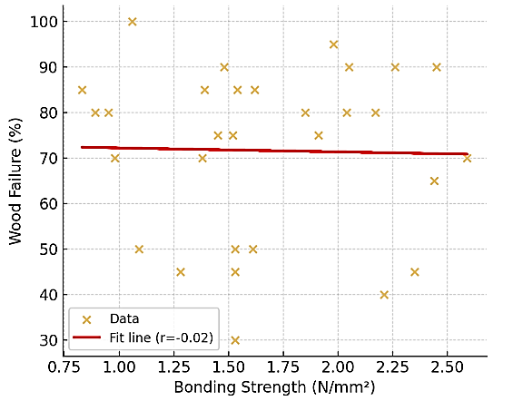
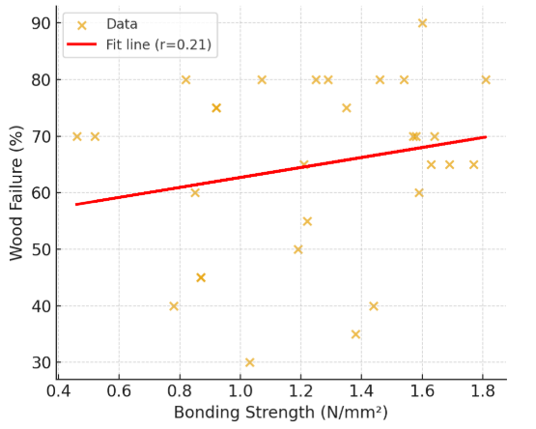
n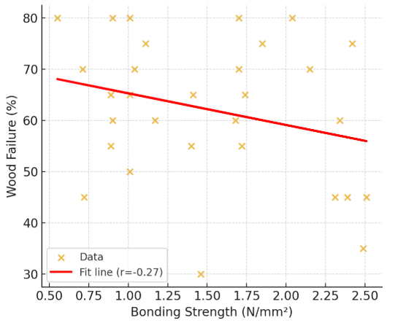
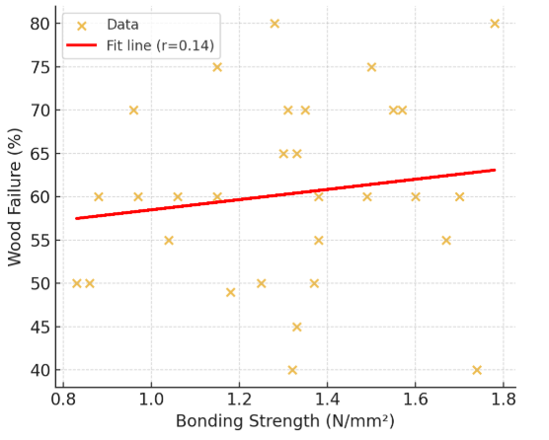
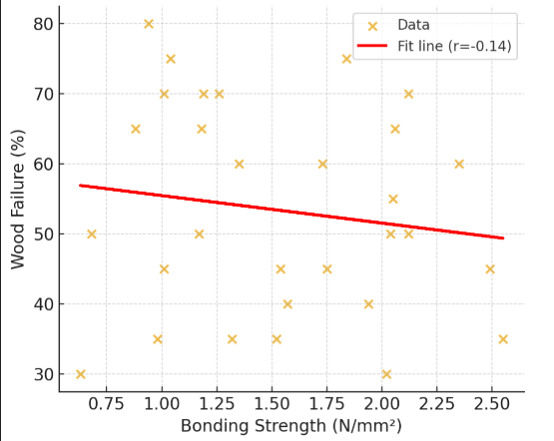
A
E
C
D
B

Figure 11: Correlation Between Bonding Strength and Wood Failure Across Varying Panel Thicknesses, A-9 mm, B-12 mm, C-15 mm, D-18 mm, and E-21 mm.

At the thickest measurement (21 mm), the connection between bonding strength and wood failure was the weakest. This suggests that other structural factors, such as internal stresses, moisture gradients, and uneven adhesive distribution, increasingly influence the failure process. This finding aligns with previous research, which indicates that thicker bonded assemblies tend to exhibit uneven stress distributions, resulting in less consistent bond performance (Kamke & Lee, 2007). Overall, these findings indicate that while higher bonding strength usually promotes desirable wood failure, the reliability of this relationship decreases as specimen thickness increases due to structural and material complexities. This has practical implications for plywood, where optimizing glue application, pressing conditions, and panel thickness is essential for achieving durable and predictable bonds.

5.4 Conclusions
This study emphasises that plywood thickness and adhesive types are important factors that affect bonding quality and wood failure performance in Eucalyptus pellita plywood. Phenol Formaldehyde (PF), as expected, consistently exhibited superior bonding strength, elevated wood failure rates, and enhanced reliability across various thicknesses, highlighting its suitability for structural and exterior applications necessitating high durability and moisture resistance. Melamine Urea Formaldehyde (MUF), on the other hand, had a wider range of bonding strengths and a much lower percentage of wood failures. This makes it better for interior or decorative uses where structural integrity isn't as important. The analysis also showed that for both adhesives, increasing the thickness beyond 15 mm generally made the bond weaker. This was especially true for MUF, which was more sensitive to changes in thickness and pressing conditions. A correlation analysis established that there was no clear relationship between apparent cohesive wood failure and bonding strength. At reduced thicknesses, stronger bonds facilitated wood failure; however, this correlation diminished at increased thicknesses could be due to differences in glue penetration resulting from the different grades of veneer used in the panel construction. Parameters such as earlywood and latewood influence, which can weaken the predictability of wood failure from bonding strength. The results confirm the fact that PF is more chemically stable and long-lasting than MUF. They also stress the need to optimise adhesive formulation, pressing parameters, and panel dimensions to get consistent and predictable bond quality. Therefore, PF remains the best adhesive for producing structural-grade plywood in Ghana. MUF, on the other hand, could be a cheaper option for non-structural uses if its problems are carefully handled.

5.6 Acknowledgment
The research team is grateful to MIRO Timber Products Ltd. For providing the samples and also making their laboratory available for the experiment. Also, the team is grateful to Esther Birago, for the help during the laboratory work.

Chapter 6. Fungal and Termite Resistance in Juvenile Eucalyptus and Birch Plywood

6.1 Background
The significant changes in our ecosystem are making the effects of climate change more obvious. Across the European nations like Spain, France, and the Balkans, rising temperatures provide the perfect environment for termite colonisation (Suppo et al., 2018). Considering this accession, proactive actions are necessary to minimise, if not address, the potential effects of termite activity on plywood. Assessing juvenile Eucalyptus plywood's resistance to termites and fungi is essential to understanding its biological durability and possible uses in the furniture and construction sectors within the European market. Because of their favourable mechanical qualities and quick growth, eucalyptus species, especially when they are young, are used as primary raw materials for the manufacturing of plywood (Alam et al., 2012; Seidu et al., 2023). According to empirical data, eucalyptus plywood could be a competitive alternative to birch plywood, which is regarded as the most durable plywood available in the EU market (Cihad Bal & Bektaş, 2014). However, a thorough investigation of their natural resistance mechanisms and implications for durability is necessary due to the vulnerability of wood-based products to biological degradation, specifically from termites and fungi (Elaieb et al., 2020; Rudman, 1964).

The longevity of wood products, like plywood, is threatened by fungal decay(Brischke et al., 2006). The chemical makeup of eucalyptus wood, particularly the presence of extractives with antifungal qualities, affects how resistant it is to fungal attack (Elaieb et al., 2020; Paes et al., 2016). According to research, some Eucalyptus species have high concentrations of phenolic compounds, which can prevent fungi from growing and decomposing on the wood or wood products made from the Eucalyptus species (Alfenas et al., 1982; Oh et al., 2008). Natural wood extractives work well as preservatives when used to protect wood and wood products from fungal attacks. Selective breeding or chemical treatments can be used to produce eucalyptus plywood for increased durability (Alfenas et al., 1982; Oh et al., 2008).
The ability of plywood to withstand termite infestations is a crucial component in determining its longevity(Cahyono et al., 2019). Both the natural chemical characteristics of the wood and the kinds of adhesives used during production have an impact on how resistant Eucalyptus plywood is to termites. Heartwood extractives contribute significantly to natural resistance against termite infestations, according to Kadir & Hale, (2012). Termite damage can be minimised, and feeding can be discouraged by the natural repellent compounds of wood. Furthermore, the vulnerability of the plywood to termite deterioration can be greatly influenced by the adhesive selection (Jimenez et al., 2021). When urea-formaldehyde (UF) adhesives are used instead of phenol-formaldehyde (PF) adhesives, which provide superior resistance because of their chemical characteristics, the former has been linked to increased vulnerability to termite attacks (Ismail et al., 2022). Plywood bonded with nano-cupric oxide-modified PF resins showed better resistance to subterranean termites, according to research by (W. Gao & Du, 2015). This suggests that improvements in adhesive technology could increase the biological durability of the plywood.
Also, it has been demonstrated that the capacity of termites to digest wood and fend off fungal infections is significantly influenced by their gut microbiota. According to research, termite gut microbial communities can break down lignocellulosic materials, which may also affect how susceptible wood is to fungal decay (Auer et al., 2017; Mathew et al., 2021). This implies that utilising the symbiotic connections between termites and their gut microbiota could improve the biological resistance of eucalyptus plywood. The biological durability of juvenile Eucalyptus plywood is significantly impacted by termite and fungal resistance. Furthermore, methods for enhancing the durability and functionality of plywood in a variety of applications can be informed by knowledge of the ecological relationships between termites, fungi, and eucalyptus wood.
This study aims to assess juvenile Eucalyptus plywood's resistance to termites and fungi to ascertain its biological durability and suitability for use in furniture manufacturing and construction. The study specifically looks into the natural resistance of birch plywood made in Europe and eucalyptus plywood made in Ghana. The study's findings will assign the juvenile eucalyptus plywood to a durability class. A favourable result will show that buildings and furniture have a longer lifespan due to resistance to termite and fungal infestations.

6.2 Materials and Methods

6.2.1 Termite

6.2.1.1 Materials
For this experiment, three different plywood and wood species were adopted. Tab. 1 indicates the number of samples prepared from each material.

Table 9: Plywood types of control sample used in the termite exposure experiment.
Plywood | ID Prefix | Adhesive | Quantity
Birch plywood | BP | Possibly PF | 22
MIRO Plywood | MMP | MUF | 25
MIRO Plywood | PMP | PF | 25
Wawa | WW | - | 10
BP-Birch plywood, MMP-Melamine MIRO Plywood and PMP – Phenol -formaldehyde MIRO Plywood
A low-density wood, Triplochiton scleroxylon, locally called Wawa, which is susceptible to termite attack, was used as a control sample to monitor the activities of the termite. 10 samples were placed randomly on the test field.

6.2.1.2 Sample Preparation
The field experiment was carried out by adopting and applying aspects of EN 350: 2016 (Durability of wood and wood-based products and classification of the durability to biological agents of wood and wood-based materials), EN 117: 2012 (Wood preservatives - Determination of toxic values against Reticulitermes species (European termites), and EN 252-2 (Field test method for determining the relative protective effectiveness of a wood preservative in ground contact) with acceptable modifications to suit the sample preparation. The birch plywood was sourced from the EU market (the name of the company was withheld for the sake of confidentiality). The plywood samples were prepared to a dimension of 300 mm x 50 mm x Y mm, where Y represents thickness. The control sample, which is solid wood, was cut to a dimension of 20 mm x 20 mm x 300 mm.

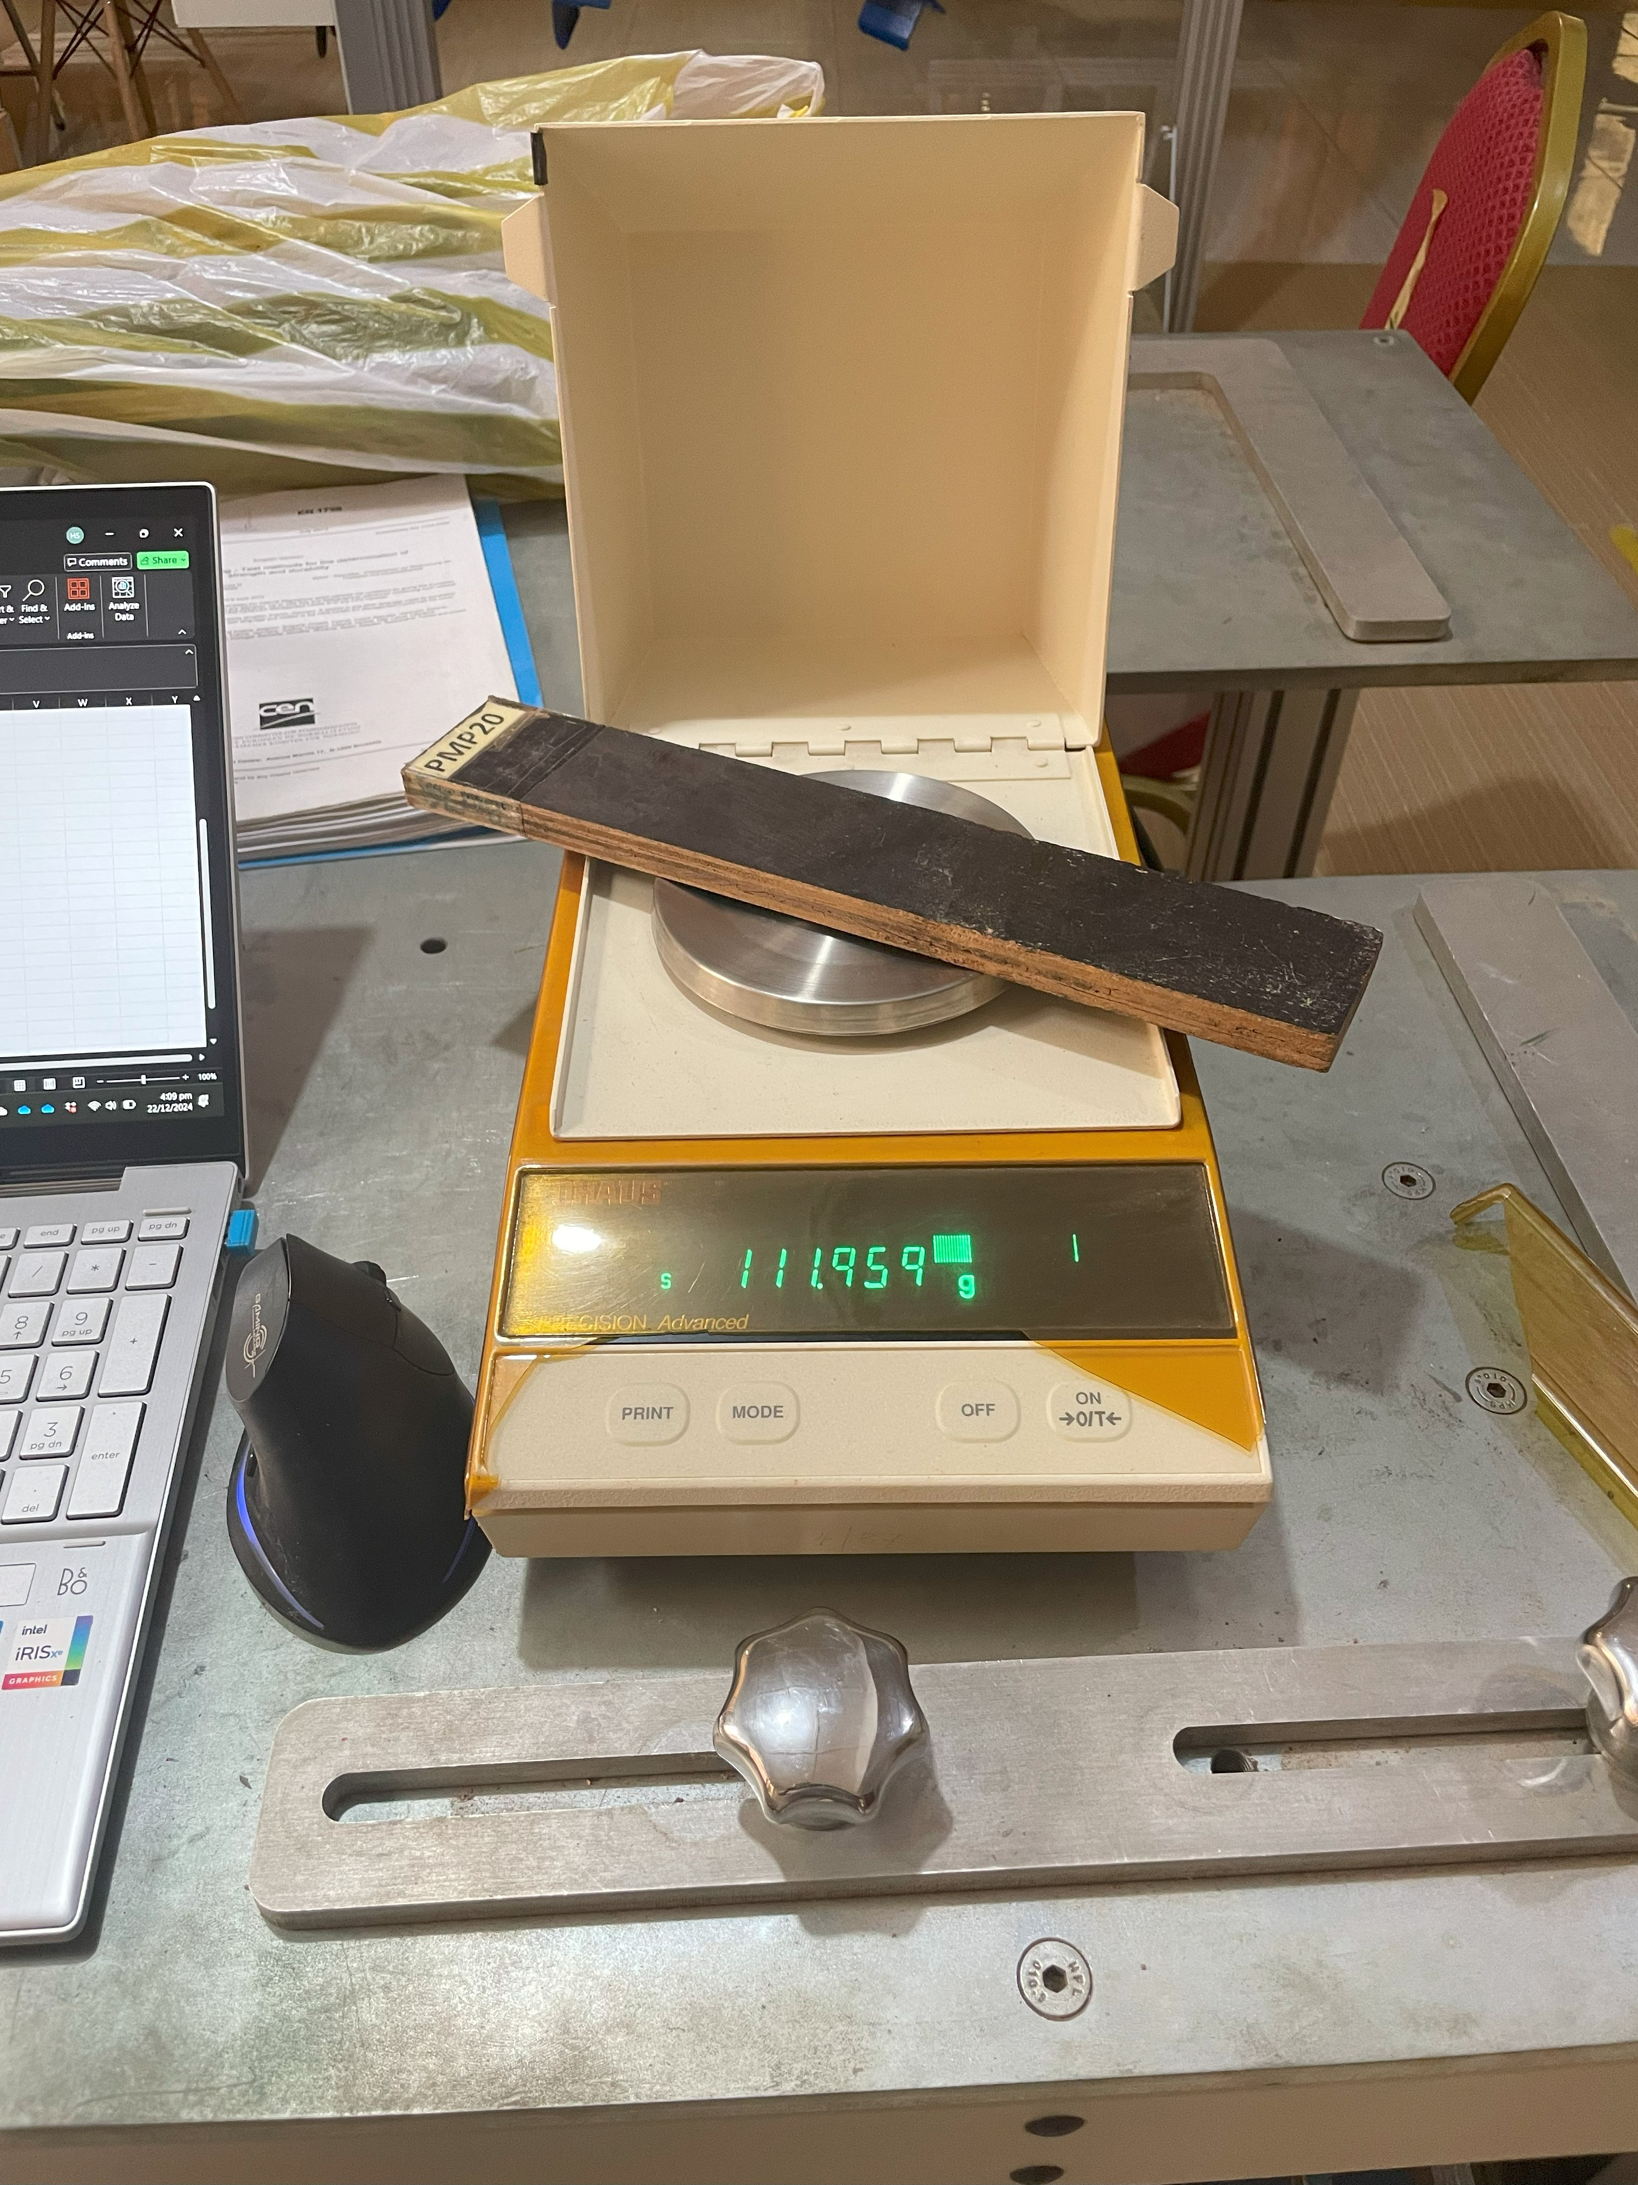

Figure 12: Labelled sample being weighed before drying (Ohaus weighing Scale).

6.2.1.3 Land Preparation and Staking
A portion of land with an area of (20 x 12) ft was prepared by removing all the weeds and dug holes of 15 cm deep. Staking intervals of 30 cm within rows and 60 cm between rows were used as shown in Figure 13. The measurements were carried out with a tape measure (grinder)

Figure 13: Installation of Birch and Eucalyptus Plywood stakes (samples)

6.2.1.4 Experimental Control Measures Adopted
The following quality control measures were adopted to ensure the integrity of the experiment.
- Free waters were removed from the samples before and after staking to ensure accurate determination of mass loss. All samples were placed in an oven before and after staking at 104°C for 72 hours, as shown in Figure 16.
- Adhering soil particles were carefully removed from the samples using a soft brush, ensuring that no wood material was dislodged in the process.
- The samples were returned to the oven to evaporate any residual moisture from the soil. Subsequently, brush off any remaining soil particles.
- An air blower was used to remove all residual soil particles from the samples, ensuring their surfaces were clean for further analysis.

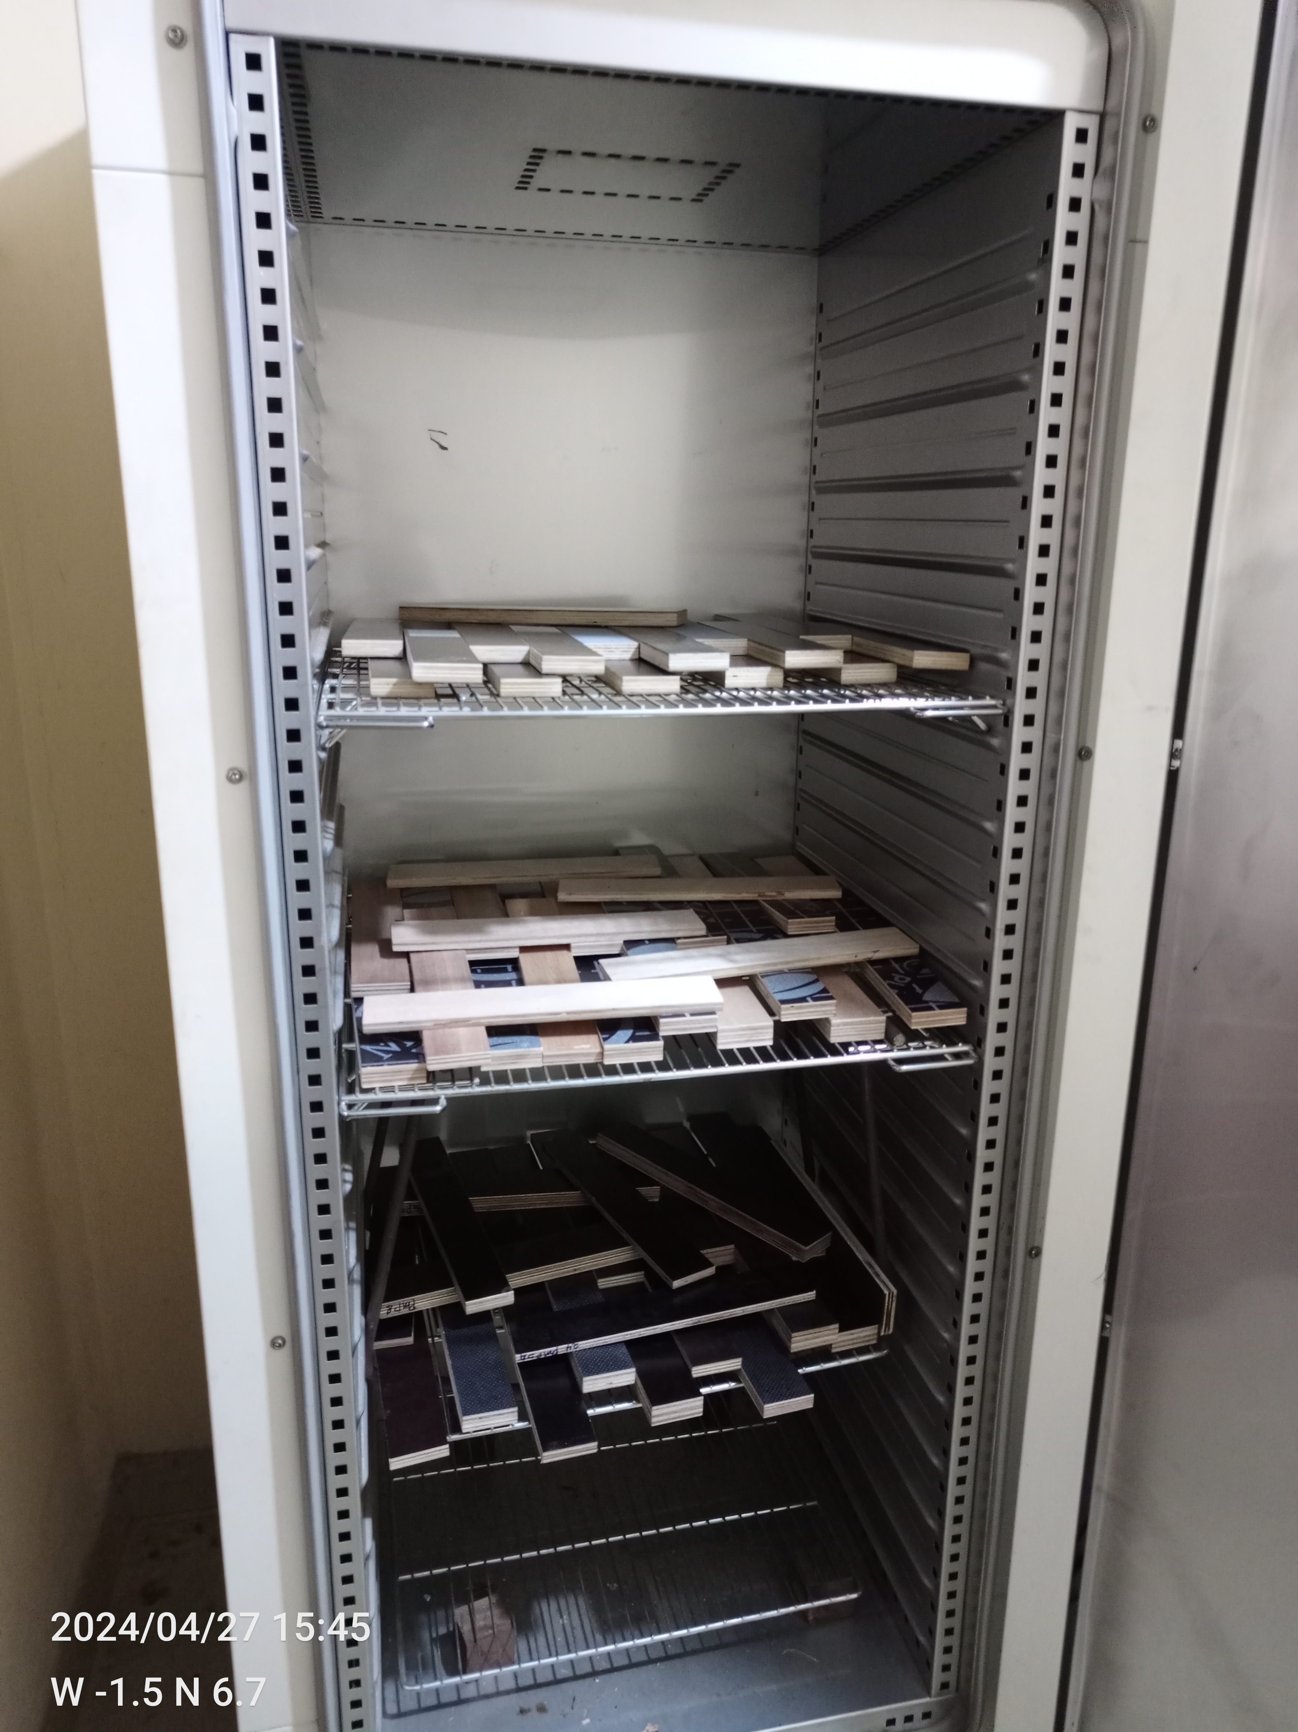

Figure 14: Samples being dried in Venticell oven at 104ºC

6.2.1.5 Examination and Inspection Criteria
Tab 10 Classification of Durability of Wood and Wood-based materials to termite attack based EN 117 ratings.
Durability class | Description | Rating
DC DC M DC S | Durable Moderately durable Not Durable | ≥ 90% “0 or 1” and max 10% “2”  < 50% “3, 4”  ≥ 50% “3, 4”
a90% of the test samples rated 0 or 1 and a maximum of 10% of the test samples rated 2 and 0 % “3 and 4”

Tab. 11 Rating system for the assessment of attack by termites on test stakes BS EN 252-2
Rating | Classification | Definition of condition
0 | No attack | No sign of attack
1 | Slight attack | Perceptibility, but slight attack, taking the form of a very superficial deterioration of approximately 1 mm to 2 mm deep, at some points or over small areas.
2 | Moderate attack | Moderate attack shown by deteriorated areas covering several cm2 and 2 mm to 5 mm deep, or by scattered points down to a depth exceeding 5 mm, or by different combinations of the two types of attack.
3 | Severe attack | Severe attack, showing extended and deep destruction of approximately 5 mm to 10 mm or tunnels reaching to the centre of the stake, or by different combinations of the two types of severe attack.
4 | Failure | Extreme attack, overall generalized penetration involving a total or almost total destruction of the state.

According to BS 252-2 and EN 350, test results are valid when at least 75% of the control samples are rated 4 as prescribed in the tab. 3

6.2.2 Fungi

6.2.2.1 Materials
The materials used include birch plywood, eucalyptus plywood, and beech wood, used as control samples. Both the birch (BP) and eucalyptus plywood bonded by MUF (MMP) and PF (PMP) adhesives were categorized as indicated in the Table 12.
Table 12: Plywood types and control samples used in the fungal exposure experiment.
Plywood | ID Prefix | Adhesive | Quantity
Birch plywood | BP | PF | 24
MIRO Plywood | MMP | MUF | 12
MIRO Plywood | PMP | PF | 12
Beech (control) | B | - | 12
BP-Birch plywood, MMP-Melamine MIRO Plywood, and PMP – Phenol -formaldehyde MIRO Plywood

6.2.2.2 Sample Preparation and Conditioning
The samples were prepared to a dimension of (50 x 50) mm, including the beech size control samples, with thicknesses of the tested plywood (12 and 15 mm). Another set of control samples was applied with the dimensions of 15×25×50 mm. The samples were then conditioned in a climate-controlled chamber till they stabilized in mass and a moisture content of 12%. Selected samples were used to determine the initial oven-dry weight of the samples, using a gravimetric method.

6.2.2.3 Growth Medium Preparation and Inoculation
The medium used for this experiment was 20 g of malt extract, 20 g of agar, and 1 litre of distilled water. The mixture was heated until the agar was completely dissolved, then allowed to cool to about 45 °C as shown in Figure 15 A . Quantities of 90 ml of the mixture were poured into the Kolle flask and tightly sealed with cotton gauze and were placed in the autoclave for 20 minutes at 121 °C to ensure its sterilization. The sterilized Kolle flasks were placed flat to allow solidification at room temperature. Once the medium was solidified, they were inoculated with the fungal mycelium (Coriolus versicolor) evenly across the surface of the medium. The inoculated Kolle flasks were placed in an incubator as shown in Figure 15 B, with a temperature of 22 °C and high humidity (75%) to support the growth of the fungi.

A
B
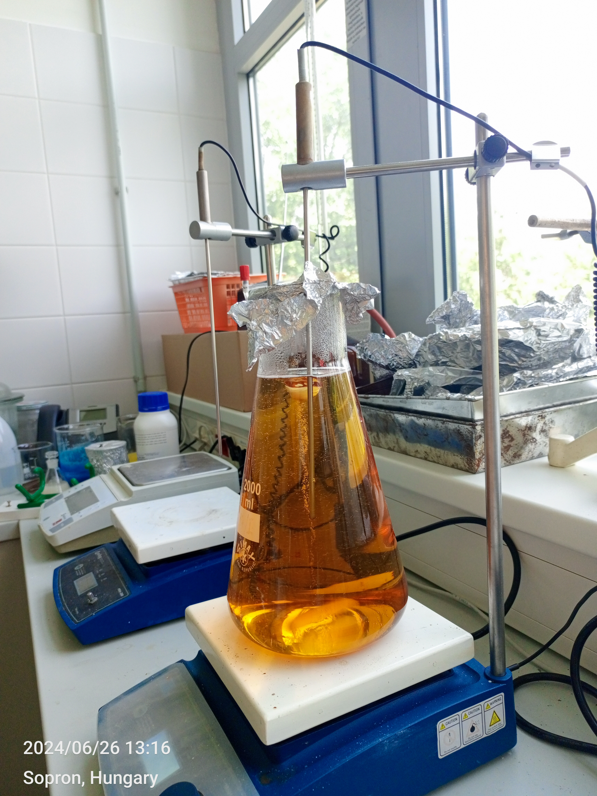
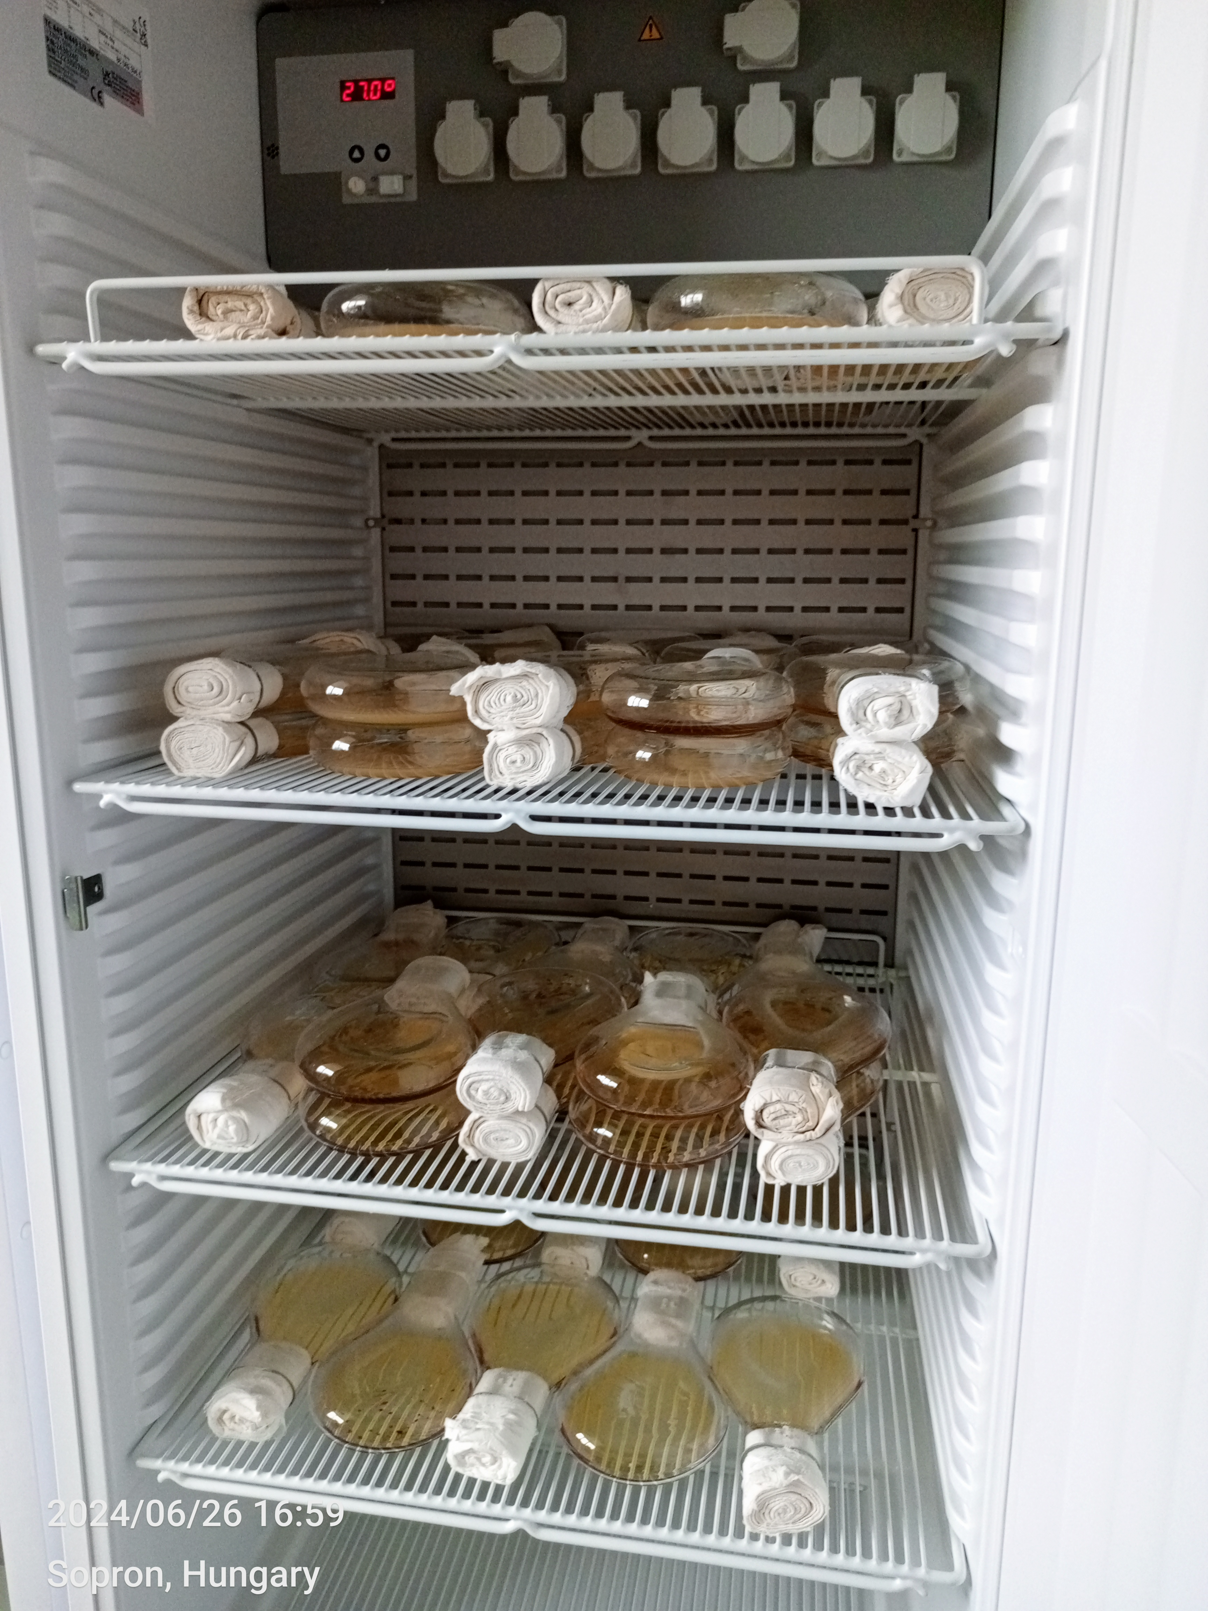

Figure 15 Preparation of the growth medium shown in ‘A’ and the inoculated growth medium in an incubator shown in ‘B’.

6.2.2.4 Sample placement and testing.
After the fungal growth, the plywood and control samples were placed in the collar flat and were left in the incubator for 16 weeks. The samples were carefully monitored to ensure the condition of the incubator remained intact for effective growth around the test specimen.

6.2.2.5 Examination and Inspection Criteria
Table 13 shows the criteria for determining the durability class (DC) based on CEN/TS 15083-1. The table ranges the durability class from DC1 through to DC-5 with DC 1 indicating high durability against the fungi and DC 5 indicating non-durability.

Table 13 Durability Class of wood and wood-based material to fungi.
Durability class (DC) | Description | Percentage Mass Loss (ML)
DC 1 | Very Durable | ML ≤ 5
DC 2 | Durable | 5 < ML ≤ 10
DC 3 | Moderately durable | 10 < ML ≤ 15
DC 4 | Slightly durable | 15 < ML ≤ 30
DC 5 | Not durable | ML > 30
ML = highest of median mass loss (in %) determined for test specimens exposed to each of the used test fungi.

6.3 Results and Discussion

6.3.1Termite Test
The termite resistance of birch plywood was evaluated following the EN 350: 2016 and BS 252-2 standard, which assesses the susceptibility of wood or wood-based materials to attack by subterranean termites. According to standards, material performance is primarily judged by percentage mass loss, with values indicating better resistance. Generally, the classifications Durability Class 1 (Durable) and Class 2 (Moderately Durable) are further rated according to Table 9, that is, 0-4, implying no attack to failure.

6.3.1.1 Birch Plywood
The average mass loss recorded in Table 14, for the birch plywood in this study was 40.59%, which categorizes it as not durable, meaning a complete failure to the termite test. This means that largely the samples were extremely attacked, overall generalized penetration involving a total or almost destruction of the sample. The results mean that the plywood it is not resistant under EN 350 and BS 252-2. Analyzing the data, it was found that the highest recorded mass loss was 86.77%, which is an indication that plywood can break down very quickly when it is exposed to termites' attack. The minimum recorded loss of 8.06% shows that no sample was completely safe from termites. The high standard deviation of 24.21% for percentage mass loss means that the samples are very different from each other. This could be because the density of the veneer, how deep the adhesive penetrates, or how termites feed in certain areas are all different.

Table 14: Summarised termite test results for Birch Plywood
Plywood Type | Oven D.W (g) | Grave Y.W (g) | M. Loss (g) | M. Loss (%)
Mean | 161.04 | 95.72 | 65.32 | 40.59
St. Deviation | 12.07 | 39.21 | 38.64 | 24.21
Maximum | 187.87 | 158.95 | 134.62 | 86.77
Minimum | 144.75 | 20.52 | 11.66 | 8.06
Count | 22 | 22 | 22 | 22

This inconsistency shows that the tested specimens may not be 100% birch veneers and that there could be different species that are either resisting termites or influencing the deterioration. From a practical point of view, untreated birch plywood does not meet the BS 252-2and EN 350 standards for termite resistance. Based on its performance as shown in Figure 16, it is clear that structural uses in areas where termites are common would need extra protection since it is not naturally durable, like being treated with biocidal preservatives, using termite-resistant resins, or being treated by thermal or chemical treatments. The results also show that birch plywood is valued for its strength and smooth surface(T. Wang et al., 2022) but it is not very durable against termites, according to this study. It would be in the lowest durability class against termites according to the standards. This shows how important it is to use preservation methods before using them in places that are likely to be damaged.
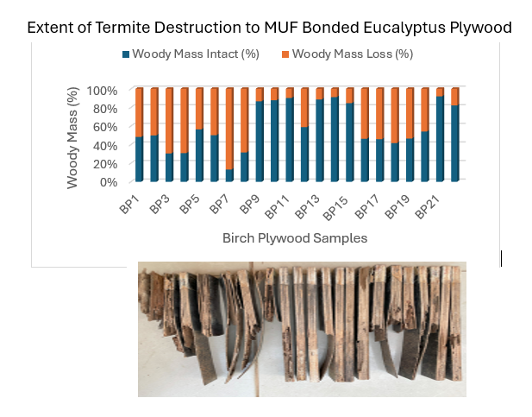

Figure 16 Graph and Image of the Birch plywood samples after 7 months of exposure to termites

6.3.1.1 Eucalyptus PF Bonded Plywood
Table 13. shows the results of the termite exposure test conducted on eucalyptus plywood bonded with PF adhesive. The results were evaluated using BS 252-2 and EN 350 standards as indicated in Tables 8 and 9. The plywood samples recorded an average oven-dry weight of 154.40 g and a mean graveyard weight of 141.15 g. This means that overall, the PF eucalyptus lost 13.25 g, or 9.44%, of its weight as an average across the 25 samples employed in this study. According to the durability classification system, the eucalyptus PF bonded plywood can be classified in the Durability Classification 1 (Durable) which means perceptibility, but slight attack, taking the form of a very superficial deterioration of approximately 1 mm to 2 mm deep, at some points or over small areas as can be seen in Figure 16.

Table 15 Summarised Termite Results for Eucalyptus PF Bonded Plywood
Plywood Type | Oven D.W (g) | Grave Y.W (g) | M. Loss (g) | M. Loss (%)
Mean | 154.40 | 141.15 | 13.25 | 9.44
St. Deviation | 44.51 | 45.43 | 6.53 | 6.47
Maximum | 226.85 | 212.38 | 34.99 | 32.76
Minimum | 105.02 | 71.83 | 6.84 | 3.12
Count | 25 | 25 | 25 | 25

The standard deviation of 6.47% shows that the 25 specimens did not all perform the same way. This kind of inconsistency could be due to differences in the density of the veneer, how deep the adhesive goes, or how termites feed in certain areas in the field. The average durability rating suggests that the plywood can be considered resistant to termite attack under controlled conditions. However, the wide range of performance shows that there are possible risks when using it in the field, especially in areas where termites are common. Though this type of plywood got a "Durable" rating overall, it would be beneficial to add extra protective treatments like preservative impregnation or resin modification to make it more consistent and ensure it works well over time(Smith & Wu, 2005), bearing in mind the veneers were produced from juvenile eucalyptus. The results are graphically presented in Figure 17.
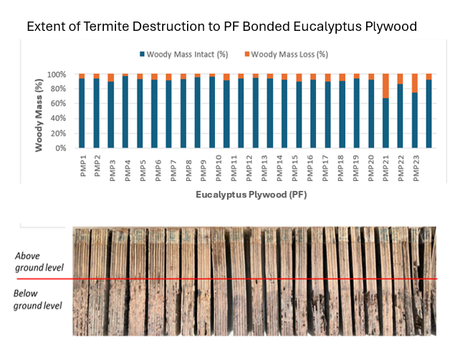
Figure 17 Graph & Image of Eucalyptus PF-bonded Plywood samples after 7 months of exposure to termites.

6.3.1.2 Eucalyptus MUF Bonded Plywood
The summarised results for the termite resistance test for eucalyptus MUF bonded plywood is presented in Table 16, showing an average oven-dry weight of 153.31 g and a mean graveyard (tested) weight of 132.82 g. This means that the average mass loss was 20.50 g, translating to 14.03%. This places the MUF-bonded Eucalyptus plywood in Durability Class 3 (Moderately Durable) according to the EN 350 and BS 252-2 durability classification. This means that it is moderately resistant to termite attacks, that is, there was moderate attack shown by deteriorated areas covering several cm2 and 2 mm to 5 mm deep, or by scattered points down to a depth exceeding 5 mm, or by different combinations of the two. Analysing the data, it is clear that all 25 samples subjected to the termite test were not exposed to an equal level of attack. The mass losses range from 5.63% to 41.23%, and the standard deviation of 6.87% shows the performance variation. It was interesting to note that almost all the samples were attacked below the ground, meaning the portion of the samples buried was attacked, as indicated with a red line in Figure 18. This means using plywood on structural designs above the ground may not be directly attacked by termites.

Table 16: Summarised Termite Results for Eucalyptus MUF Bonded Plywood
Plywood Type | Oven D.W (g) | Grave Y.W (g) | M. Loss (g) | M. Loss (%)
Mean | 153.31 | 132.82 | 20.50 | 14.03
St. Deviation | 40.52 | 39.85 | 8.85 | 6.87
Maximum | 216.52 | 195.22 | 49.57 | 41.23
Minimum | 92.04 | 70.65 | 9.62 | 5.63
Count | 25 | 25 | 25 | 25

However, the fact that some samples are very degraded shows that the plywood's resistance is not always the same, which could be attributed to differences in veneer quality, resin distribution, or the termite movement in the test field. Despite the plywood being classified as moderately durable, it must be used with caution and some level of treatment since its natural durability might not be enough for full protection from termite attack. In ensuring the plywood lasts longer and lowers the risk of severe termite damage in the field, it is best to use preservatives, modify the resin, or add surface coatings.

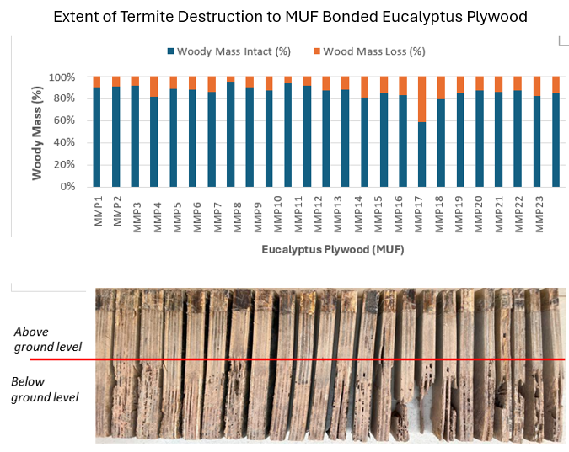
Figure 18: Graph and Image of Eucalyptus MUF-bonded plywood after 7 months of exposure to termites

6.3.1.3 Triplochiton scleroxylon (Wawa) – Control group
In conducting a biological durability test, it is always important to have a control group that will validate the test results of the experimental group. In this study, the control sample was reduced to 10 samples to reduce the crowding of termites on the susceptible control samples. The results are summarised in Table 17, showing an average oven-dry weight of 49.14 g and a post-exposure graveyard weight of just 13.97 g; the control sample lost an average of 35.17 g of mass, or 71.50% of its initial dry weight.

Table 17: Summarised Termite results for Triplochiton scleroxylon (Wawa), the control group.
Plywood Type | Oven D.W (g) | Grave Y.W (g) | M. Loss (g) | M. Loss (%)
Mean | 49.14 | 13.97 | 35.17 | 71.50
St. Deviation | 3.54 | 3.33 | 4.63 | 6.93
Maximum | 54.00 | 17.96 | 44.28 | 82.00
Minimum | 43.80 | 8.76 | 27.90 | 62.00
Count | 49.14 | 13.97 | 35.17 | 71.50

The results, therefore, place the control in Durability rating 4, Class 5 which indicates complete failure, meaning extreme attack, overall generalized penetration involving a total or almost destruction of the sample durability classification, indicating extreme susceptibility to termite attack. The level of destruction shows a strong presence of termites at the testing site, as indicated by the narrow standard deviations of 4.63 g of mass loss, which is consistent with attacks on all samples. While the most heavily attacked sample suffered an 82% loss, indicating total vulnerability, even the best-performing sample (62% loss) was still well within the non-durable range. The level of degradation is shown graphically in Figure 19.

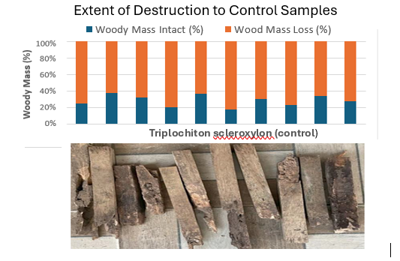
Figure 19: Graph and Image of the control samples after 7 months of exposure to termites

6. 3.2 Fungal Test Results
Table 18 presents the mean results of the fungal inoculation test conducted on birch and two eucalyptus pellita plywood bonded by both the PF and MUF adhesives. The durability evaluation of the samples demonstrated significant disparities in fungus resistance, especially when compared to the control group (beech). Birch plywood had an average mass loss of 2.70%, categorising it as very durable (DC 1), according to CEN/TS 15083-1. This aligns with the findings of (Grinins et al., 2021), which demonstrates that durability evaluation of the examined plywood varieties showed significant differences in fungus resistance, especially compared to the beech control. The notable resistance is likely due to the wood's structure and the protective role of the PF adhesive used for bonding the veneers. Eucalyptus pellita plywood, when bonded with PF or MUF adhesives, showed mean mass losses of 2.55% and 3.12%, respectively, both categorised as Very Durable (DC 1).

Table 18: Summary Results of Fungal (Coriolus versicolor) exposure test of Birch and Eucalyptus plywood
Material | n | Mean m_{u} (g) | Mean  M₀ (g) | Mean  ML (%) | SD (%ML) | Classification (CEN/TS 15083-1)
Experimental group (plywood)
Birch | 24 | 21.99 | 21.42 | 2.70 | 1.27 | DC1 - V. Durable
Eucalyptus PF | 12 | 27.29 | 26.60 | 2.55 | 1.10 | DC1 - V. Durable
Eucalyptus MUF | 12 | 21.53 | 20.86 | 3.12 | 0.81 | DC1 - V. Durable
Control group (wood)
Beech | 12 | 21.69 | 13.99 | 35.69 | 3.89 | DC5 – Not Durable
n- number of replicates, m_{u}- Initial dry mass, m₀- final dry mass, ML-mass loss

PF-bonded eucalyptus plywood performed slightly better than the eucalyptus plywood bonded by MUF adhesive and the birch plywood bonded by PF, indicating the superior moisture resistance and long-term stability of phenol–formaldehyde compared to MUF, as reported by (Karthäuser et al.,2024). However, in this study, the natural resistance of the eucalyptus species to fungi might have been stronger than that of the birch; that is why it performed better than that. The control group, which consisted of beech plywood, suffered significant damage from fungal exposure, with an average mass loss of 35.69%. This score places it in the Not Durable (DC 5) category, consistent with beech's known poor natural decay resistance (Szczepkowski, 2010). The high standard deviation for beech (3.89%) indicates variability in fungal attack among samples, a pattern observed in earlier studies of untreated hardwoods (U. Müller et al., 2004). However, the low variation among the other plywood types highlights their reliable resistance to fungal decay. Using beech wood as the control emphasises the difference; although untreated beech deteriorated quickly, birch and Eucalyptus pellita plywood maintained their integrity, demonstrating the benefits of species selection and adhesive type. The results confirm that PF- and MUF-bonded Eucalyptus pellita and birch plywood are highly suitable for outdoor or humid environments where fungal exposure is a concern. PF-bonded birch plywood had markedly reduced mass loss and enhanced decay resistance.

6.4 Conclusion
The results show that the tested plywood's durability varied a lot depending on the type of wood and the type of adhesive used. Birch plywood was not very resistant to termite attacks, losing an average of 40.59% of its mass. This put it in the lowest durability class under EN 350 and BS 252-2 and showed that it is not safe to use in areas where termites are likely to be present without protective treatment. Eucalyptus plywood bonded with PF adhesive, on the other hand, was highly resistant to termites, losing only 9.44% of its mass and being rated as "Durable." Eucalyptus plywood bonded with MUF adhesive, on the other hand, showed moderate resistance (14.03% loss), putting it in the "Moderately Durable" class. The control group (Wawa) showed that they were very susceptible by losing 71.50% of their data, which confirmed the testing conditions. Fungal resistance tests showed a different pattern. Birch and eucalyptus plywood bonded with either PF or MUF adhesives all did very well, with very low mass losses (<3.5%) and the highest durability classification (DC 1 – Very Durable). On the other hand, as expected, the beech control deteriorated severely (35.69% loss, DC 5 – Not Durable).

6.5 Acknowledgment
The research team is grateful to MIRO Timber Products Ltd. For providing the samples and also making their laboratory available for the experiment. Dr. Bak Mikos for assisting with the fungal test, and the CSIR-Forestry Research Institute of Ghana for making their termite test site available.

Chapter 7. Research Summary
The feasibility of hybrid Eucalyptus pellita plywood as a sustainable alternative to European birch plywood was the focus of this thesis. This research idea was conceived in response to the shortage of Birch plywood in the EU market, resulting from the sanctions imposed on Russian imports and Ghana's dwindling and rapid forest depletion, which has affected traditional wood species used in plywood production. In Ghana, the private sector is becoming more interested in fast-growing eucalyptus as a new raw material for the production of plywood despite their despite their small diameter, there exist technologies that makes their use easy The research examines the modulus of elasticity, modulus of rupture, bonding quality, physical properties, and durability of eucalyptus plywood in relation to birch for the biological examinations, considering eucalyptus adaptability to the climate of Ghana. The results are anticipated to align with EU market requirements and Ghana's sustainable forestry objectives, while also enhancing global understanding of tropical plywood production. The study also recognises constraints concerning species diversity and adhesive accessibility.
The mechanical properties of Eucalyptus pellita plywood produced in Ghana, emphasising the impact of panel thickness and adhesive types on strength. This objective examined the modulus of elasticity (MOE) and modulus of rupture (MOR) of plywood samples measuring five different thicknesses, that is, 9, 11, 15, 18, and 21 mm, bonded with either phenol-formaldehyde (PF) or melamine urea-formaldehyde (MUF), in both longitudinal and transverse orientations. The results showed that the thicker the panel, the weaker it was mechanically. Thinner panels had higher MOE and MOR values. PF-bonded eucalyptus plywood was found to have better properties than MUF-bonded eucalyptus plywood, especially when considered longitudinally. This was because it had a stronger bond and was better at withstanding heat and moisture. The statistical analysis showed that most thicknesses exhibited significant anisotropy, but this effect weakened in thicker panels because stress was spread across several veneer layers. This behaviour was particularly seen when the transverse and longitudinal orientations were compared, and the difference minimizes as the panel thickness increases, clearly obeying the principle of 'levelling effect'. MUF-bonded panels were more sensitive to orientation effects, which means they may not be suitable for structural applications that require high strength. Overall, the results show that eucalyptus plywood could be a more environmentally friendly option than traditional hardwood plywood. Thinner PF-bonded panels are ideal for structural and industrial applications that require high strength-to-weight performance.
The physical property performance of plywood made from juvenile Eucalyptus pellita in Ghana was studied, focusing on density and dimensional stability (thickness swelling). Samples with varying panel thicknesses (9–21 mm) were bonded using phenol-formaldehyde (PF) and melamine-urea-formaldehyde (MUF) adhesives and tested in accordance with European standards. Results indicated that density decreased as thickness increased. In contrast, PF-bonded panels consistently showed higher densities and less swelling compared to MUF-bonded panels, confirming their better dimensional stability and durability. Statistical analyses (ANOVA and regression) demonstrated that thickness and density significantly influence swelling, with adhesive type strongly mediating these effects. PF enhanced resistance to moisture-related deformation, whereas MUF demonstrated greater variability and higher swelling, especially in thinner panels. The findings suggest that Eucalyptus pellita plywood can serve as a sustainable alternative to traditional hardwood plywood, provided that moisture management, adhesive selection, and processing conditions are carefully optimized to meet international performance standards.
Bonding strength and wood failure performance of juvenile Eucalyptus pellita plywood in Ghana, using Phenol Formaldehyde (PF) and Melamine Urea Formaldehyde (MUF) adhesives across various panel thicknesses (9–21 mm). The results indicate that PF consistently outperformed MUF, forming stronger and more reliable bonds with higher wood failure rates (78–83%) and less variation. This suggests that PF is suitable for structural and outdoor use. MUF exhibited moderate bonding strength but was more sensitive to changes in thickness and had significantly lower wood failure rates (53–72%). This indicates that the adhesive–wood interactions were weaker and less durable, making MUF more appropriate for indoor or decorative applications. The study found that thickness impacts bond quality, with panels thicker than 15 mm generally showing weaker bonds because there is a non-uniform pressure distribution during pressing; while the outer layers receive adequate pressure, the inner layers often experience insufficient compression, leading to weaker bonds. Correlation analyses revealed very weak relationship. Overall, PF remains the top choice for high-performance plywood. MUF, in contrast, could be a cost-effective option for non-structural uses if its limitations are managed through optimal pressing conditions and adhesive formulations.
This study evaluated the biological durability of juvenile Eucalyptus pellita plywood compared to birch and control wood samples by examining their resistance to termite and fungal attacks following standardized European protocols. The results showed significant differences depending on the type of adhesive and species. Birch plywood was very susceptible to termites, losing an average of 40.59% of its mass, and was rated as "Not Durable." Eucalyptus plywood bonded with phenol-formaldehyde (PF) performed much better, losing only 9.44% of its mass and earning a "Durable" rating. Eucalyptus plywood bonded with melamine-urea-formaldehyde (MUF) did less well, losing 14.03% of its mass and receiving a "Moderately Durable" rating. The control (Wawa) exhibited a very weak response, with a 71.5% mass loss. In fungal resistance tests, both birch and eucalyptus plywood (PF and MUF bonded) exhibited high resistance, with less than 3.5% mass loss, placing them in the "Very Durable" category. The beech control, however, lost 35.69% of its mass, classifying it as "Not Durable." Overall, findings indicate that eucalyptus plywood, especially PF-bonded panels, is a durable and eco-friendly choice for construction and furniture in termite- and fungus-prone areas. These results also highlight the crucial role of adhesive type in enhancing longevity.

Novel Finding

Thesis 1. Mechanical Properties
A significant new finding of this study is the identification of an inverse correlation between panel thickness and mechanical strength (MOE and MOR) in juvenile Eucalyptus pellita plywood. Thinner panels consistently outperformed thicker ones, particularly in PF-bonded plywood, which exhibited enhanced stiffness and strength. This demonstrates the importance of veneer layering and adhesive penetration for performance, a relationship that hasn't been well-documented before for tropical plywood. The research additionally indicated that anisotropy effects were more pronounced in thinner panels and diminished as thickness increased, owing to a more uniform distribution of stress across multiple layers. These insights highlight the potential of thinner eucalyptus panels as viable substitutes for birch plywood, which has gained popularity due to its strength in structural applications that require high strength-to-weight ratios.

Thesis 2. Physical Properties
The study first revealed the important role of adhesive type in affecting the physical properties of juvenile Eucalyptus pellita plywood. PF-bonded panels consistently showed higher densities and less thickness swelling than MUF-bonded panels, demonstrating better resistance to moisture-induced deformation. This adhesive effect became especially important as thickness increased, with PF maintaining dimensional stability while MUF-bonded plywood showed greater variability. The research also confirmed that swelling depends not only on veneer quality or panel thickness but also on adhesive penetration and bonding properties. These findings provide a practical basis for selecting adhesives to improve durability in humid or outdoor environments.

Thesis 3. Bonding Quality
The bonding quality results demonstrated that PF-bonded eucalyptus plywood achieved substantially higher wood failure percentages (78–83%) compared to MUF-bonded panels (53–72%), indicating stronger adhesive–wood interactions. A notable outcome of this study is the observed decline in bond quality with increasing panel thickness. This reduction is likely due to non-uniform pressure distribution during pressing; while the outer layers receive adequate pressure, the inner layers often experience insufficient compression, leading to weaker bonds. Although thin PF-bonded panels promoted desirable wood failure, this relationship diminished as thickness increased, suggesting a trade-off between panel size and bonding performance. Such adhesive–thickness interactions have rarely been examined in tropical plywood. Overall, the findings underscore PF as the preferred adhesive for structural and industrial-grade panels, whereas MUF appears more suitable for non-structural or decorative applications.

Thesis 4. Biological Durability
This research provided the first comparative assessment of termite and fungal resistance between juvenile Eucalyptus pellita plywood and birch plywood. Novel insights emerged, showing that untreated birch plywood, despite its mechanical reputation, was highly vulnerable to termites (40.59% mass loss, “Not Durable”). In contrast, PF-bonded eucalyptus plywood proved resistant (9.44% mass loss, “Durable”), and MUF-bonded eucalyptus achieved only moderate resistance (14.03% mass loss, “Moderately Durable”). Interestingly, adhesive type strongly influenced termite resistance (PF > MUF) but had little effect on fungal durability, where both eucalyptus and birch plywoods showed very low mass losses (<3.5%) and were classified as “Very Durable.” This dual evaluation demonstrates the potential of eucalyptus plywood, particularly PF-bonded, as a sustainable alternative to birch in regions prone to termite and fungal infestations, while also highlighting the crucial role of adhesive technology in determining biological durability.

Reference
A Critical Revision of the Genus Eucalyptus. (1905). Nature, 72(1853). https://doi.org/10.1038/072006c0
Abbasi, S., Peerzada, M. H., Nizamuddin, S., & Mubarak, N. M. (2020). Functionalized nanomaterials for the aerospace, vehicle, and sports industries. In Handbook of Functionalized Nanomaterials for Industrial Applications. https://doi.org/10.1016/B978-0-12-816787-8.00025-9
Akkurt, T., Kallakas, H., Rohumaa, A., Hunt, C. G., & Kers, J. (2022). Impact of Aspen and Black Alder Substitution in Birch Plywood. Forests, 13(2), 142. https://doi.org/10.3390/f13020142
Alam, N., Islam, N., Rahman, K.-S., & Alam, M. R. (2012). Comparative Study on Physical and Mechanical Properties of Plywood Produced from Eucalyptus (Eucalyptus camaldulensis Dehn.) and Simul (Bombax ceiba L.) Veneers. In Research Journal of Recent Sciences (Vol. 1, Issue 9).
Alfenas, A. C., Hubbes, M., & Couto, L. (1982). Effect of phenolic compounds from Eucalyptus on the mycelial growth and conidial germination of Cryphonectria cubensis . Canadian Journal of Botany, 60(12). https://doi.org/10.1139/b82-307
Ambrose, G. J., Callen, R. A., Flint, R. B., & Lange, R. T. (1979). Eucalyptus fruits in stratigraphic context in Australia [8]. In Nature (Vol. 280, Issue 5721). https://doi.org/10.1038/280387a0
Amorim, E. P., Menucelli, J. R., Santos, C. H., Freitas, M. L. M., Pissarra, T. C. T., Silva, M. E. C. M. da, Zanata, M., & Longui, E. L. (2021). WOOD EVALUATION OF Eucalyptus pellita F.Muell. AND Eucalyptus tereticornis Smith AS POTENTIAL FOR PULP AND PAPER PRODUCTION. Revista Do Instituto Florestal, 33(2), 139–149. https://doi.org/10.24278/2178-5031.202133202
Anderson, R. C., & Hansen, E. N. (2004). Determining consumer preferences for ecolabeled forest products: An experimental approach. Journal of Forestry, 102(4). https://doi.org/10.1093/jof/102.4.28
Aro, M. D., Brashaw, B. K., & Donahue, P. K. (2014). Mechanical and physical properties of thermally modified plywood and oriented strand board panels. In Forest Products Journal (Vol. 64, Issues 7–8). https://doi.org/10.13073/FPJ-D-14-00037
Ashori, A., Heydari, V., & Ayrilmiş, N. (2023). Preparation and characterization of plywood panels using recycled HDPE as a formaldehyde-free adhesive: A comparative study. Journal of Wood Chemistry and Technology, 43(5). https://doi.org/10.1080/02773813.2023.2251463
Attuaquayefio, D., & Folib, J. (2009). An overview of biodiversity conservation in Ghana: Challenges and prospects. West African Journal of Applied Ecology, 7(1). https://doi.org/10.4314/wajae.v7i1.45621
Auer, L., Lazuka, A., Sillam-Dussès, D., Miambi, E., O’Donohue, M., & Hernandez-Raquet, G. (2017). Uncovering the potential of termite gut microbiome for lignocellulose bioconversion in anaerobic batch bioreactors. Frontiers in Microbiology, 8(DEC). https://doi.org/10.3389/fmicb.2017.02623
Aydin, I., & Colakoglu, G. (2005). Formaldehyde emission, surface roughness, and some
properties of plywood as function of veneer drying temperature. Drying Technology, 23(5). https://doi.org/10.1081/DRT-200059142
Ayrilmis, N., & Winandy, J. E. (2009). Effects of post heat-treatment on surface characteristics and adhesive bonding performance of medium density fiberboard. Materials and Manufacturing Processes, 24(5). https://doi.org/10.1080/10426910902748032
Bal, B. C., & Bektaş, ibrahim. (2014a). Some mechanical properties of plywood produced from eucalyptus, beech, and poplar veneer. Maderas: Ciencia y Tecnologia, 16(1). https://doi.org/10.4067/S0718-221X2014005000009
Bal, B. C., & Bektaş, ibrahim. (2014b). Some mechanical properties of plywood produced
from eucalyptus, beech, and poplar veneer. Maderas: Ciencia y Tecnologia, 16(1), 99–108. https://doi.org/10.4067/S0718-221X2014005000009
Barnes, D. (2002). A model of the effect of strand angle and grain angle on the strength properties of oriented veneer and strand wood composites. Forest Products Journal, 52(4).
Bekhta, P., Müller, M., & Hunko, I. (2020). Properties of Thermoplastic-Bonded Plywood: Effects of the Wood Species and Types of the Thermoplastic Films. Polymers, 12(11), 2582. https://doi.org/10.3390/polym12112582
Bekhta, P., Niemz, P., & Sedliacik, J. (2012). Effect of pre-pressing of veneer on the glueability and properties of veneer-based products. European Journal of Wood and Wood Products, 70(1–3). https://doi.org/10.1007/s00107-010-0486-y
Bekhta, P., Ortynska, G., & Sedliacik, J. (2014). Properties of modified phenol-formaldehyde adhesive for plywood panels manufactured from high moisture content veneer. Drvna Industrija, 65(4). https://doi.org/10.5552/drind.2014.1350
Bekhta, P., Salca, E. A., & Lunguleasa, A. (2020a). Some properties of plywood panels manufactured from combinations of thermally densified and non-densified veneers of different thicknesses in one structure. Journal of Building Engineering, 29, 101116. https://doi.org/10.1016/j.jobe.2019.101116
Bekhta, P., Salca, E. A., & Lunguleasa, A. (2020b). Some properties of plywood panels manufactured from combinations of thermally densified and non-densified veneers of different thicknesses in one structure. Journal of Building Engineering, 29. https://doi.org/10.1016/j.jobe.2019.101116
Bekhta, P., & Sedliacik, J. (2015). Effect of surface treatment on bondability of birch veneer with PF resin. International Wood Products Journal, 6(2). https://doi.org/10.1179/2042645314Y.0000000089
Bekhta, P., Sedliačik, J., & Bekhta, N. (2020). Effects of selected parameters on the bonding quality and temperature evolution inside plywood during pressing. Polymers, 12(5). https://doi.org/10.3390/POLYM12051035
Belleville, B., Redman, A., Chounlamounty, P., Phengthajam, V., Xiong, S., Boupha, L., & Ozarska, B. (2018). Potential of Veneer Peeled from Young Eucalypts in Laos. BioResources, 13(4). https://doi.org/10.15376/BIORES.13.4.7581-7594
Bennet, L. T., Weston, C. J., & Attiwill, P. M. (1997). Biomass, nutrient content and growth response to fertilisers of six-year-old Eucalyptus globulus plantations at three contrasting sites in Gippsland, Victoria. Australian Journal of Botany, 45(1). https://doi.org/10.1071/bt96057
Birinci, E. (2022). Determination of Physical and Mechanical Properties of Plywood Produced Using Beech, Okoume and Ozigo Species. Anadolu Orman Araştırmaları Dergisi, 8(2), 11–15. https://doi.org/10.53516/ajfr.1141172
Böhm, M., Kobetičová, K., Procházka, J., & Černý, R. (2019). Moisture sorption and thickness swelling of wood-based materials intended for structural use in humid conditions and bonded with melamine resin. IOP Conference Series: Materials Science and Engineering, 549(1). https://doi.org/10.1088/1757-899X/549/1/012042
Bomba, J., Šedivka, P., Böhm, M., & Devera, M. (2014). Influence of Moisture Content on the Bond Strength and Water Resistance of Bonded Wood Joints. BioResources, 9(3). https://doi.org/10.15376/biores.9.3.5208-5218
Bosu, P. P., Apetorgbor, M. M., Nkrumah, E. E., & Bandoh, K. P. (2013). The impact of Broussonetia papyrifera (L.) vent. on community characteristics in the forest and forest-savannah transition ecosystems of Ghana. African Journal of Ecology, 51(4). https://doi.org/10.1111/aje.12063
Bremer, L. L., & Farley, K. A. (2010). Does plantation forestry restore biodiversity or create green deserts? A synthesis of the effects of land-use transitions on plant species richness. Biodiversity and Conservation, 19(14). https://doi.org/10.1007/s10531-010-9936-4
Brischke, C., Bayerbach, R., & Otto Rapp, A. (2006). Decay-influencing factors: A basis for
service life prediction of wood and wood-based products. Wood Material Science and Engineering, 1(3–4). https://doi.org/10.1080/17480270601019658
Cabral, J. P., Kafle, B., Subhani, M., Reiner, J., & Ashraf, M. (2022). Densification of timber: a review on the process, material properties, and application. In Journal of Wood Science (Vol. 68, Issue 1). https://doi.org/10.1186/s10086-022-02028-3
Cahyono, T. D., Yanti, H., Massijaya, M. Y., Iswanto, A. H., & Uluputty, M. R. (2019). The durability of OSB composite plywood with avocado, mahogany, and pine wood veneers against drywood and subterranean termites. IOP Conference Series: Earth and Environmental Science, 260(1). https://doi.org/10.1088/1755-1315/260/1/012067
Cesprini, E., Resente, G., Causin, V., Urso, T., Cavalli, R., & Zanetti, M. (2020). Energy recovery of glued wood waste – A review. In Fuel (Vol. 262). https://doi.org/10.1016/j.fuel.2019.116520
Chandler, J. G., Brandon, R. L., & Frihart, C. R. (2005). Examination of adhesive penetration in modified wood using fluorescence microscopy. ASC Spring 2005 Convention and Exposition, April, c(January 2005).
Chapman, K. M. (2006). Wood-based panels: Particleboard, fibreboards and oriented strand board. In Primary Wood Processing: Principles and Practice (Vol. 9781402043932). https://doi.org/10.1007/1-4020-4393-7_12
Choo, A. C. Y., Md. Tahir, P., Karimi, A., Bakar, E. S., Abdan, K., Ibrahim, A., & Feng, L. Y. (2011). Density and humidity gradients in veneers of oil palm stems. European Journal of Wood and Wood Products, 69(3). https://doi.org/10.1007/s00107-010-0483-1
Chybiński, M., & Polus. (2021). Experimental and numerical investigations of laminated veneer lumber panels. Archives of Civil Engineering, 67(3). https://doi.org/10.24425/ace.2021.138060
Cihad Bal, B., & Bektaş, İ. (2014). SOME MECHANICAL PROPERTIES OF PLYWOOD PRODUCED FROM EUCALYPTUS, BEECH, AND POPLAR VENEER. Ciencia y Tecnología, 16(1), 99–108. https://doi.org/10.4067/S0718-221X2014005000009
Cīrule, D., Kuka, E., Verovkins, A., & Andersone, I. (2018). Restriction of Liquid Water Spreading in Overlaid Plywood Top Veneer. https://doi.org/10.22616/rrd.24.2018.013
Corpataux, L., Okuda, S., & Kua, H. W. (2020). Panel and plate properties of Cross-laminated timber (CLT) with tropical fast-growing timber species in compliance with Eurocode 5. Construction and Building Materials, 261. https://doi.org/10.1016/j.conbuildmat.2020.119672
Country Profile – Ghana – FLEGT IMM. (n.d.). Retrieved December 30, 2022, from https://flegtimm.eu/country-profiles/ghana/
Cremonini, C., Negro, F., & Zanuttini, R. (2015). Wood-based panels for land transport uses. Drewno , 58(195). https://doi.org/10.12841/wood.1644-3985.125.11
Crespo, J., Majano-Majano, A., Lara-Bocanegra, A. J., & Guaita, M. (2020). Mechanical properties of small clear specimens of eucalyptus globulus labill. Materials, 13(4). https://doi.org/10.3390/ma13040906
Dias, A. M., Machado, J. S., Dias, A. M. P. G., Silvestre, J. D., & de Brito, J. (2022). Influence of the Wood Species, Forest Management Practice and Allocation Method on the Environmental Impacts of Roundwood and Biomass. Forests, 13(9). https://doi.org/10.3390/f13091357
Dick, G., Eufrade-Junior, H. J., Schumacher, M. V., Azevedo, G. B., & Guerra, S. P. S. (2021). Eucalypt Clonal Hybrid Influences the Carbon Amount of Below-Ground Biomass in Oxisol, Brazil. https://doi.org/10.3390/iecf2020-07868
Dieste, A., Krause, A., Bollmus, S., & Militz, H. (2008). Physical and mechanical properties of plywood produced with 1.3-dimethylol-4.5-dihydroxyethyleneurea (DMDHEU)-modified veneers of Betula sp. and Fagus sylvatica. Holz Als Roh - Und Werkstoff, 66(4). https://doi.org/10.1007/s00107-008-0247-3
Donaldson, L. A. (2019). Wood cell wall ultrastructure the key to understanding wood properties and behaviour. IAWA Journal, 40(4). https://doi.org/10.1163/22941932-40190258
Dwi Sulichantini, E., Sutisna, M., Sukartiningsih, S., & Rusdiansyah, R. (2014). Clonal Propagation of Two Clones Eucalyptus Pellita F. Muell By Mini-Cutting. International Journal of Science and Engineering, 6(2). https://doi.org/10.12777/ijse.6.2.117-121
El Haouzali, H., Marchal, R., Bléron, L., Butaud, J. C., & Kifani-Sahban, F. (2020). Some properties of plywood produced from 10 cultivars of poplar. International Wood Products Journal, 11(2). https://doi.org/10.1080/20426445.2020.1735729
Elaieb, M. T., Ben Ayed, S., Dumarçay, S., De Freitas Homen De Faria, B., Thévenon, M. F., Gérardin, P., & Candelier, K. (2020). Natural durability of four Tunisian Eucalyptus spp. And their respective compositions in extractives. Holzforschung, 74(3). https://doi.org/10.1515/hf-2019-0090
Eštoková, A., Fabianová, M., & Radačovský, M. (2023). Life Cycle Assessment and Environmental Impacts of Building Materials: Evaluating Transport-Related Factors †. Engineering Proceedings, 57(1). https://doi.org/10.3390/engproc2023057005
Eucalyptus pellita. (n.d.).
Ewudzie, J., Gemadzie, J., & Adjarko, H. (2018). Exploring the Utilization of Lesser-Known Species for Furniture Production—A Case Study in the Western Region, Ghana. OALib, 05(11). https://doi.org/10.4236/oalib.1104916
Fadwati, A. D., Hidayati, F., & Na’iem, M. (2023). Evaluation of Genetic Parameters of Growth Characteristics and Basic Density of Eucalyptus pellita Clones Planted at Two Different Sites in East Kalimantan, Indonesia. Journal of the Korean Wood Science and Technology, 51(3). https://doi.org/10.5658/WOOD.2023.51.3.222
Falade, O. E., Belleville, B., Spokevicius, A., Ozarska, B., Bossinger, G., Dewi, L. M., Ibrahim, U., & Thumma, B. (2025). SNP-Based Genetic Analysis of Dimensional Stability and Wood Density in Eucalyptus pellita F.Muell. and Hybrids. Forests 2025, Vol. 16, Page 1301, 16(8), 1301. https://doi.org/10.3390/F16081301
Final Regulation Order AIRBORNE TOXIC CONTROL MEASURE TO REDUCE FORMALDEHYDE EMISSIONS FROM COMPOSITE WOOD PRODUCTS. (n.d.).
Forest product statistics. (n.d.). Retrieved December 30, 2022, from
https://www.fao.org/forestry/statistics/80938/en/
Fortino, S., Hradil, P., Sippola, M., & Toratti, T. (2014). Hygro-thermal numerical models for stress-laminated timber decks. COST Timber Bridges Conference.
Frihart, C. R., & Hunt, C. G. (2010). Adhesives with Wood Materials- Bond Formation and Performance. In Wood Handbook: Wood as an Engineering Material (Issue General Technical Report FPL-GTR-190, Chapter 10).
Gao, Q., Dang, R., Sang, Z., Zhang, S., & Li, J. (2010). Investigation of soybean/PF resin
based adhesive applying on plywood. Advanced Materials Research, 113–116. https://doi.org/10.4028/www.scientific.net/AMR.113-116.2007
Gao, Q., Shi, S. Q., Zhang, S., Li, J., Wang, X., Ding, W., Liang, K., & Wang, J. (2012). Soybean meal-based adhesive enhanced by MUF resin. Journal of Applied Polymer Science, 125(5). https://doi.org/10.1002/app.36700
Gao, W., & Du, G. (2015). Physico-mechanical properties of plywood bonded by nano cupric oxide (CUO) modified PF resins against subterranean termites. Maderas: Ciencia y Tecnologia, 17(1). https://doi.org/10.4067/S0718-221X2015005000013
Geng, X., Deng, J., & Zhang, S. Y. (2006). Effects of hot-pressing parameters and wax content on the properties of fiberboard made from paper mill sludge. Wood and Fiber Science, 38(4).
Ghana Forestry Commission - Ghana Wood Products, Timber Products - Species. (2011). https://www.ghanatimber.org/species.php
Gonçalves, C., Paiva, N. T., Ferra, J. M., Martins, J., Magalhães, F., Barros-Timmons, A., &
Carvalho, L. (2018). Utilization and characterization of amino resins for the production of wood-based panels with emphasis on particleboards (PB) and medium density fibreboards (MDF). A review. In Holzforschung (Vol. 72, Issue 8). https://doi.org/10.1515/hf-2017-0182
Gonçalves, D., Bordado, J. M., Marques, A. C., & Dos Santos, R. G. (2021). Non-formaldehyde, bio-based adhesives for use in wood-based panel manufacturing industry—a review. In Polymers (Vol. 13, Issue 23). https://doi.org/10.3390/polym13234086
Gonçalves, S., Paiva, N. T., Martins, J., Magalhães, F. D., & Carvalho, L. H. (2024). Effect of Lignosulphonates on the Moisture Resistance of Phenol–Formaldehyde Resins for Exterior Plywood. Materials, 17(15). https://doi.org/10.3390/ma17153715
Gong, X., Meng, Y., Lu, J., Tao, Y., Cheng, Y., & Wang, H. (2022). A Review on Lignin-Based Phenolic Resin Adhesive. In Macromolecular Chemistry and Physics (Vol. 223, Issue 4). https://doi.org/10.1002/macp.202100434
Grinins, J., Biziks, V., Marais, B. N., Rizikovs, J., & Militz, H. (2021). Weathering stability and durability of birch plywood modified with different molecular weight phenol-formaldehyde oligomers. Polymers, 13(2). https://doi.org/10.3390/polym13020175
Guo, F., Altaner, C. M., & Jarvis, M. C. (2020). Thickness-dependent stiffness of wood: Potential mechanisms and implications. In Holzforschung (Vol. 74, Issue 12). https://doi.org/10.1515/hf-2019-0311
Handbook of Wood Chemistry and Wood Composites - Google Books. (n.d.). Retrieved September 14, 2025, from https://books.google.com.gh/books?hl=en&lr=&id=Kn_RBQAAQBAJ&oi=fnd&pg=PA255&dq=Frihart,+C.+R.+(2005).+Wood+adhesion+and+adhesives.+In+R.+Rowell+(Ed.),+Handbook+of+wood+chemistry+and+wood+composites+(pp.+215%E2%80%93278).+CRC+Press.&ots=pDug-1eufE&sig=2_v20RNFysdMENcdVzML0g5Zioc&redir_esc=y#v=onepage&q&f=false
Harte, A. M. (2017). Mass timber – the emergence of a modern construction material. Journal of Structural Integrity and Maintenance, 2(3). https://doi.org/10.1080/24705314.2017.1354156
Hegde, M., Palanisamy, K., & Yi, J. S. (2013). Acacia mangium Willd. - A Fast Growing Tree for Tropical Plantation. Journal of Forest and Environmental Science, 29(1). https://doi.org/10.7747/jfs.2013.29.1.1
Hemmilä, V., Adamopoulos, S., Karlsson, O., & Kumar, A. (2017). Development of sustainable bio-adhesives for engineered wood panels-A Review. In RSC Advances (Vol. 7, Issue 61). https://doi.org/10.1039/c7ra06598a
HEMSLEY, W. B. (1920). A Critical Revision of the Genus Eucalyptus. Nature, 106(2654). https://doi.org/10.1038/106045a0
Hii, S. Y., Ha, K. S., Ngui, M. L., Ak Penguang, S., Duju, A., Teng, X. Y., & Meder, R. (2017). Assessment of plantation-grown Eucalyptus pellita in Borneo, Malaysia for solid wood utilisation. Australian Forestry, 80(1). https://doi.org/10.1080/00049158.2016.1272526
Hong, M. K., & Park, B. D. (2017). Effect of urea-formaldehyde resin adhesive viscosity on plywood adhesion. Journal of the Korean Wood Science and Technology, 45(2). https://doi.org/10.5658/WOOD.2017.45.2.223
Huang, C., Peng, Z., Li, J., Li, X., Jiang, X., & Dong, Y. (2022). Unlocking the role of lignin for preparing the lignin-based wood adhesive: A review. In Industrial Crops and Products (Vol. 187). https://doi.org/10.1016/j.indcrop.2022.115388
Hummen, T., Hellweg, S., & Roshandel, R. (2023). Optimizing Lifespan of Circular
Products: A Generic Dynamic Programming Approach for Energy-Using Products. Energies, 16(18). https://doi.org/10.3390/en16186711
Huo, H., Song, F., Yang, Y., Zhang, L., Zhang, X., Zhang, J., Yue, K., & Zhang, Z. (2023). Preparation of Environmentally Friendly Glueless Boxwood Timber by Acidic Environmental Treatment and High-Temperature Pressing. Polymers, 15(1). https://doi.org/10.3390/polym15010011
Huzyan, H. I., Aziz, A. A., & Hazwan Hussin, M. (2021). Ecofriendly Wood Adhesives from Date Palm Fronds Lignin for Plywood. BioResources, 16(2). https://doi.org/10.15376/biores.16.2.4106-4125
Indrayadi, H., Glen, M., Kurniawan, Y. R., Brawner, J. T., Herdyantara, B., Beadle, C., Tjahjono, B., & Mohammed, C. (2023). Using Transferable Eucalypt Microsatellite Markers to Identify QTL for Resistance to Ceratocystis Wilt Disease in Eucalyptus pellita F. Muel. (Myrtales, Myrtaceae). Forests, 14(9). https://doi.org/10.3390/f14091703
Irribarra, L. M., Kamke, F. A., & Leavengood, S. (2021). Dimensional Stability of Modified Wood Composite Panels. Wood and Fiber Science, 53(4). https://doi.org/10.22382/wfs-2021-25
Ismail, A. C., Salim, S., Tahir, P. M., Lee, S. H., Ghani, M. A. A., Edrus, S. S. Al, & Faisal, F. Q. A. (2022). Properties Enhancement of Oil Palm Trunk Plywood against Decay and Termite for Marine Applications. Polymers, 14(13). https://doi.org/10.3390/polym14132680
Iswanto, A. H., Munthe, R., Darwis, A., Azhar, I., Susilowati, A., Prabuningrum, D. S., & Fatriasari, W. (2019). Effect of several exterior adhesive types on the dimensional stability of bamboo-oriented particleboard. Korean Journal of Materials Research, 29(5). https://doi.org/10.3740/MRSK.2019.29.5.277
Iwakiri, S., Matos, J. L. M. de, Prata, J. G., Trianoski, R., & Silva, L. S. da. (2013). Evaluation of the use potential of nine species of genus Eucalyptus for the production of veneers and plywood panels. CERNE, 19(2). https://doi.org/10.1590/s0104-77602013000200010
Jakubowski, M., Tomczak, A., Jelonek, T., & Grzywiński, W. (2020). Variations of wood properties of birch (Betula pendula roth) from a 23-year old seed orchard. Wood Research, 65(1), 75–86. https://doi.org/10.37763/wr.1336-4561/65.1.075086
Japarudin, Y., Lapammu, M., Alwi, A., Chiu, K. C., Ghaffariyan, M., Brown, M., & Meder, R. (2021). Veneering and sawing performance of plantation-grown Eucalyptus pellita, aged 7–23 years, in Borneo Malaysia. International Wood Products Journal, 12(2). https://doi.org/10.1080/20426445.2020.1871275
Japarudin, Y., Meder, R., Lapammu, M., Alwi, A., Ghaffariyan, M., & Brown, M. (2021). Compression and flexural properties of plantation-grown Eucalyptus pellita in Borneo, Malaysia. Potential for structural timber end use. Australian Forestry, 84(3). https://doi.org/10.1080/00049158.2021.1962628
Jeong, B., & Park, B. D. (2019). Practical relationship between apparent viscosity and molecular weight of urea-formaldehyde resin adhesives. Journal of Adhesion Science and Technology, 33(3). https://doi.org/10.1080/01694243.2018.1529282
Jesus, D. S. de, & Silva, J. S. (2020). Variação radial de propriedades anatômicas e físicas da madeira de eucalipto. Cadernos de Ciência & Tecnologia, 37(1). https://doi.org/10.35977/0104-1096.cct2020.v37.26476
Jia, L., Chu, J., Ma, L., Qi, X., & Kumar, A. (2019). Life Cycle Assessment of Plywood Manufacturing Process in China. International Journal of Environmental Research and Public Health, 16(11), 2037. https://doi.org/10.3390/ijerph16112037
Jimenez, J. P., Acda, M. N., & Hernandez, H. P. (2021). Effect of glueline treatment using tobacco stalk and leaf midrib additives on the bond strength and termite resistance of urea-formaldehyde bonded plywood. International Wood Products Journal, 12(1). https://doi.org/10.1080/20426445.2020.1830347
Johnson, A., & Laestadius, L. (2011). Newlaws, newneeds: The role of wood science in global policy efforts to reduce illegal logging and associated trade. IAWA Journal, 32(2). https://doi.org/10.1163/22941932-90000048
Kaba, G. (2024). Review of the Properties, Acceptance, and Use of Eucalyptus as an Alternative Species in Ethiopia’s Wood Industries. Indonesian Journal of Innovation and Applied Sciences (IJIAS), 4(2), 188–197. https://doi.org/10.47540/IJIAS.V4I2.1366
Kadir, R., & Hale, M. D. (2012). Comparative termite resistance of 12 Malaysian timber species in laboratory tests. Holzforschung, 66(1). https://doi.org/10.1515/HF.2011.116
Kajaks, J., Reihmane, S., Grinbergs, U., & Kalnins, K. (2012). Use of innovative environmentally friendly adhesives for wood veneer bonding. Proceedings of the Estonian Academy of Sciences, 61(3). https://doi.org/10.3176/proc.2012.3.10
Kallakas, H., Rohumaa, A., Vahermets, H., & Kers, J. (2020). Effect of Different Hardwood Species and Lay-Up Schemes on the Mechanical Properties of Plywood. Forests, 11(6), 649. https://doi.org/10.3390/f11060649
Kamke, F. A., & Lee, J. N. (2007). Adhesive penetration in wood - A review. In Wood and Fiber Science (Vol. 39, Issue 2).
Kaplinsky, R. (2010). the Role of Standards in Global Value Chains. World Bank.
Karthäuser, J., Raskop, S., Slabohm, M., & Militz, H. (2024). Modification of plywood with phenol–formaldehyde resin: substitution of phenol by pyrolysis cleavage products of softwood kraft lignin. European Journal of Wood and Wood Products, 82(2). https://doi.org/10.1007/s00107-023-02029-z
Kim, K. D., Shim, G., Choi, H. I., & Kim, D. H. (2023). Effect of the Timber Legality Requirement System on Lumber Trade: Focusing on EUTR and Lacey Act. Forests, 14(11). https://doi.org/10.3390/f14112232
Knorz, M., Niemz, P., & Van De Kuilen, J. W. (2016). Measurement of moisture-related strain in bonded ash depending on adhesive type and glueline thickness. Holzforschung, 70(2). https://doi.org/10.1515/hf-2014-0324
Kojima, Y., Norita, H., & Suzuki, S. (2009). Evaluating the durability of wood-based panels using thickness swelling results from accelerated aging treatments. Forest Products Journal, 59(5).
Kretschmann, D. E. (2010). Wood Handbook, Wood as an Engineering Material.
Krivorotova, A. I., & Orlov, A. A. (2020). Improving the performance characteristics of glued materials based on thermally modified veneer. IOP Conference Series: Materials Science and Engineering, 822(1). https://doi.org/10.1088/1757-899X/822/1/012004
Kūliņš, L., Meija, A., Roziņš, R., Liepa, K. H., & Spulle, U. (2021). Influence of Veneer Density on Plywood Thickness and Some Mechanical Properties. Rural Sustainability Research, 46(341), 66–74. https://doi.org/10.2478/plua-2021-0018
Kulmann, M. S. de S., Eufrade-Junior, H. de J., Dick, G., Schumacher, M. V., de Azevedo, G. B., Azevedo, G. T. de O. S., & Guerra, S. P. S. (2022). Belowground biomass harvest influences biomass production, stock, export and nutrient use efficiency of second rotation Eucalyptus plantations. Biomass and Bioenergy, 161. https://doi.org/10.1016/j.biombioe.2022.106476
KUWAMURA, H. (2010). ANISOTROPIC ELASTICITY AND STRENGTH IN IN-PLANE BEHAVIOR OF PLYWOOD. Journal of Structural and Construction Engineering (Transactions of AIJ), 75(653). https://doi.org/10.3130/aijs.75.1317
Kwame, O. H. (2014). The state of biodiversity in Ghana: Knowledge gaps and prioritization. International Journal of Biodiversity and Conservation, 6(9). https://doi.org/10.5897/ijbc2014.0739
Laskowska, A. (2024). Characteristics of the Pressing Process and Density Profile of MUPF-Bonded Particleboards Produced from Waste Plywood. Materials, 17(4). https://doi.org/10.3390/ma17040850
Lavalette, A., Cointe, A., Pommier, R., Danis, M., Delisée, C., & Legrand, G. (2016). Experimental Design to Determine the Manufacturing Parameters of a Green-Glued Plywood Panel. European Journal of Wood and Wood Products, 74(4), 543–551. https://doi.org/10.1007/s00107-016-1015-4
Lemessa, D., Mewded, B., Legesse, A., Atinfau, H., Alemu, S., Maryo, M., & Tilahun, H. (2022). Do Eucalyptus plantation forests support biodiversity conservation? Forest Ecology and Management, 523. https://doi.org/10.1016/j.foreco.2022.120492
Li, B., Zhang, J. Z., Ren, X. Y., Chang, J. M., & Gou, J. S. (2014). Preparation and Characterization of Bio-Oil Modified Urea-Formaldehyde Wood Adhesives. BioResources, 9(3). https://doi.org/10.15376/biores.9.3.5125-5133
Li, Q., Pang, Y., Liu, X., Xi, E., Mao, A., & Wan, H. (2020). Addition of polyurethane foam waste to polymeric diphenyl methane diisocyanate to improve plywood binder performance. Forest Products Journal, 70(3). https://doi.org/10.13073/FPJ-D-19-00062
Li, W., Liu, C., Wang, X., Shi, J., Mei, C., Van den Bulcke, J., & Van Acker, J. (2023). Understanding the impact of wood type and moisture on the bonding strength of glued wood. Wood Material Science and Engineering, 18(1). https://doi.org/10.1080/17480272.2021.2021448
Li, W., Van den Bulcke, J., De Windt, I., Dhaene, J., & Van Acker, J. (2016). Moisture behavior and structural changes of plywood during outdoor exposure. European Journal of Wood and Wood Products, 74(2). https://doi.org/10.1007/s00107-015-0992-z
Li, Z., Long, K., Zhang, Y., Chen, K., & Lin, L. (2022). Effect of PF resin penetration on interphase microstructure and quantitative micromechanical properties of different grained-wood laminates. Holzforschung, 76(6). https://doi.org/10.1515/hf-2021-0213
Liang, X., Gu, X., Hsu, M. M. P., He, Y., Zhang, R., Cai, C., & Wang, Z. (2023). Design and Development of Composite Plywood That Integrates Fire Resistance, Water Resistance and Wear Resistance. Journal of Renewable Materials, 11(5), 2333–2344. https://doi.org/10.32604/jrm.2023.026137
Liu, D., An, Y., Li, Z., Wang, Z., Zhao, Y., & Wang, X. (2024). Differences and similarities in radial growth of Betula species to climate change. Journal of Forestry Research, 35(1). https://doi.org/10.1007/s11676-023-01690-7
Liu, J., Yue, K., Xu, L., Wu, J., Chen, Z., Wang, L., Liu, W., & Lu, W. (2020). Bonding performance of melamine-urea–formaldehyde and phenol-resorcinol–formaldehyde adhesive glulams at elevated temperatures. International Journal of Adhesion and Adhesives, 98. https://doi.org/10.1016/j.ijadhadh.2019.102500
Liu, Z., Zhang, X., Zhou, W., Wang, G., Liu, T., Luo, J., Gao, Q., Luo, J., & Li, J. (2023). Bioinspired water-retaining and strong soybean flour-based adhesive for efficient preparation of plywood. Journal of Cleaner Production, 414. https://doi.org/10.1016/j.jclepro.2023.137739
Lubis, M. A. R., Labib, A., Sudarmanto, -, Akbar, F., Nuryawan, A., Antov, P., Krišťák, Ľ., Papadopoulos, A. N., & Pizzi, A. (2022). Influence of Lignin Content and Pressing Time on Plywood Properties Bonded With Cold-Setting Adhesive Based on Poly (Vinyl Alcohol), Lignin, and Hexamine. Polymers, 14(10), 2111. https://doi.org/10.3390/polym14102111
Lumbres, R. I. C., Seo, Y. O., Son, Y. M., Doyog, N. D., & Lee, Y. J. (2018). Height-age model and site index curves for Acacia mangium and Eucalyptus pellita in Indonesia. Forest Science and Technology, 14(2). https://doi.org/10.1080/21580103.2018.1452798
Luo, J., Luo, J., Bai, Y., Gao, Q., & Li, J. (2016). A high performance soy protein-based bio-adhesive enhanced with a melamine/epichlorohydrin prepolymer and its application on plywood. RSC Advances, 6(72). https://doi.org/10.1039/c6ra15597a
Ma, Y., Kou, Z., Hu, Y., Zhou, J., Bei, Y., Hu, L., Huang, Q., Jia, P., & Zhou, Y. (2023). Research advances in bio-based adhesives. In International Journal of Adhesion and Adhesives (Vol. 126). https://doi.org/10.1016/j.ijadhadh.2023.103444
Ma, Y., Zhu, X., Zhang, Y., Li, X., Chang, X., Shi, L., Lv, S., & Zhang, Y. (2024). Castor oil-based adhesives: A comprehensive review. In Industrial Crops and Products (Vol. 209). https://doi.org/10.1016/j.indcrop.2023.117924
Macak, T., Hron, J., & Stusek, J. (2020). A causal model of the sustainable use of resources: A case study on a woodworking process. Sustainability (Switzerland), 12(21). https://doi.org/10.3390/su12219057
Maiden, J. H., & Flockton, M. (2011). A critical revision of the genus Eucalyptus. In A critical revision of the genus Eucalyptus. https://doi.org/10.5962/bhl.title.46291
Mantanis, G. I., Athanassiadou, E. T., Barbu, M. C., & Wijnendaele, K. (2018). Adhesive systems used in the European particleboard, MDF and OSB industries*. In Wood Material Science and Engineering (Vol. 13, Issue 2). https://doi.org/10.1080/17480272.2017.1396622
Matchawet, S., Johns, J., Artchomphoo, J., Boonsong, K., & Sookyung, U. (2023). Improving the Performance of Wood Adhesive with Waste Rubber Tire. Trends in Sciences, 20(9). https://doi.org/10.48048/tis.2023.6826
Mathew, G. M., Sindhu, R., Huang, C. C., Pandey, A., & Binod, P. (2021). Microbial diversity in termite gut ecosystem and their role in lignocellulosic degradation. In Microbial Diversity and Ecology in Hotspots. https://doi.org/10.1016/B978-0-323-90148-2.00002-X
Megat Mohamed Nazir, M. N., Terhem, R., Norhisham, A. R., Mohd Razali, S., & Meder, R. (2021). Early monitoring of health status of plantation-grown eucalyptus pellita at large spatial scale via visible spectrum imaging of canopy foliage using unmanned aerial vehicles. Forests, 12(10). https://doi.org/10.3390/f12101393
Merhar, M. (2020). Determination of elastic properties of beech plywood by analytical, experimental and numerical methods. Forests, 11(11). https://doi.org/10.3390/f11111221
Merline, D. J., Vukusic, S., & Abdala, A. A. (2013). Melamine formaldehyde: Curing studies and reaction mechanism. Polymer Journal, 45(4). https://doi.org/10.1038/pj.2012.162
Miao, Y., Pan, S., & Xu, W. (2022). Staple Holding Strength of Furniture Frame Joints Constructed of Plywood and Solid Wood. Forests, 13(12). https://doi.org/10.3390/f13122006
Mirski, R., Kawalerczyk, J., Dziurka, D., Siuda, J., & Wieruszewski, M. (2020). The application of oak bark powder as a filler for melamine-urea-formaldehyde adhesive in plywood manufacturing. Forests, 11(12). https://doi.org/10.3390/f11121249
Morris, P. I., Minchin, D., & Zylkowski, S. (2007). A mold resistance test on adhesives used in wood composite products. Forest Products Journal, 57(12).
Muhammad, A., Rahman, M. R., Baini, R., & Bin Bakri, M. K. (2020). Applications of sustainable polymer composites in automobile and aerospace industry. In Advances in Sustainable Polymer Composites. https://doi.org/10.1016/B978-0-12-820338-5.00008-4
Mukhametzyanova, L. R., Yao, M. K., Emanova, J. G., Yao, L. M., & Pushkar, T. (2021). Artistic image in furniture craft. LAPLAGE EM REVISTA, 7(Extra-D). https://doi.org/10.24115/s2446-622020217extra-d1069p.76-81
Müller, M. T., Haselein, C. R., De Melo, R. R., & Stangerlin, D. M. (2015). Influência de diferentes combinações de lâminas de Eucalyptus saligna E Pinus taeda em painéis LVL. Ciencia Florestal, 25(1). https://doi.org/10.5902/1980509817473
Müller, U., Bammer, R., & Teischinger:, A. (2004). Detection on Incipient Fungal Attack in Wood Using Magnetic Resonance Parameter Mapping Wood Studied by Liquid State NMR Measurements. Holzforschung, 56(5). https://doi.org/10.1515/hf.2002.081
Myers, G. E., Christiansen, A. W., Geimer, R. L., Follensbee, R. A., & Koutsky, J. A. (1991). Phenol–formaldehyde resin curing and bonding in steam‐injection pressing. I. Resin synthesis, characterization, and cure behavior. Journal of Applied Polymer Science, 43(2). https://doi.org/10.1002/app.1991.070430203
Nakayasu, A. (2013). Prospective Indonesian Plywood in the Global Market. Journal of Life Sciences and Technologies. https://doi.org/10.12720/jolst.1.3.190-195
Nakos, P., Achelonoudis, C., Papadopoulou, E., Athanassiadou, E., & Karagiannidis, E. (2016). Environmentally-friendly adhesives for wood products used in construction applications. WCTE 2016 - World Conference on Timber Engineering.
Naresh, K., Alia, R. A., Cantwell, W. J., Umer, R., & Khan, K. A. (2023). Influence of face sheet thickness on flexural strength characteristics of carbon/epoxy/Nomex honeycomb sandwich panels. Journal of Sandwich Structures and Materials, 25(5). https://doi.org/10.1177/10996362231159925
Negro, F., Cremonini, C., Zanuttini, R., & Fringuellino, M. (2016). Development of framed poplar plywood for acoustic improvement. Wood Research, 61(1).
Niklas, K. J., & Spatz, H. C. (2010). Worldwide correlations of mechanical properties and green wood density. American Journal of Botany, 97(10). https://doi.org/10.3732/ajb.1000150
Nurul Hazwani Abd Hilmi, Valeritta Lodin, & Melissa Sharmah Gilbert Jesuet. (2023). Biodegradability Properties of Polyurethane Film Made from Eucalyptus pellita Wood Polyol. Borneo International Journal of Biotechnology (BIJB), 3. https://doi.org/10.51200/bijb.v3i.4720
Oduro, K. A., Agyeman, V. K., & Gyan, K. (2011). Implementing timber legality assurance regime in Ghana: a review of stakeholders concerns and current institutional constraints. Ghana J. Forestry, 27.
Oh, S. O., Kim, J. A., Jeon, H. S., Park, J. C., Koh, Y. J., Hur, H., & Hur, J. S. (2008). Antifungal activity of eucalyptus-derived phenolics against postharvest pathogens of kiwifruits. Plant Pathology Journal, 24(3). https://doi.org/10.5423/PPJ.2008.24.3.322
Okuma, M. (1976). Plywood properties influenced by the glue line. Wood Science and Technology, 10(1). https://doi.org/10.1007/BF00376385
Paes, J. B., Guerra, S. C. S., Da Silva, L. F., De Oliveira, J. G. L., & São Teago, G. B. (2016). Efeito do teor de extrativos na resistência natural de cinco madeiras ao ataque de cupins xilófagos. Ciencia Florestal, 26(4). https://doi.org/10.5902/1980509825137
Pang, H., Ma, C., Shen, Y., Sun, Y., Li, J., Zhang, S., Cai, L., & Huang, Z. (2021). Novel Bionic Soy Protein-Based Adhesive with Excellent Prepressing Adhesion, Flame Retardancy, and Mildew Resistance. ACS Applied Materials and Interfaces, 13(32). https://doi.org/10.1021/acsami.1c11004
Parthiban, K. T., Dey, S., Krishnakumar, N., & Das, A. (2019). Wood and plywood quality characterization of new and alternate species amenable for composite wood production. Wood and Fiber Science, 51(4). https://doi.org/10.22382/wfs-2019-040
Pesantren Tinggi Darul Ulum Jombang, U., Chung, E., Hadi Soeroyo, F., & Munir Al Fattah, M. (2024). Analysis Of Suffixed Words of Plywood Manufacturing Article. Jurnal Kajian Kebahasaan Dan Kesusastraan, 15(2), 199–210.
Pizzi, A., & Mittal, K. L. K. (2017). Handbook of adhesive technology, third edition. In Handbook of Adhesive Technology, Third Edition. https://doi.org/10.1201/9781315120942
Plywood Global Market Report 2024 - Research and Markets. (n.d.). Retrieved January 25, 2025, from https://www.researchandmarkets.com/reports/5939362/plywood-global-market-report?srsltid=AfmBOopQ-6nPXhxwp9Ncw1jgHCoC_egxnZnOsaeXOKOzk3ww0-gtU4b4
Plywood Market Size to Reach USD 162.66 Billion by 2034. (n.d.). Retrieved January 25, 2025, from https://www.precedenceresearch.com/plywood-market
Popović, M., Điporovic-Momčilović, M., & Gavrilović-Grmuša, I. (2020). New standards and regulations on formaldehyde emission from wood-based composite panels. Zastita Materijala, 61(2). https://doi.org/10.5937/zasmat2002152p
Prastyaningsih, S. R., Juliarti, A., Suhesti, E., & Syatrawati, S. (2023). Keanekaragaman Tumbuhan Bawah Pada Tegakan Eucalyptus Pellita Di Fakultas Kehutanan Unilak Riau. AGRICA, 16(1). https://doi.org/10.37478/agr.v16i1.2676
Puettmann, M. E., & Wilson, J. B. (2005). Life-cycle analysis of wood products: Cradle-to-gate LCI of residential wood building materials. Wood and Fiber Science, 37.
Qin, Z., & Teng, K. (2022). Mechanical model and changed chemical structure of phenol-formaldehyde adhesive on plywood with different hot press process. In Journal of Adhesion (Vol. 98, Issue 15). https://doi.org/10.1080/00218464.2021.1970545
Rahman, W. M. N. W. A., Yunus, N. Y., Sa’Ad, M. F., Amin, M. F. M., Mohamad, M. A. N., Chotikhan, A., Ahmad, M. I., & Rasat, M. S. M. (2021). Evaluation on mechanical properties of plywood from two fast growing species: Neolamarckia cadamba and Paraserianthes falcataria. IOP Conference Series: Earth and Environmental Science, 842(1). https://doi.org/10.1088/1755-1315/842/1/012074
Ramadan, A., Indrioko, S., Eko, D., & Hardiyanto, B. (2018). PARAMETER GENETIK SIFAT PERTUMBUHAN DAN KERAPATAN KAYU KLON Eucalyptus pellita F. Muell. DI DUA TAPAK YANG BERBEDA DI KALIMANTAN TIMUR Genetic parameters for growth and basic density of Eucalyptus pellita F. Muell. clones at two different sites in East Kalimantan. Jurnal Pemuliaan Tanaman Hutan, 12(2), 115–125.
Ranjan, M., Nandanwar, A., & Kushwaha, P. K. (2022). COMPARATIVE STUDY ON PHYSICAL-MECHANICAL PROPERTIES OF PLYWOOD PRODUCED FROM EUCALYPTUS GRANDIS AND POPULUS DELTOIDS VENEERS. Wood Research, 67(6), 1074–1080. https://doi.org/10.37763/WR.1336-4561/67.6.10741080
Rathke, J., Sinn, G., Harm, M., Teischinger, A., Weigl, M., & Müller, U. (2012). Fracture energy vs. internal bond strength - mechanical characterization of wood-based panels. In Wood Material Science and Engineering (Vol. 7, Issue 4). https://doi.org/10.1080/17480272.2012.699979
Raydan, N. D. V., Leroyer, L., Charrier, B., & Robles, E. (2021). Recent advances on the development of protein-based adhesives for wood composite materials—a review. In Molecules (Vol. 26, Issue 24). https://doi.org/10.3390/molecules26247617
Regulation (EC) No 1907/2006 - Registration, Evaluation, Authorisation and Restriction of Chemicals (REACH) | Safety and health at work EU-OSHA. (n.d.). Retrieved November 9, 2025, from https://osha.europa.eu/en/legislation/directives/regulation-ec-no-1907-2006-of-the-european-parliament-and-of-the-council
Réh, R., Igaz, R., Krišt’ák, L., Ružiak, I., Gajtanska, M., Božíková, M., & Kučerka, M. (2019). Functionality of beech bark in adhesive mixtures used in plywood and its effect on the stability associated with material systems. Materials, 12(8). https://doi.org/10.3390/ma12081298
Réh, R., Krišťák, Ľ., Sedliačik, J., Bekhta, P., Božiková, M., Kunecová, D., Vozárová, V., Tudor, E. M., Antov, P., & Savov, V. (2021). Utilization of birch bark as an eco-friendly filler in urea-formaldehyde adhesives for plywood manufacturing. Polymers, 13(4), 1–21. https://doi.org/10.3390/polym13040511
Rhazi, N., Oumam, M., Sesbou, A., Hannache, H., & Charrier-El Bouhtoury, F. (2017). Physico-mechanical properties of plywood bonded with ecological adhesives from Acacia mollissima tannins and lignosulfonates ∗. EPJ Applied Physics, 78(3). https://doi.org/10.1051/epjap/2017170067
Romero, A., & Odenbreit, C. (2023). Experimental Investigation on Strength and Stiffness Properties of Laminated Veneer Lumber (LVL). Materials, 16(22). https://doi.org/10.3390/ma16227194
Rudman, P. (1964). Durability in the genus eucalyptus. Australian Forestry, 28(4). https://doi.org/10.1080/00049158.1964.10675949
Saadaoui, E., Ben Yahia, K., Dhahri, S., Ben Jamaa, M. L., & Khouja, M. L. (2017). An overview of adaptative responses to drought stress in Eucalyptus spp. Forestry Studies, 67(1). https://doi.org/10.1515/fsmu-2017-0014
Salca, E. A., Bekhta, P., & Seblii, Y. (2020). The effect of veneer densification temperature and wood species on the plywood properties made from alternate layers of densified and non-densified veneers. Forests, 11(6). https://doi.org/10.3390/f11060700
Sargent, R. (2019). Evaluating dimensional stability in solid wood: a review of current practice. Journal of Wood Science, 65(1), 1–11. https://doi.org/10.1186/S10086-019-1817-1/METRICS
Sari, B., Nemli, G., Baharoǧlu, M., Bardak, S., & Zekoviç, E. (2013). The role of solid content of adhesive and panel density on the dimensional stability and mechanical properties of particleboard. Journal of Composite Materials, 47(10). https://doi.org/10.1177/0021998312446503
Sarmin, S. N., Zakaria, S. A. K. Y., Kasim, J., & Shafie, A. (2013). Influence of resin content and density on thickness swelling of three-layered hybrid particleboard composed of sawdust and Acacia mangium. BioResources, 8(4). https://doi.org/10.15376/biores.8.4.4864-4872
Seidu, H., Németh, R., Owusu, F. W., Korang, J., Emmanuel, A. K., Govina, J. K., Younis, F. A. A. A., & Ibrahim, S. (2023). MECHANICAL PROPERTIES OF PF AND MUF BONDED JUVENILE HYBRID EUCALYPTUS PLYWOODS PRODUCED IN GHANA. Wood Research, 68(3). https://doi.org/10.37763/wr.1336-4561/68.3.521531
Seng Hua, L., Wei Chen, L., Antov, P., Kristak, L., & Md Tahir, P. (2022). Engineering Wood Products from Eucalyptus spp. In Advances in Materials Science and Engineering (Vol. 2022). https://doi.org/10.1155/2022/8000780
Sernek, M., Resnik, J., & Kamke, F. A. (1999). Penetration of liquid urea-formaldehyde adhesive into beech wood. Wood and Fiber Science, 31(1).
Setter, C., Zidanes, U. L., Miranda, E. H. de N., Brito, F. M. S., Mendes, L. M., & Junior, J. B. G. (2021). Influence of different sheet compositions and commercial adhesives on the performance of multilaminated plywood. https://doi.org/10.21203/RS.3.RS-220197/V1
Setyaji, T., Sunarti, S., & Nirsatmanto, A. (2016). Early Growth and Stand Volume Productivity of Selected Clones of Eucalyptus pellita. Indonesian Journal of Forestry Research, 3(1). https://doi.org/10.20886/ijfr.2016.3.1.27-32
Shalbafan, A., Nadali, A., & Thoemen, H. (2020). A multifunctional mineral binder for plywood production: The effect of manufacturing parameters on bonding quality. Materials, 13(10). https://doi.org/10.3390/ma13102360
Shi, S. Q., & Gardner, D. J. (2006). Effect of density and polymer content on the hygroscopic thickness swelling rate of compression molded wood fiber/polymer composites. Wood and Fiber Science, 38(3).
Smith, W. R., & Wu, Q. (2005). Durability improvement for structural wood composites through chemical treatments: Current state of the art. Forest Products Journal, 55(2).
Sokolović, N., Kontić, A., & Josifovski, A. (2020). Application of Veneer Based Panels in Exoskeleton Architecture. https://doi.org/10.18485/arh_pt.2020.7.ch21
Soti, R., Ho, T. X., & Sinha, A. (2021). Structural Performance Characterization of Mass Plywood Panels. Journal of Materials in Civil Engineering, 33(10). https://doi.org/10.1061/(asce)mt.1943-5533.0003902
Spelter, H., Stone, R. N., & McKeever, D. B. (1978). WOOD USAGE TRENDS IN THE FURNITURE AND FIXTURES INDUSTRY. USDA For Serv Res Note FPL, 239.
Stanturf, J. A., Vance, E. D., Fox, T. R., & Kirst, M. (2013). Eucalyptus beyond Its Native Range: Environmental Issues in Exotic Bioenergy Plantations. International Journal of Forestry Research, 2013. https://doi.org/10.1155/2013/463030
STAPE, J. L., BINKLEY, D., RYAN, M. G., & DO NASCIMENTO GOMES, A. (2004). Water use, water limitation, and water use efficiency in a Eucalyptus plantation. Bosque (Valdivia), 25(2). https://doi.org/10.4067/s0717-92002004000200004
Steenhuis, T. S., Alemie, T. C., Muche, H., Tilahun, S. A., Zimale, F. A., & Mhiret, D. A. (2023). Effect of eucalyptus on blue and green water availability and discharge in the tropical highlands: An interpretation of available literature. Journal of Hydrology and Hydromechanics, 71(3). https://doi.org/10.2478/johh-2023-0020
Suppo, C., Robinet, C., Perdereau, E., Andrieu, D., & Bagnères, A. G. (2018). Potential spread of the invasive North American termite, Reticulitermes flavipes, and the impact of climate warming. Biological Invasions, 20(4). https://doi.org/10.1007/s10530-017-1581-3
SYCZ, K., & KOWALUK, G. (2019). The influence of structure on selected properties of a lignocellulosic composite. Annals of WULS, Forestry and Wood Technology, 106. https://doi.org/10.5604/01.3001.0013.7747
Szczepkowski, A. (2010). Resistance of wood of European beech (Fagus sylvatica L.) trees representing various health conditions to decay caused by fungi. Forest Research Papers, 71(1). https://doi.org/10.2478/v10111-010-0001-6
Thompson, D. W., Anderson, R. C., Hansen, E. N., & Kahle, L. R. (2010). Green segmentation and environmental certification: Insights from forest products. Business Strategy and the Environment, 19(5). https://doi.org/10.1002/bse.647
Tuffour-Mills, D., Antwi-Agyei, P., & Addo-Fordjour, P. (2020). Trends and drivers of land cover changes in a tropical urban forest in Ghana. Trees, Forests and People, 2. https://doi.org/10.1016/j.tfp.2020.100040
UU Republik Indonesia, Munawir, M., Nasional, B. S., Susanta, G., Jatimnet.com, MajaMojokerto.net, Radarmojokerto.jawapos.com, Wijayakusuma, D. M. S., Nahman, A., Godfrey, L., Jacobsen, R., Buysse, J., Gellynck, X., Bayu, D., Depkes, R., Soekidjo Notoatmodjo, Boulanger, L., Ismoyo, I. H., Tarigan, R., … Sanyal, S. (2022). PENENTUAN ALTERNATIF LOKASI TEMPAT PEMBUANGAN AKHIR (TPA) SAMPAH DI KABUPATEN SIDOARJO. Energies, 15(1).
Valenzuela, J., & Westermeyer, C. (1993). Non-Emulsifiable, water-based, mixed diisocyanate adhesive systems for exterior plywood : Part II. theory application and industrial results. Holzforschung, 47(1). https://doi.org/10.1515/hfsg.1993.47.1.68
Wang, B. J. (2009). Increasing value recovery of mountain pine beetle (MPB)-attacked lodgepole pine logs for specialty plywood products. In Forest Products Journal (Vol. 59, Issues 1–2).
Wang, T., Wang, Y., Crocetti, R., & Wålinder, M. (2022). In-plane mechanical properties of birch plywood. Construction and Building Materials, 340. https://doi.org/10.1016/j.conbuildmat.2022.127852
Wang, X., Li, Y., Wang, S., Yu, W., & Deng, Y. (2017). Temperature-dependent mechanical properties of wood-adhesive bondline evaluated by nanoindentation. Journal of Adhesion, 93(8). https://doi.org/10.1080/00218464.2015.1130629
Wascher, R., Avramidis, G., & Viöl, W. (2021). Plywood made from plasma-treated veneers: Investigation of performance differences between plasma-pretreated and untreated beech veneers at comparable melamine resin load. Forests, 12(10). https://doi.org/10.3390/f12101423
Wascher, R., Kühn, C., Avramidis, G., Bicke, S., Militz, H., Ohms, G., & Viöl, W. (2017). Plywood made from plasma-treated veneers: melamine uptake, dimensional stability, and mechanical properties. Journal of Wood Science, 63(4). https://doi.org/10.1007/s10086-017-1632-5
Wen, M. Y., Zhu, J. Z., Zhu, M., Sun, Y. X., Park, H. J., & Shi, J. (2020). Research on flame retardant formaldehyde-free plywood glued by aqueous polymer isocyanate adhesive1. Journal of the Korean Wood Science and Technology, 48(5). https://doi.org/10.5658/WOOD.2020.48.5.755
Wongprom, J., Jumwong, N., Sangvisitpirom, P., Diloksumpun, S., & Thaopimai, L.-O. (2025). Growth, Productivity, and Nutrient Return of a Mixed Plantation of Fast-Growing Eucalyptus Hybrid and Acacia auriculiformis Trees in Thailand. 16, 182. https://doi.org/10.3390/f16010182
Wu, C., Vahedi, N., Vassilopoulos, A. P., & Keller, T. (2020). Mechanical properties of a balsa wood veneer structural sandwich core material. Construction and Building Materials, 265. https://doi.org/10.1016/j.conbuildmat.2020.120193
Wu, Z., Zhan, Y., He, S., Yue, P., Song, G., Rao, J., Lv, Z., Jiang, B., Baozhong, L., Chen, G., & Peng, F. (2023). A self-adhesive bark veneer for all-natural plywood. EcoMat, 5(11). https://doi.org/10.1002/eom2.12405
Yang, L., & Jin, H. (2021). Effect of heat treatment on the physic-mechanical characteristics of eucalyptus urophylla s.T. blake. Materials, 14(21). https://doi.org/10.3390/ma14216643
Yin, H., Zheng, P., Zhang, E., Rao, J., Lin, Q., Fan, M., Zhu, Z., Chen, M., Cheng, S., Zeng, Q., & Chen, N. (2021). An environmentally-friendly soybean based resin as an alternative to formaldehyde-based counterpart for biomass composites. International Journal of Adhesion and Adhesives, 104. https://doi.org/10.1016/j.ijadhadh.2020.102755
Youssef, G., Fréour, S., & Jacquemin, F. (2009). Stress-dependent Moisture Diffusion in Composite Materials. Journal of Composite Materials, 43(15). https://doi.org/10.1177/0021998309339222
Yu, Z., & Fan, M. (2017). Short- and long-term performance of wood based panel products subjected to various stress modes. Construction and Building Materials, 156. https://doi.org/10.1016/j.conbuildmat.2017.09.025
Yue, H., Mai, L., Xu, C., Yang, C., Shuttleworth, P. S., & Cui, Y. (2023). Recent advancement in bio-based adhesives derived from plant proteins for plywood application: A review. In Sustainable Chemistry and Pharmacy (Vol. 33). https://doi.org/10.1016/j.scp.2023.101143
Yue, L., Shi, R., Yi, Z., Shi, S. Q., Gao, Q., & Li, J. (2020). A high-performance soybean meal-based plywood adhesive prepared via an ultrasonic process and using significantly lower amounts of chemical additives. Journal of Cleaner Production, 274. https://doi.org/10.1016/j.jclepro.2020.123017
Yuniarti, K., & Nirsatmanto, A. (2018). Several physical properties of Eucalyptus pellita F. Muell from different provenances and sampling position on tree. Jurnal Penelitian Kehutanan Wallacea, 7(2). https://doi.org/10.18330/jwallacea.2018.vol7iss2pp151-163
Zhao, W., Hsu, S. L., Ravichandran, S., & Bonner, A. M. (2019). Moisture Effects on the Physical Properties of Cross-linked Phenolic Resins. Macromolecules, 52(9). https://doi.org/10.1021/acs.macromol.9b00385
Zuo, S., Liang, Y., Wu, Y., Ge, S., Shi, J., Ma, X., Cai, L., Li, J., Lam, S. S., & Xia, C. (2023). Using environmentally friendly technology for fabricating special plywood with ultra-high strength. Journal of Cleaner Production, 396. https://doi.org/10.1016/j.jclepro.2023.136462
Аnanyev, M. (2023). Engineering Calculations and Numerical Modeling of Composite Adhesive Plywood Panels. E3s Web of Conferences, 460, 10019. https://doi.org/10.1051/e3sconf/202346010019

